CDS: Fire Safety Course for CDS Employees

INTERESTING FACT:
Why the second week of October is designated National Fire Prevention Week? The answer to this burning question goes back to the Great Chicago Fire, an epic tragedy that lit up that city on October 9, 1871. On that day, more than 300 people lost their lives and more than 100,000 people were made homeless. To observe the anniversary of the Great Fire in a meaningful way, an entire week was dedicated to the prevention of fires.
--From the National Fire Protection Association



Introduction to the Course:
It is always tragic when someone dies in a fire. It is even more tragic when that death is caused by a smoke alarm that didn't work, or a child who was playing with matches. With a few tools and some preplanning, you can lower the risk for your residential program or someone being hurt in a fire.
This course will explore how the participants and employees care worker can be "fire smart" and "emergency ready." CDS EMPLOYEES will learn about conducting effective fire drills, using a fire extinguisher correctly, identifying potentially dangerous firesetting behaviors in adolescence, and promote general home safety. CDS EMPLOYEES will also learn what the DCF regulations require of licensed child caring facilities regarding fire safety. Throughout the course, the student will be reading material about fire safety and prevention, visiting other websites to learn more about how to keep safe, and have a chance to learn the material through activities and review questions.
An Ounce of Prevention

Understanding the Nature of Fire

We've all seen fire on television and we all have some idea what a fire in our home might be like. We've seen the movies with brave firefighters who go into brightly burning buildings and rescue the dog and the baby. We think ahead of time what valuables and keepsakes we would want to take with us if we woke up to a fire in the middle of the night. But what is fire really like? Following are some of the myths we have about fires.
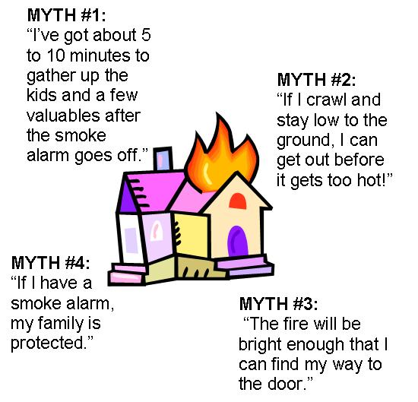

MYTH#1: “I’ve got about five to ten minutes to gather up the kids and a few valuables and get out after the smoke alarm goes out.”

REALITY: Fire is FAST! There is little time! You only have (on average) about two minutes to escape.

In less than 30 seconds a small flame can get completely out of control and turn into a major fire. It only takes minutes for thick black smoke to fill a house and the smoke will most likely kill you long before the flames ever reach you. In minutes, a house can be engulfed in flames. Most fires occur in the home when people are asleep. If you have to wake up participants and employees because of a fire, you won't have time to grab valuables because fire spreads too quickly and the smoke is too thick. There is only time to escape.

MYTH#2: “If I crawl and stay low to the ground, I can get out before it gets too hot!”

REALITY: Fire is HOT!

Heat is more threatening than flames. A fire's heat alone can kill. Room temperatures in a fire can be 100 degrees at floor level and rise to 600 degrees at eye level. Inhaling this super hot air will scorch your lungs. This heat can melt clothes to your skin. In five minutes a room can get so hot that everything in it ignites at once: this is called "flashover".

MYTH#3: “The fire will be bright enough that I can find my way to the door.”

REALITY: Fire is DARK!

Fire isn't bright, its pitch black. Fire starts bright, but quickly produces black smoke and complete darkness. Participants and employees who wake up to a fire you may be blinded, disoriented and unable to find their way around the facility.

MYTH#4: “If I have a smoke alarm, I’m protected.”

REALITY: Fire is DEADLY!

Smoke and toxic gasses kill more people than flames do. Most household items contain chemicals that can burn toxic in a short amount of time. Fire uses up the oxygen you need and produces smoke and poisonous gases that kill. Breathing even small amounts of smoke and toxic gases can make you drowsy, disoriented and short of breath. The odorless, colorless fumes can lull you into a deep sleep before the flames reach your door. Participants and employees may not wake up in time to escape.

Looking For Potential Safety Hazards in Your Home

Hazards

Prevention is the best tool in keeping your program safe. By looking at the programs space with a critical eye, you may stop a problem before it starts. Use the exercise below to learn what to look for to help prevent a fire from starting. This is a good activity to use with kids, too! Another great resource for checking out home safety is the “Your Home Fire Safety Checklist” published by the US Consumer Product Safety Commission. This comprehensive booklet is available on line and covers a wide variety of safety tips that will keep your family safer from common causes of home fires.

Fire Extinguishers 101 have a great listing of safety tips for your home. (http://www.fire-extinguisher101.com/hazards.html).

Quick Stats

The Overall Fire Picture - 2007
- There were 3,430 civilians that lost their lives as the result of fire.
- There were 17,675 civilian injuries that occurred as the result of fire.
- There were 118 firefighters killed while on duty.
- Fire killed more Americans than all natural disasters combined.
- 84 percent of all civilian fire deaths occurred in residences.
- There were an estimated 1.6 million fires in 2007.
- Direct property loss due to fires was estimated at $14.6 billion.
- An estimated 32,500 intentionally set structure fires resulted in 295 civilian deaths.
- Intentionally set structure fires resulted in an estimated $733 million in property damage.
Source: National Fire Protection Association Fire Loss in the U.S. 2007 and USFA's Firefighter Fatalities in the United States in 2007.

Alaska Center for Resource Families Regulations Regarding Fire Safety
The State of Florida DCF Licensing Regulations establishes basic fire safety standards for Child Caring Facilities. Yearly, your DCF licensing worker inspects your program to make sure that your facility meets the basic health and safety requirements.
All residential child-caring agencies must meet fire safety standards for such agencies adopted by the Division of State Fire Marshal of the Department of Financial Services and must be inspected annually. At the request of the department, fire safety inspections shall be conducted by the Division of State Fire Marshal or a local fire department official who has been certified by the division as having completed the training requirements for persons inspecting such agencies. Inspection reports shall be furnished to the department within 30 days of a request.

Common fire safety equipment includes:
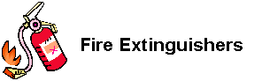
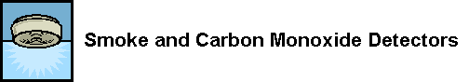

Your “evacuation plan” should get everyone out of the facility within 2 1/2 minutes. All programs practice fire drills and document the fire drills and note the following information:
- The date and time of the drill
- The names of everyone who participated
- The amount of time needed to complete the drill
- A brief evaluation of the drill
- Documentation of why a drill may have been postpone
“FIREDRILL REPORT” is located on the intranet for use in record keeping.

The Best Plan for Getting Out Safe and Alive...
The best plan for keeping participants and employees safe in a fire is to prevent fires from happening in the first place and practicing how to get out of a fire if one happens.

ka Center for Resource CDS EMPLOYEES Web Based Course
Lesson 2: Practice! Practice! Practice!

Why Fire Safety Is So Important With Adolescence

Ask yourself why it might be especially important for CDS Employees to talk to adolescence about fire safety and practice fire drills. Also, ask yourself what puts our participants more are risk during an emergency. Write your answers on a separate piece of paper.
Why is it important to talk to adolescence about safety?
What puts adolescence in your program more at risk for harm during an emergency?

Specials Reasons Why Planning Ahead Is Especially Important for Adolescence
Compare your answers you wrote in the exercise above with the answers provided.

Why Participants Especially Youth Need Good Fire Safety Education....

- In an emergency, participants tend to panic and forget what they know. They may put themselves in more danger by hiding or running into a room that's filled with smoke.
- Residential participants may be hard to wake from a deep sleep or may not recognize what the smoke alarm sounds like. They may hide under the covers or just go back to sleep.
- Participants in our care often have special needs and it may be harder to move from place to place. They may be over stimulated or overwhelmed by the sound of the smoke alarm.
- When participants come into our facilities, they are unfamiliar with the layout. During the panic of a fire or emergency, they may forget where the door is or how to get out if they haven't practice.
- Participants may bring firesetting behaviors into the program, giving us the double challenge of keeping all participants and employees safe but also addressing the firesetting behaviors in the participants and employees.

What about Adults?
What about you? Do you know how to work the fire extinguisher? Do you know how you’ll react if there is a fire? Do you know if the residential participants in their deep sleep will they be able to hear the smoke alarm? What happens if they can’t? Where will you find each other if you get out of the facility separately? Adults need to practice, too!
This lesson will help you look at what makes an effective escape plan, how to conduct an effective fire drill and how to use your fire extinguisher.

Alaska Center for Resource Families Web Based Co

urse

Planning Your Fire Escape Plan


Planning Your Fire Escape
Before you can practice your fire escape plan, you have to become familiar with your facilities evacuation plan. Your facilities evacuation plan and your buildings plans are on the CDS intranet. Know what to do. Practice mock drills having the fire spread to an area and then block your exit from the building. Know what to do so you can teach it to your participants.
Fire can spread rapidly through your facility, leaving you as little as two minutes to escape safely once the alarm sounds. Your ability to get out depends on advance warning from smoke alarms and advance planning—a facility fire escape plan that everyone on your shift is familiar with and has practiced. Walk through your program and inspect all possible exits and escape routes.
As you walk through your program, make sure escape routes are clear and doors and windows can be opened easily. Make sure smoke alarms and fire extinguishers are working and you and your co-workers and the participants know how to use them.
Choose two escape routes out from each room, in case fire or smoke blocks an exit. Meet outside at the designated place, a safe distance away where everyone can meet after they've escaped. Have everyone memorize the emergency phone number of the fire department in order to call from a neighbor's home or a cell phone once outside.
Under no circumstances should you ever go back into a burning building. If someone is missing, inform the fire department dispatcher when you call. Firefighters have the skills and equipment to perform rescues.

Considering Some Fire Drill Scenarios
Practicing Your Fire Escape Plan
Practice your escape plan and discuss different scenarios with your participants. Just don't talk about it-- do it! Participants and employees need to practice. They need to recognize the sound of the smoke detector. They need to recognize when smoke and heat may make their first choice of exit unsafe. They need to know what to do in case you are not able to reach them.
Niki Pereira, a former fire fighter and a fire education specialist in Anchorage, developed the following fire escape plans to teach families the essential of a good fire escape plan. One is when you can use your planned exits. The second scenario is when your exits are blocked.

FIRE ESCAPE SCENARIO #1:

Participants are sleeping with their bedroom. Participants awaken to the sound of your smoke alarm in the middle of the night.

Following is an effective response to this scenario for residential participants.
- Roll out of bed. Stay low on the floor.
- Crawl to your bedroom door.
- If the bedroom door is closed feel the cracks around the door for heat. Look for smoke coming through the door.
- If you feel no heat and see no smoke, open it just a crack.
- If the bedroom door is open look for smoke or feel for heat, if you feel no heat or see no smoke, crawl to the nearest door to go outside.
- Crawl to the nearest door to the outside and get out!
- Go to the pre-assigned meeting space.
- Call the fire department or your emergency number.
Here is another fire escape scenario put together by Niki Pereira. This time, you can't get out of fire by your regularly planned exits!

FIRE ESCAPE SCENARIO #2:

Residential participants are sleeping with bedroom door closed to protect youth from smoke and heat. Participants awaken to the sound of smoke alarm in the middle of the night. This time, participants are trapped in the bedroom. Participants’ bedroom door is blocked by heat and smoke and participants can’t get out their window. Participants can’t get out!

Following is an effective response to this scenario.

1. Roll out of bed. Stay low on the floor.

2. Crawl to your closed bedroom door.

3. Feel the cracks around the door for heat and look for smoke.

4. There is warm air coming in around the door. Keep the door closed!

5. Crawl to your second way out…the bedroom window.

6. Keep crawling and stay low to the ground. Stay calm and think!

7. Stuff clothing or bedding in the places where smoke is coming in.

8. Hang something light colored out the window such as a sheet or clothing.

10. Stay close to the floor and keep out in the open.

11. Wait for the firefighters.

Again, discuss these scenarios with your participants. And Practice! Practice! Practice!

If You Have A Participant or Co-worker With A Disability...

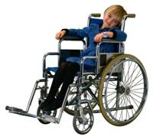

Fire Safety with Individuals with Disabilities. Individuals with disabilities have special issues when thinking about preparing for an escape from a fire. Planning ahead of time is particularly important. Think about what the person needs in order to get out, keep safe or get noticed. Plan, prepare and practice!
Fire Safety with Anxious Individuals. When afraid, kids commonly seek sheltered places such as a closet or under the bed. Encourage them to exit outside. Do not allow them to hide. Make sure they can operate the windows, and lower themselves to the ground through a window. Lower smaller participants and employees to the ground before you exit from the window. They may panic and not follow if an adult goes first. CDS Employees should practice saying the fire department number, the facilities name, and street address.
Hypersensitive and Easily Stimulated Children. For hypersensitive and easily stimulated participants and employees, unplanned fire drills can be very upsetting. At the facility, help the participants and employees learn to recognize the sound of the alarm and have some time to get used to it. When you practice your fire alarms, warn the participants and employees ahead of time and let him or her see you press the alarm. For a very sensitive individual, let them cover their ears at first and gradually take their hands away to get used to the sound.
Individuals with disabilities: Plan specifically around the special needs of the disabled participants and employees in care. For an individual with visual impairments, using an alarm that uses flashing lights can help or assign someone in a nearby room to be responsible for the person. If the participants and employees are mentally impaired, again arrange for their sleeping area to be near someone who can help and practice the drill more frequently.
If the person is in a wheelchair, then you need to help them learn how to get to the ground in case of a fire. If a person catches on fire and is unable to STOP, DROP, and ROLL, you may need to teach how to smother a flame with a blanket or teach others in the shelter to use a blanket to smother the flames. Teach the basic information about what to do if you are trapped, such as stay out in the open, get as low as possible and let someone know where you are. You may choose to have an emergency whistle in their room or place a light near the window.

Knowing How to Use a Fire Extinguisher
All license facilities need to have a fire extinguisher located in a convenient and easily accessible place. But how many of us have had to actually use our fire extinguishers? We may honestly not know that fire extinguishers are made to put out different kinds of fires and that there is a correct way to operate you’re your fire extinguisher.

The goal of this activity is to know how fire extinguishers work, how to use a fire extinguisher and how to use the PASS system, and what kind of maintenance is needed.
Understanding and Using a Fire Extinguisher
Excerpted from the Mt. Pleasant, Michigan homepage at http://www.mt-pleasant.org/depts/fire/extinguish.htm and
From Fire Extinguishers 101 at http://www.fire-extinguisher101.com/using.html
Studies show that from the time a fire starts, a person has less than four minutes to
Escape the overcoming effects of smoke, poisonous gases or superheated air. A fire extinguisher is your best defense against small, contained fires that have just begun to burn. Extinguishers can control flames until the fire department arrives, and buy you enough time to get out of a burning structure.
What's Your Type of Fire Extinguisher?
Every type of extinguisher is designed to fight a certain class or classes of fire. There are four classes which are determined by the type of fuel. Learning to identify these classes will help you select the right fire extinguisher. Using the wrong type of fire extinguisher can cause a fire to spread and place you in greater danger.
Type A extinguishers fight ordinary combustibles such as burning wood, cloth, paper, rubber, upholstery and plastics.
Type B extinguishers fight flammable liquids, gases and greases such as oils, paints and gasoline.
Type C extinguishers fight energized electrical fires such as burning wires, fuse boxes, circuit breakers, machinery and appliances.
Type D extinguishers are used on fires caused by combustible metals such as magnesium, sodium, potassium and aluminum. This type of extinguisher must match the type of metal that is burning for safety and maximum effectiveness. A list of metals that match the unit's extinguishing agent should be on the label.

There are also multipurpose fire extinguishers that can be used on type A, B and C classes of fire. Here are the most common types of fire extinguishers:
• Water extinguishers or APW extinguishers (air-pressurized water) are suitable for class A fires only. Never use a water extinguisher on grease fires, electrical
fires or class D fires - the flames will spread and make the fire bigger! Water
extinguishers are filled with water and pressurized with oxygen. Again - water
extinguishers can be very dangerous in the wrong type of situation. Only fight the
fire if you're certain it contains ordinary combustible materials only.
• Dry chemical extinguishers come in a variety of types and are suitable for a
combination of class A, B and C fires. These are filled with foam or powder and pressurized with nitrogen.
o BC - This is the regular type of dry chemical extinguisher. It is filled with sodium bicarbonate or potassium bicarbonate. The BC variety leaves a mildly corrosive residue which must be cleaned immediately to prevent any damage to materials.
ABC - This is the multipurpose dry chemical extinguisher. The ABC type is filled with
monoammonium phosphate, a yellow powder that leaves a sticky residue that may be damaging to electrical appliances such as a computer. Dry chemical extinguishers have an advantage over CO2 extinguishers since they leave a non-flammable substance on the extinguished material, reducing the likelihood of re-ignition.

What's the PASS?
To use an extinguisher safely, stand six to eight feet from the fire with your back to an unblocked exit and use the PASS procedure:
• Pull the safety pin at the top of the extinguisher. (Some units have latches or levers instead.)
• Aim the nozzle, horn or hose at the base of the flames. Hold the extinguisher vertically to ensure the unit will have enough pressure.
• Squeeze or press the handle to release the extinguishing agent. Contents empty fast.
• Sweep from side to side at the base of the fire and at least six inches past the edges of the flames until completely extinguished.

A typical fire extinguisher contains 10 seconds of extinguishing power. This could be less if it has already been partially discharged. Always read the instructions that come with the fire extinguisher beforehand and become familiarized with its parts. It is highly recommended by fire prevention experts that you get hands-on training before operating a fire extinguisher. Most local fire departments offer this service.
Once the fire is out, don't walk away! Watch the area for a few minutes in case it reignites. Recharge the extinguisher immediately after use.

Keep in a Location Near You
Keep extinguishers close to high-traffic areas, in easy-to-access locations. Place extinguishers on wall brackets no higher than five feet from the floor. Install them near
exists and hazard areas. Keep one on each level of the dwelling, in the garage, and near the doors of furnace and mechanical rooms.

It's About Time
Acting fast can make the difference between and small fire and one that consumes your whole building. Before fighting a fire, be certain that everyone has been alerted to the fire and is leaving the building, and that the fire department has been called. Fight the fire only if the fire is small and contained, a correct type of extinguisher is within easy reach, and you are near a clear exit in case you need to escape.

Ready for Inspection
After each use, service rechargeable units and replace disposable models immediately.
Check pressure gauges and carbon dioxide containers monthly. Inspect all containers on a regular basis looking for damage, corrosion or tampering. Make sure extinguishers are easy to remove from hooks or wall brackets. Maintain inspection records of usage and service. Records are helpful after a fire to prove to insurance companies that
extinguishers were all serviced and in working order.

Fire Safety First!
• Practice fire prevention.
• Install and maintain fire extinguishers.
• Learn to operate extinguishers properly.
• Remember that extinguishers have limits.
• When in doubt, get out and leave the firefighting to the professionals.
OR
OPTION TWO: Video based activity: If you prefer a visual tutorial in how to use a fire extinguisher, click on this link and go through the web based tutorial from fireextinguisher.com. When you are given a choice what fire extinguishers to learn about, choose the A, B and C types. This tutorial will take you about 10-15 minutes to complete
Go to fireextinguisher.com located at http://www.fireextinguisher.com/

Alaska Center for Resource Families

Adolescence Who Use Fire

Why Do Adolescence Use Fire?
We often say that it's normal that kids "play" with fire. Many of us who are taking this class experimented with candles, matches, and fire when we were young. Fire has a power and a fascination for many participants and employees. It important to understand that there are different levels of this fascination. And it's also important to understand the danger in all fire. A fire set by a child experimenting with a lighter can cause as much damage as a teen that intentionally sets a fire. But the ways we work with adolescence may vary depending on the type of firesetting behavior it is.
Misuse of Fire Happens On A Continuum
Why do kids set fires? There can be many different reasons. The boxes below show that we can place children and adolescents who use fire in three different categories: Curiosity, Definite Concern, and Extreme Concern. Read a profile of each of these types of firesetting behaviors.
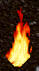
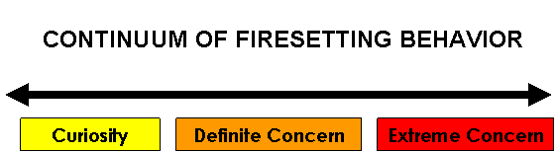

Children Who Set Fires Out Of Curiosity

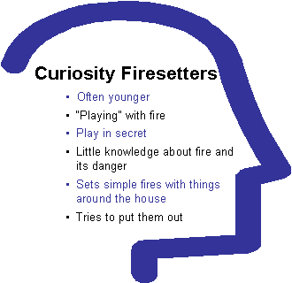
The biggest group of children misuse fire out of CURIOSITY. They are usually young, play in secret and have access to lighters and matches. They “play with fire” to see what will happen, but probably don’t have the motive of destroying a house or hurting anyone. They often try to light materials that they find around the home, such as paper or cloth. They may try to put them out, instead of letting them burn.
These children often imitate the adults around them who they see lighting cigarettes, candles, fireplaces or cooking grills. Most often these children are younger, but some children with developmental delays may fit in the curiosity category.
These children most often need fire safety education and supervision. Caretakers of these children also need education and skills for making their home safe from fires.

Firesetting That Is Of Definite Concern

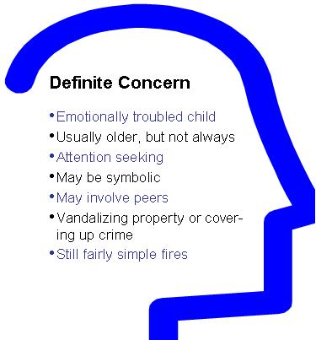
Some children’s misuse of fire is of DEFINITE CONCERN. These children are emotionally troubled. They may be acting out in other ways, set fires to get attention or use fire to destroy clothes or personal property that hold some meaning to them.
These children are typically older, such as between 7 and 14 but can be of any age. Something may be upsetting them or troubling them and they may not have very good skills to talk about them. They may set fires to get attention or in a veiled way to let adults know they are hurting.
Sometimes these children have mental emotional disturbances or are psychologically stressed because of events in their life. These children may be beginning a pattern of misusing fire to gain attention or to cry out for help. Like the curiosity fire setter, these children often set fairly simple fires and use matches and lighters and materials around the house.
These children need fire safety education too, but will also benefit from counseling for the underlying problems. Some children may be very troubled or have mental health problems such as a conduct disorder. Firesetters of Definite Concern usually benefit from a combination of fire safety education and mental health counseling or intervention. Again, parents and caretakers also benefit from fire safety education in this category.
Firesetting That Is Of Extreme Concern

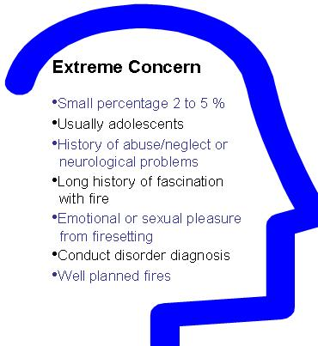
Firesetting that is considered EXTREME CONCERN is the most dangerous of the continuum of why children misuse fire. This is a small percentage of children who set fires, about 2 to 5%.
These are usually older adolescents often have a history of medical or neurological problems, academic and behavior problems. They have a long history of fascination with and misuse of fires and have probably set dozens of fires. These children may find pleasure or gratification in setting a fire, or use fire as a way to get revenge on people who have wronged them or made fun of them
The severely disturbed fire setter has often been a victim of physical or sexual abuse, and may get sexual pleasure or excitement in the planning and setting of fires. They may intend to cause damage or injury to others. They have a history of chronic, disruptive behavior and often a diagnosis of conduct disorder. These children and participants and employees already know the danger of fire. Their fires may be well planned, and are often ignited with fire starting materials such as gas or kerosene.
Fire education is not what these children need. These children need assessment and intense mental health intervention, possibly even mental health residential treatment.

Knowing the Red Flags of Firesetting Behavior


When Should CDS EMPLOYEES Be Concerned About Firesetting?
The answer is ALWAYS! It is important to take use of firesetting seriously, since even simple curiosity can result in harm to people and property. But some signs are of particular importance
RED FLAGS:
- Chronic history of misusing fire
- Firesetting seen in a child who also shows a pattern of being cruel to animals
- Firesetting in older children
- Threats of setting fires or actual firesetting to scare or control adults
- Psychiatric diagnosis of conduct disorder along with firesetting behavior
- Rageful, vengeful anger that accompany firesetting

OTHER WARNING SIGNS:
- Fascination with fires and candles
- Stashing matches or lighters; hiding or hoarding matches
- Stealing matches from purses or restaurants
- Talk about fires
- Smelling smoke in bedrooms, bathrooms or hiding places
- Past history of misuse of fire

Any time that you feel that misuse of fire goes beyond curiosity and becomes serious or becomes a pattern; contact your supervisor and residential counselor for additional help for the child.

What Participants and employees Need
Participants and employees will need different things depending on why they are setting fires. Curiosity in young firesetters usually need education about fire safety hazards and need good supervision and environment control. This means their parents need education too!
Children and adolescent who set fires for other reasons, such as to cause harm, or who are neurologically or psychologically affected, or are greatly aroused by fire, often need a combination of education with an emphasis on assessment and psychological assistance. As one author wrote, "A brief visit to the fire house with a ride on a truck or a brief 'lecture' from a local Fire Chief may not be enough for a youngster with a history of impulsivity, depression and/or family conflict." (Barreto and Boekamp.)
These same authors state that "parents of children who set fires report greater psychological distress, heightened marital conflict, less acceptance of and involvement with the child, less frequent and effective parental supervision, inconsistent and harsh discipline strategies and a great number of stressful life events.”

Safety Tips for CDS Employees

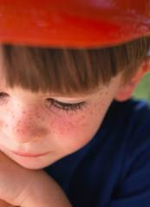
How Can All Families Keep Themselves Safer?

Strategy #1: Educate Yourself About The Misuse Of Fire By Children.
Learn everything you can about fire use in children. Start with the Bibliography/Other Resources page for this course to begin.

Strategy #2: Do Everything You Can To Control Your Programs Environment.
Lock up matches and lighters. Set a good example when it comes to using fire. Provide good supervision for children and teens and keep kids busy and occupied. Make sure your smoke detectors and fire extinguishers are maintained and working. Be diligent in practicing your fire escape plan. Educate your participants and employees that fire is a tool, not a toy or play thing.

Strategy #3: Refer Participants and employees for an Assessment For Firesetting.
If you are caring for a participant that uses fire, talk to your supervisor or residential counselor, a knowledgeable mental health professional or your local fire department. An assessment can help determine the cause behind the fire use and suggest appropriate intervention with the child or adolescent.

CONCLUSION

Let's Do Everything To Keep Our Program Safe
We all want our program to be safe and stay safe. But when fire comes to our facility, we also want our participants and employees to be prepared and be ready. The regulations provide several guidelines for making sure that smoke detectors and fire extinguishers are available in the facility, but the real education and preparedness takes place through knowledge and practice.
In this course, you learned how to use a basic fire escape plan, the requirements of the residential child caring agency regulations, the elements of a good fire drill, how to use a fire extinguishers, and the "red flags" of child firesetting behavior.


You have now completed the CDS: "Fire Safety Training Course for CDS Employees."

Fire Safety Course for Resource CDS EMPLOYEES
Bibliography and Resources Used in Making This Course

Web Based Resources
The National Fire Protection Association (www.nfpa.org) is the premier organization for fire safety and training information. The National Fire Protection Association also put together a Family Escape Plan. Check it out at NFPA´s Escape Plan Grid .
NFPA is also the organization behind the Sparky the Fire Dog Safety Campaign for Adolescence, which offers lots of fun and informative activities for adolescence. Check it out at http://www.sparky.org/. Also find Sparky the Firedog Tips for Kids http://www.nfpa.org/assets/images/FPW05/Gamesparky.pdf
Your Home Fire Safety Checklist from the Consumer Product Safety Commission Washington DC 20207 - View as HTML . Also available on a special. Hotline number 1-800-638-8270 www.cpsc.gov/CPSCPUB/PUBS/556.pdf US
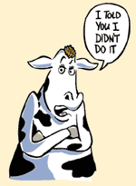
Fire Prevention week is the result of the Big Chicago Fire in 1871. (Yep, Mrs. Leary’s Cow is the reason that October 8 is Fire Prevention Week!) Check out the story HERE.
Virginia Department of Foresty Fire Resources for Teachers and Adolescence has a great listing of resources for educators and CDS EMPLOYEES. (http://www.dof.virginia.gov/edu/fire-resources.shtml)
Juvenile Firesetting Iinterventions: What works for adolescence and CDS EMPLOYEES? Steven Barreto, Ph.D., and John Boekamp, Ph.D. Child Research Net, Brown University (http://www.childresearch.net/RESOURCE/NEWS/2005/200506.HTM#1)
"Firesetting and Participants and employees" Focus Adolescent Services (http://www.focusas.com/Firesetting.html)
Niki Pereira, Fire Education Specialist and a Fire Stopper Assessor, has been a great help and resource in putting this course together. She is currently housed with the Alaska Injury Prevention Council in Anchorage. Contact Fire Education Specialist Niki Pereira at http://www.alaska-ipc.org/ or email her at niklnuk@gci.net
Fire In Alaska 2004 Report of fire related statistics published by the Department of Public Safety. (www.dps.state.ak.us/fire/pdf/2004ak.pdf) - View as HTML
Fire Extinguisher 101 A web page devoted to learning how to use your fire extinguisher properly. (http://www.fire-extinguisher101.com/using.html)

Videos, DVDs and Articles
The following resources are available: www.acrf.org or by emailing acrf@nwresource.org
Plan To Get Out Alive Safety Video published by Fire Alert and McDonalds, WCBS-New York. 1988
Home Fire Drills: What Every Parent Should Know Published by National Fire Protection Association, 2002 with footage from WCCO-TV in Minnesota.
Fostering A Fire Safe Home: A Guide for Foster Parents Caring for a Child with Firesetting Behavior. Self Study Course by the Alaska Center for Resource at www.acrf.org and the Anchorage Fire Department Firestoppers Program.

