Meeting Minutes
CDS Family & Behavioral Health Services, Inc.

Meeting: IYPC STAFF MEETING/TRAINING
Date: November 7, 2019
Time: 4:00PM
Location: 1400 NW 29TH ROAD, GAINESVILLE, FLORIDA
Date of Next Meeting: THE 2ND and 4TH THURSDAYS
Present: C. McCray, Z. Whitter, N. Thompson J. Turk, B. Smith, J. Mattox, S. Carter, S. Durham, K. Lee, R. McBride, M. McMann,
S. Parker, S. Twining, N. Wales, D. Walker, A. Rowden, W. Harmon, E. McCrea, S. Warmack
Absent: O. Jones, J. Johnson, A. Dennis, B. Cox,, J. Bartley, S. Davis, G. Strickland
I. Business Operations:
A. Monthly Budget (Revenue and Expenses)
1. Sub-topic:
Discussion: No discussion
Outcome, Actions, Timeframe:
B. Marketing and Business Development
1. Sub-topic:
Discussion: No discussion
Outcome, Actions, Timeframe:
C. Regulatory Issues
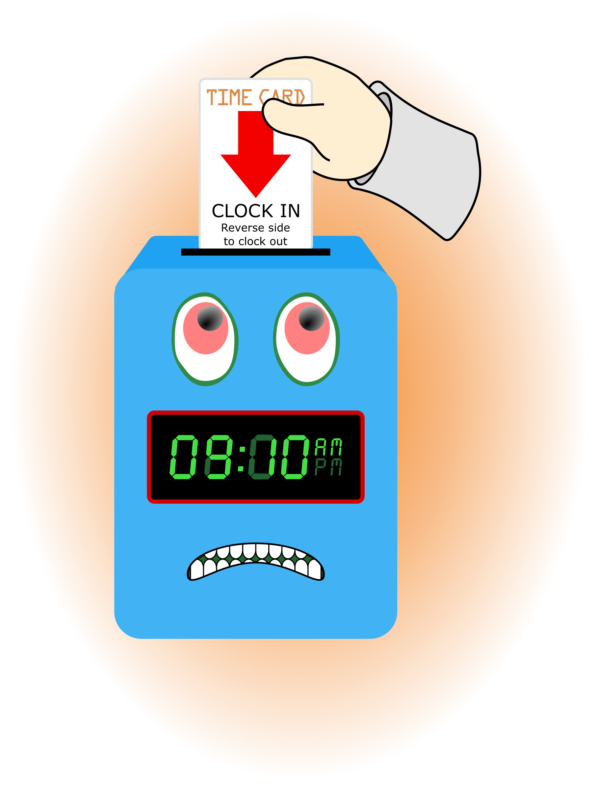
1. Sub-topic:
Discussion: No discussion
Outcome, Actions, Timeframe:
D. Human Resource Issues (Staffing and Training)
1. Sub-topic: Time Sheets Due
Discussion:
Outcome, Actions, Timeframe: Staff should submit time sheets by Friday November 15, 2019 @ 12:00 noon.
2. Sub-topic: Training Needs
Discussion: Areas identified by supervisors and staff discussed
Outcome, Actions, Timeframe:
3. Sub-topic: Training Topic (s)- Epi Pen use
Discussion: discussion on how to use an Epi Pen, we currently have an intern w/severe peanut allergies. The snack schedule was discussed. There are designated “nut free” rooms. Alert the intern if you are aware of any concerns.
Outcome, Actions, Timeframe: A. Rowden, nurse, covered the procedures for use of the Epi Pen. The intern carries their pen.
4. Sub-topic: New Hire
Discussion:

Outcome, Actions, Timeframe: WELCOME! Shakira Warmack

E. Annual Budget Planning and Process
1. Sub-topic:
Discussion: No discussion
Outcome, Actions, Timeframe:

II. Health and Safety: Program/Regional Coordinators
A. External Inspections
1. Sub-topic:
Discussion: No discussion
Outcome, Actions, Timeframe:
B. Self-Inspections (Reports, analysis, and recommendations)
1. Sub-topic:
Discussion: No discussion
Outcome, Actions, Timeframe:
C. Incident Reports (Reports, analysis of trends, recommendations)
1. Sub-topic:
Discussion: No discussion
Outcome, Actions, Timeframe:
III. Quality Improvement
A. File Audits and Case Record Review (reports and recommendations)
1. Sub-topic:
Discussion: No discussion
Outcome, Actions, Timeframe:
B. Outcome Management (status, reports, recommendations)
1. Sub-topic:
Discussion:
Outcome, Actions, Timeframe:
C. Accreditation and Regulatory Requirements
1. Sub-topic:
Discussion: No discussion
Outcome, Actions, Timeframe:

D. Policy and Procedure Updates and/or Review
1. Sub-topic:
Discussion: No discussion
Outcome, Actions, Timeframe:
E. Participant Complaint and Grievance (specific and quarterly review of trends)
1. Sub-topic:
Discussion: No discussion
Outcome, Actions, Timeframe:
F. Planning Documents (reports, status of goals and objectives, reformulation)
1. Sub-topic: Strategic Plan
Discussion: No discussion
Outcome, Actions, Timeframe:
2. Sub-topic: Accessibility Plan
Discussion: No discussion
Outcome, Actions, Timeframe:
3. Sub-topic: Cultural Competence Plan
Discussion: No discussion
Outcome, Actions, Timeframe:
4. Sub-topic: Input Plan
Discussion: No discussion
Outcome, Actions, Timeframe:
5. Sub-topic: Community Relations plan
Discussion: No discussion

Outcome, Actions, Timeframe:

IV. Risk Management
A. Risk Management Plan (exposure to loss)
1. Sub-topic:
Discussion: No discussion
Outcome, Actions, Timeframe:

B. Employee Concerns or Complaints
1. Sub-topic: Open Mic
Discussion: Staff Questions, Concerns, Complaints, Requests, etc.
Outcome, Actions, Timeframe: A concern for increased security was expressed and the question was posed to do double locks within the building to prevent/limit movement from one side to the other. Our first line of defense is ourselves to ensure we are actively doing what we can do to ensure the maximum amount of security is occurring now.
C. Potential regulatory audits and/or investigation of operations
1. Sub-topic:
Discussion: No discussion
Outcome, Actions, Timeframe:
V. Information Technology
A. Technology Plan
1. Sub-topic:
Discussion: No discussion
Outcome, Actions, Timeframe:
VI. Clinical/Program
A. Medical and Medication Issues
1. Sub-topic: FOCUS FOCUS FOCUS
Discussion: Medication Reminder Board, what it include???
Outcome, Actions, Timeframe:

B. Counseling and Programming Issues
1. Sub-topic: Participant Updates/Concerns
Discussion: Staff Secure Supervision expectations
Outcome, Actions, Timeframe: Discharges- Follow the policy and guidelines posted in control room.
2. Sub-topic: Shift Coverage Needs
Discussion: Staff are responsible to securing coverage when they would like to take time off. On the leave request staff should indicate details of the outcome for coverage.
Outcome, Actions, Timeframe:
a) Request for coverage by co-workers- Multiple staff are wanting to take Thanksgiving day and the day after off. We will be looking for anyone to assist in covering day and evening shifts on that Thursday and Friday.
b) Request for coverage by program- J. Bartley is out ill, by Dr’s order, THANKS to persons helping with that coverage. Coverage is needed for 11/9/19 and 11/16/19 day and evening shifts.
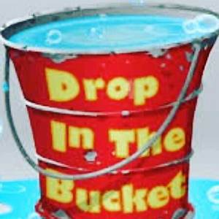
VII. Other Business:
1. Sub-topic: A Drop For Your Bucket
Discussion: Recognizing co-workers for the “extra” they do to make the work environment better. We applaud all that you do and want to let you know we are grateful. Thank You!!!
Outcome, Actions, Timeframe:

Submitted by:
Cassandra McCray 11/7/19

