Meeting Minutes
CDS Family & Behavioral Health Services, Inc.

Meeting: IYPC STAFF MEETING/TRAINING
Date: October 24, 2019
Time: 4:00PM
Location: 1400 NW 29TH ROAD, GAINESVILLE, FLORIDA
Date of Next Meeting: November 7, 2019
Present C. McCray, B. Cox, J. Mattox, J. Bartley, S. Carter, S. Davis, S. Durham, K. Lee, R. McBride, M. McMann, S. Parke,
B. Smith r, S. Twining, N. Wales, D. Walker, E. McCrea, , Z. Whitter N. Thompson, O. Jones,
Absent: J. Johnson,, A. Dennis, W. Harmon, G. Strickland, A. Rowden, J. Turk,

I. Business Operations:
A. Monthly Budget (Revenue and Expenses)
1. Sub-topic:
Discussion: No discussion
Outcome, Actions, Timeframe:
B. Marketing and Business Development
1. Sub-topic:
Discussion: No discussion
Outcome, Actions, Timeframe:
C. Regulatory Issues
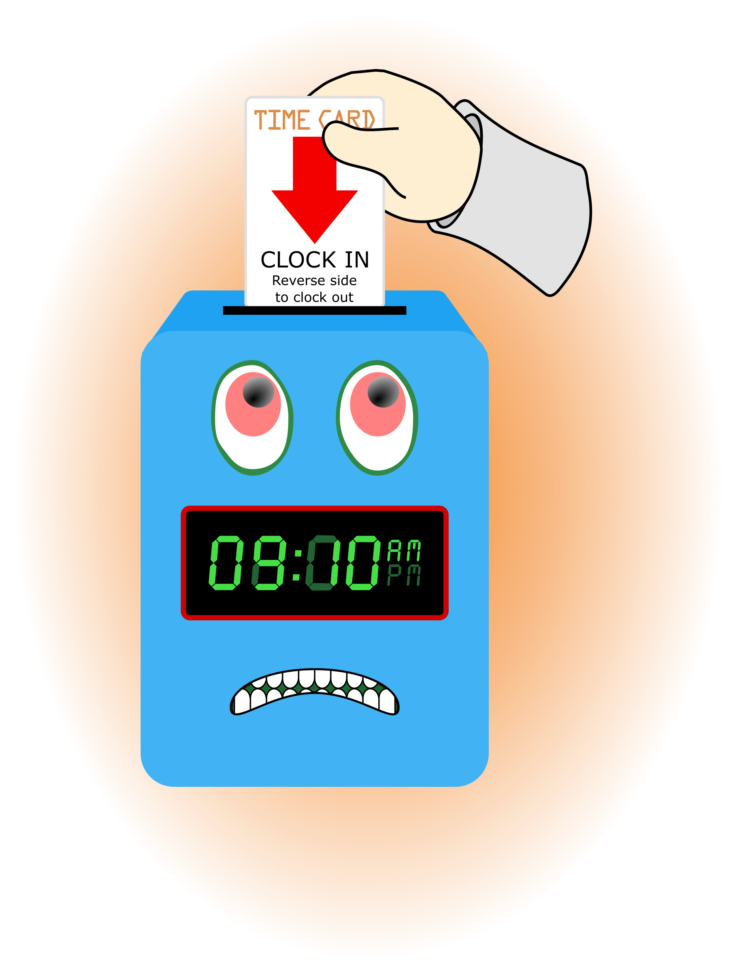
1. Sub-topic:
Discussion: No discussion
Outcome, Actions, Timeframe:
D. Human Resource Issues (Staffing and Training)
1. Sub-topic: Time Sheets Due
Discussion:

Outcome, Actions, Timeframe: Staff should submit time sheets by Friday November 1, 2019 @ 12:00 noon.
2. Sub-topic: Training Needs
Discussion: Areas identified by supervisors and staff discussed
Outcome, Actions, Timeframe: 1st Aid/ CPR; O. Jones and R. McBride, must be completed by Wednesday October 30, 2019. Turn in a copy of the Certificate/Card in your training folder.
3. Sub-topic: Training Topic (s)- Interpretive summary/IYPC Intake
Discussion: Role plays
Outcome, Actions, Timeframe: Will occur the November 7th meeting
4. Sub-topic: Pending List Needs
Discussion:
Outcome, Actions, Timeframe: Everyone is asked to continue to turn in the necessary items requested.
5. Sub-topic: Meeting Dates/ Holidays
Discussion: Changing Meeting dates for November and December. Having a holiday celebration time in December. Date options November 7th, 21st. December 19^{th..} ???
Outcome, Actions, Timeframe: We will meet November 7th , 21st and December 19, 2019. The January schedule of meeting will be back to the 2nd and 4th Thursdays.

E. Annual Budget Planning and Process
1. Sub-topic:
Discussion: No discussion
Outcome, Actions, Timeframe:

II. Health and Safety: Program/Regional Coordinators
A. External Inspections
1. Sub-topic:
Discussion: No discussion
Outcome, Actions, Timeframe:
B. Self-Inspections (Reports, analysis, and recommendations)
1. Sub-topic:
Discussion: No discussion
Outcome, Actions, Timeframe:
C. Incident Reports (Reports, analysis of trends, recommendations)
1. Sub-topic:
Discussion: No discussion
Outcome, Actions, Timeframe:

III. Quality Improvement
A. File Audits and Case Record Review (reports and recommendations)
1. Sub-topic:
Discussion: No discussion
Outcome, Actions, Timeframe:

B. Outcome Management (status, reports, recommendations)
1. Sub-topic: 30/60/90 Day Follow-up contacts/Responses
Discussion:
Outcome, Actions, Timeframe: Mr. Cox provided information for contacts that were made. Thank you to Mr. Cox for reaching out to the parents/guardians and to staff for working with the youth in a positive manner to ensure successful outcomes.
. Accreditation and Regulatory Requirements
1. Sub-topic:
Discussion: No discussion
Outcome, Actions, Timeframe:
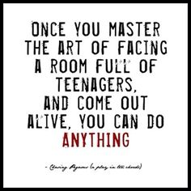
D. Policy and Procedure Updates and/or Review
1. Sub-topic:
Discussion: No discussion
Outcome, Actions, Timeframe:
E. Participant Complaint and Grievance (specific and quarterly review of trends)
1. Sub-topic:
Discussion: No discussion
Outcome, Actions, Timeframe:
F. Planning Documents (reports, status of goals and objectives, reformulation)
1. Sub-topic: Strategic Plan
Discussion: No discussion
Outcome, Actions, Timeframe:
2. Sub-topic: Accessibility Plan
Discussion: No discussion
Outcome, Actions, Timeframe:
3. Sub-topic: Cultural Competence Plan
Discussion: No discussion
Outcome, Actions, Timeframe:
4. Sub-topic: Input Plan
Discussion: No discussion
Outcome, Actions, Timeframe:
5. Sub-topic: Community Relations plan
Discussion: No discussion

Outcome, Actions, Timeframe:

IV. Risk Management
A. Risk Management Plan (exposure to loss)
1. Sub-topic:
Discussion: No discussion
Outcome, Actions, Timeframe:

B. Employee Concerns or Complaints
1. Sub-topic: Open Mic
Discussion: Staff Questions, Concerns, Complaints, Requests, etc.
Outcome, Actions, Timeframe: 1- Discussed concerns related to monies distributed last year. There are feeling no one is working on their behalf. 2- Bad f
C. Potential regulatory audits and/or investigation of operations
1. Sub-topic:
Discussion: No discussion
Outcome, Actions, Timeframe:

V. Information Technology
A. Technology Plan
1. Sub-topic:
Discussion: No discussion
Outcome, Actions, Timeframe:

VI. Clinical/Program
A. Medical and Medication Issues
1. Sub-topic: FOCUS FOCUS FOCUS
Discussion: Medication Reminder Board, what it include???
Outcome, Actions, Timeframe:

B. Counseling and Programming Issues
1. Sub-topic: Participant Updates/Concerns
Discussion: Possible Staff Secure intake
Outcome, Actions, Timeframe: One to One, additional documentation needed/check-in. runaway extra supervision.
2. Sub-topic: Shift Coverage Needs

Discussion: Staff are responsible to securing coverage when they would like to take time off. On the leave request staff should indicate details of the outcome for coverage.
Outcome, Actions, Timeframe:
a) Request for coverage by co-workers-
b) Request for coverage by program-
3. Sub-topic: Participants going to school
Discussion: Transferring Youth
Outcome, Actions, Timeframe: When a px is transferring to a Gainesville school the counselors will send the placement letter to the school. The school knows before the parent goes to the school.
VII. Other Business:
1. Sub-topic: A Drop For Your Bucket

Discussion: Recognizing co-workers for the “extra” they do to make the work environment better. We applaud all that you do and want to let you know we are grateful. Thank You!!!
Outcome, Actions, Timeframe:

2. Sub-topic:

Discussion: Wishing the October Birthday Staff many more!!!
Outcome, Actions, Timeframe:
Annette Dennis 1st
Roshanda McBride 2nd
Sherri Carter 12th
Zeke Whitter 20th

Submitted by:

Cassandra McCray 10/24/19

