Meeting Minutes
CDS Family & Behavioral Health Services, Inc.

Meeting: IYPC STAFF MEETING/TRAINING
Date: October 10, 2019
Time: 4:00PM
Location: 1400 NW 29TH ROAD, GAINESVILLE, FLORIDA
Date of Next Meeting: THE 2ND and 4TH THURSDAYS
Present: C. McCray, Z. Whitter, N. Thompson, B. Cox, A. Rowden J. Turk, B. Smith, J. Mattox, J. Bartley, S. Carter, S. Davis,
S. Durham, O. Jones, K. Lee, R. McBride, M. McMann, S. Parker, S. Twining, N. Wales, D. Walker, W. Harmon,
E. McCrea, G. Strickland
Absent: J. Johnson, A. Dennis
I. Business Operations:
A. Monthly Budget (Revenue and Expenses)
1. Sub-topic:
Discussion: No discussion
Outcome, Actions, Timeframe:
B. Marketing and Business Development
1. Sub-topic:
Discussion: No discussion
Outcome, Actions, Timeframe:
C. Regulatory Issues
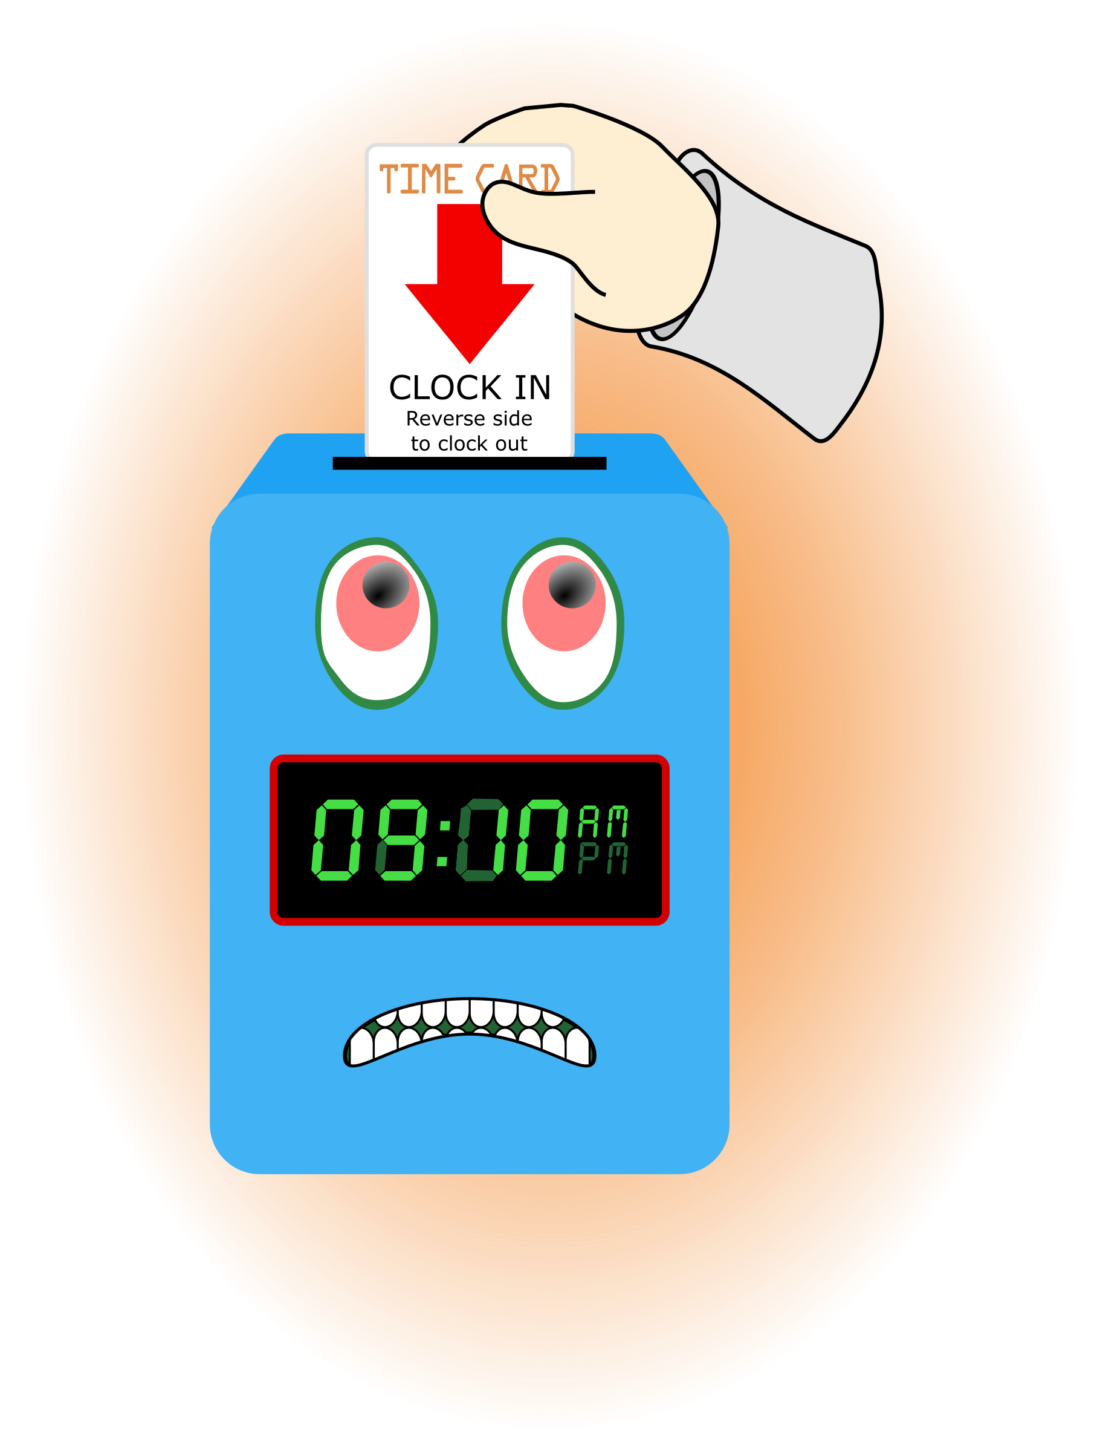
1. Sub-topic:
Discussion: No discussion
Outcome, Actions, Timeframe:
D. Human Resource Issues (Staffing and Training)
1. Sub-topic: Time Sheets Due
Discussion:
Outcome, Actions, Timeframe: Staff should submit time sheets by Friday October 18, 2019 @ 12:00 noon.
2. Sub-topic: Training Needs

Discussion: Areas identified by supervisors and staff discussed
Outcome, Actions, Timeframe:
3. Sub-topic: Training Topic (s)- Intake Process
Discussion:
Outcome, Actions, Timeframe: Roll plays
3. Sub-topic: Training Documentation
Discussion:
Outcome, Actions, Timeframe: Staff are responsible for documentation all training submitted in the training box.
4. Sub-topic: Pending List Needs
Discussion:
Outcome, Actions, Timeframe: Continue to submit items requested
5. Sub-topic: Self Evaluation
Discussion: Bruce Cox, Angie Rowden
Outcome, Actions, Timeframe: Pick-up form from Mr. Whitter

E. Annual Budget Planning and Process
1. Sub-topic:
Discussion: No discussion
Outcome, Actions, Timeframe:

II. Health and Safety: Program/Regional Coordinators
A. External Inspections
1. Sub-topic:
Discussion: No discussion
Outcome, Actions, Timeframe:
B. Self-Inspections (Reports, analysis, and recommendations)
1. Sub-topic:
Discussion: No discussion
Outcome, Actions, Timeframe:
C. Incident Reports (Reports, analysis of trends, recommendations)
1. Sub-topic:
Discussion: No discussion
Outcome, Actions, Timeframe:

III. Quality Improvement
A. File Audits and Case Record Review (reports and recommendations)
1. Sub-topic:
Discussion: No discussion
Outcome, Actions, Timeframe:
B. Outcome Management (status, reports, recommendations)
1. Sub-topic: 30/60/90 Day Follow-up contacts/Responses
Discussion:
Outcome, Actions, Timeframe: Mr. Cox provided information for contacts that were made. Thank you to Mr. Cox for reaching out to the parents/guardians and to staff for working with the youth in a positive manner to ensure successful outcomes.
C. Accreditation and Regulatory Requirements
1. Sub-topic:
Discussion: No discussion
Outcome, Actions, Timeframe:
D. Policy and Procedure Updates and/or Review
1. Sub-topic:
Discussion: No discussion
Outcome, Actions, Timeframe:
E. Participant Complaint and Grievance (specific and quarterly review of trends)
1. Sub-topic:
Discussion: No discussion
Outcome, Actions, Timeframe:
F. Planning Documents (reports, status of goals and objectives, reformulation)
1. Sub-topic: Strategic Plan
Discussion: No discussion
Outcome, Actions, Timeframe:
2. Sub-topic: Accessibility Plan
Discussion: No discussion
Outcome, Actions, Timeframe:
3. Sub-topic: Cultural Competence Plan
Discussion: No discussion
Outcome, Actions, Timeframe:
4. Sub-topic: Input Plan
Discussion: No discussion
Outcome, Actions, Timeframe:
5. Sub-topic: Community Relations plan
Discussion: No discussion

Outcome, Actions, Timeframe:

IV. Risk Management
A. Risk Management Plan (exposure to loss)
1. Sub-topic:
Discussion: No discussion
Outcome, Actions, Timeframe:

B. Employee Concerns or Complaints
1. Sub-topic: Open Mic
Discussion: Staff Questions, Concerns, Complaints, Requests, etc.
Outcome, Actions, Timeframe:
C. Potential regulatory audits and/or investigation of operations
1. Sub-topic:
Discussion: No discussion
Outcome, Actions, Timeframe:

V. Information Technology
A. Technology Plan
1. Sub-topic:
Discussion: No discussion
Outcome, Actions, Timeframe:

VI. Clinical/Program
A. Medical and Medication Issues
1. Sub-topic:
Discussion:
Outcome, Actions, Timeframe:

B. Counseling and Programming Issues
1. Sub-topic: Participant Updates/Concerns
Discussion:
Outcome, Actions, Timeframe:
2. Sub-topic: Shift Coverage Needs
Discussion: Staff are responsible to securing coverage when they would like to take time off. On the leave request staff should indicate details of the outcome for coverage.
Outcome, Actions, Timeframe:

a) Request for coverage by co-workers-
b) Request for coverage by program-
3. Sub-topic: Consistency with Px activities
Discussion: Bed times, chores, phone calls, expectations, etc.
Outcome, Actions, Timeframe: We need to be more consistent and follow through on maintaining a schedule and program.
4. Sub-topic: Review of Intake Process
Discussion: All forms and answers need to be reviewed.
Outcome, Actions, Timeframe: Key areas to review; things that will connect with the stay and our interaction with the px.
5. Sub-topic: Parameters of Confidentiality
Discussion: Who is documented legal guardian, what information can be discussed, etc.
Outcome, Actions, Timeframe:
6. Sub-topic: Overall Program Upkeep
Discussion:
Outcome, Actions, Timeframe: Identifying area we can all work on
7. Sub-topic: Forms are Important
Discussion:
Outcome, Actions, Timeframe: Provide ALL information requested, especially your name.
8. Sub-topic: Phone Extension List
Discussion:
Outcome, Actions, Timeframe: Put in ID pouch.

VII. Other Business:
1. Sub-topic: A Drop For Your Bucket

Discussion: Recognizing co-workers for the “extra” they do to make the work environment better. We applaud all that you do and want to let you know we are grateful. Thank You!!!
Outcome, Actions, Timeframe:

Submitted by:
Cassandra McCray 10/10/19

