Meeting Minutes
CDS Family & Behavioral Health Services, Inc.

Meeting: IYPC STAFF MEETING/TRAINING
Date: September 5, 2019
Time: 4:00PM
Location: 1400 NW 29TH ROAD, GAINESVILLE, FLORIDA
Date of Next Meeting: THE 2ND and 4TH THURSDAYS NEXT MEETING – September 26, 2019
Present: C. McCray, B. Cox, A. Rowden, J. Turk, J. Mattox, S. Carter, S. Davis, S. Durham, K. Lee, R. McBride,
M. McMann, S. Parker, S. Twining, N. Wales, A. Dennis, W. Harmon, J. Martinez, E. McCrea.
Coverage: N. Thompson, Z. Whitter
Absent: B. Smith, J. Bartley, O. Jones, D. Walker, J. Johnson, G. Strickland
I. Business Operations:
A. Monthly Budget (Revenue and Expenses)
1. Sub-topic:
Discussion: No discussion
Outcome, Actions, Timeframe:
B. Marketing and Business Development
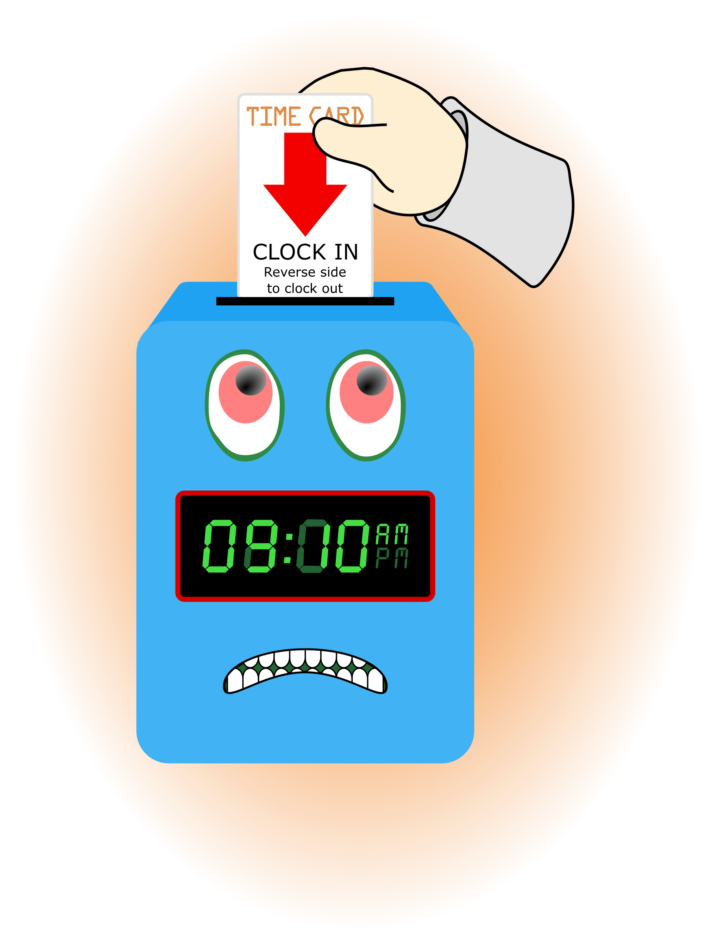
1. Sub-topic:
Discussion: No discussion
Outcome, Actions, Timeframe:
C. Regulatory Issues
1. Sub-topic:
Discussion: No discussion
Outcome, Actions, Timeframe:
D. Human Resource Issues (Staffing and Training)
1. Sub-topic: Time Sheets Due
Discussion: Individual sign-in sheets must be attached to your time sheet.
Outcome, Actions, Timeframe: Staff should submit time sheets by Friday September 6, 2019 @ 12:00 noon.
2. Sub-topic: Training Needs

Discussion: Areas identified by supervisors and staff discussed
Outcome, Actions, Timeframe:
3. Sub-topic: Training Topic (s)-Behavior Management / FACE System
Discussion: Maximizing the use of the system.
Outcome, Actions, Timeframe: Staff are the primary reason for the success of the system working. If staff don’t work the system it WILL NOT work. Staff completed role plays of positive & negative scenarios to look at options on how to use the FACE system and coach px to change behaviors.
4. Sub-topic: Pending List Needs
Discussion:
Outcome, Actions, Timeframe:
5. Sub-topic: Self Evaluation
Discussion:
Outcome, Actions, Timeframe: J. Mattox turn in, to Zeke Whitter, by Friday September 6, 2019.

E. Annual Budget Planning and Process
1. Sub-topic:
Discussion: No discussion
Outcome, Actions, Timeframe:

II. Health and Safety: Program/Regional Coordinators
A. External Inspections
1. Sub-topic:
Discussion: No discussion
Outcome, Actions, Timeframe:
B. Self-Inspections (Reports, analysis, and recommendations)
1. Sub-topic:
Discussion: No discussion
Outcome, Actions, Timeframe:
C. Incident Reports (Reports, analysis of trends, recommendations)
1. Sub-topic:
Discussion: No discussion
Outcome, Actions, Timeframe:

III. Quality Improvement
A. File Audits and Case Record Review (reports and recommendations)
1. Sub-topic:
Discussion: No discussion
Outcome, Actions, Timeframe:

B. Outcome Management (status, reports, recommendations)
1. Sub-topic: 30/60/90 Day Follow-up contacts/Responses

Discussion:
Mr. Cox,

Special Thanks to everyone who assisted in meeting the program needs during his absence.
YOU ARE GREATLY APPRECIATED!

C. Accreditation and Regulatory Requirements
1. Sub-topic:
Discussion: No discussion
Outcome, Actions, Timeframe:
D. Policy and Procedure Updates and/or Review
1. Sub-topic:
Discussion: No discussion
Outcome, Actions, Timeframe:
E. Participant Complaint and Grievance (specific and quarterly review of trends)
1. Sub-topic:
Discussion: No discussion
Outcome, Actions, Timeframe:
F. Planning Documents (reports, status of goals and objectives, reformulation)
1. Sub-topic: Strategic Plan
Discussion: No discussion
Outcome, Actions, Timeframe:
2. Sub-topic: Accessibility Plan
Discussion: No discussion
Outcome, Actions, Timeframe:
3. Sub-topic: Cultural Competence Plan
Discussion: No discussion
Outcome, Actions, Timeframe:
4. Sub-topic: Input Plan
Discussion: No discussion
Outcome, Actions, Timeframe:
5. Sub-topic: Community Relations plan
Discussion: No discussion

Outcome, Actions, Timeframe:

IV. Risk Management
A. Risk Management Plan (exposure to loss)
1. Sub-topic:
Discussion: No discussion
Outcome, Actions, Timeframe:

B. Employee Concerns or Complaints
1. Sub-topic: Open Mic
Discussion: Staff Questions, Concerns, Complaints, Requests, etc.
Outcome, Actions, Timeframe:
C. Potential regulatory audits and/or investigation of operations
1. Sub-topic:
Discussion: No discussion
Outcome, Actions, Timeframe:

V. Information Technology
A. Technology Plan
1. Sub-topic:
Discussion: No discussion
Outcome, Actions, Timeframe:

VI. Clinical/Program
A. Medical and Medication Issues
1. Sub-topic: FOCUS FOCUS FOCUS
Discussion: The temporary storage area for medication should remain locked even when no medication is inside.
Outcome, Actions, Timeframe: Everyone should remember to not be distracted by anything while handling medication.

B. Counseling and Programming Issues
1. Sub-topic: Participant Updates/Concerns
Discussion: Complete screening forms on all calls and we will begin to do follow-up calls on screenings in the current and past month.
Outcome, Actions, Timeframe: A focus needs to be on getting youth into the program.

2. Sub-topic: Shift Coverage Needs

Discussion: Staff are responsible to securing coverage when they would like to take time off. On the leave request staff should indicate details of the outcome for coverage.
Outcome, Actions, Timeframe:
a) Request for coverage by co-workers-
b) Request for coverage by program-
Female for Overnight Saturday, 9/7/19
Anyone for Evening Sunday 9/8/19 (9:00pm to Midnight)
3. Sub-topic: Female Feminine Hygiene Products
Discussion: The program will supply sanitary napkins- various sizes and tampons- regular size only.

Outcome, Actions, Timeframe: When a px brings their person items they should not be mixed in with Interface provided items. List the items on the px inventory so they can be returned at discharge.
4. Sub-topic: Interface Loan Clothing vs Cloths Closet Items
Discussion: Some youth come into the program with only the clothing they are wearing.

Outcome, Actions, Timeframe: We have t-shirts and shorts for loan while they shower and their items are getting washed. Staff should identify which items were given to the px and staff should get the loan items back, wash the items, when the px receives their personal items back.
5. Sub-topic: Bed Wetter Contracts
Discussion: Reviewed the contract and process

Outcome, Actions, Timeframe:
6. Sub-topic: Day Bins
Discussion: Each living room will have a Cubie Unit.
Outcome, Actions, Timeframe: Px should store personal items not being used neatly in the cubie that matches their bed #. Items not properly stored in the appropriate cubie or bed bin will be taken away and the youth will have to see Mrs. McCray to get it back.
VII. Other Business:
1. Sub-topic: A Drop For Your Bucket

Discussion: Recognizing co-workers for the “extra” they do to make the work environment better. We applaud all that you do and want to let you know we are grateful. Thank You!!!
Outcome, Actions, Timeframe:

Submitted by:
Cassandra McCray 9/5/19

