Meeting Minutes
CDS Family & Behavioral Health Services, Inc.

Meeting: IYPC STAFF MEETING/TRAINING
Date: July 25, 2019
Time: 4:00PM
Location: 1400 NW 29TH ROAD, GAINESVILLE, FLORIDA
Date of Next Meeting: THE 2ND and 4TH THURSDAYS August 8, 2019
Present: J. Bartley, S. Carter, S. Durham, C. McCray, W. Harmon, K. Lee, J. Mattox, E. McCrea, M. McMann,
T. Scott, B. Smith, J. Turk, S. Twining, N. Wales, J. Johnson
Present/coverage: S. Parker, S. Walker, Z. Whitter, A. Rowden
Absent: B. Cox, S. Davis, A. Dennis, O. Jones, J. Martinez, G. Strickland, N. Thompson,
I. Business Operations:
A. Monthly Budget (Revenue and Expenses)
1. Sub-topic:
Discussion: No discussion
Outcome, Actions, Timeframe:
B. Marketing and Business Development
1. Sub-topic:
Discussion: No discussion
Outcome, Actions, Timeframe:
C. Regulatory Issues
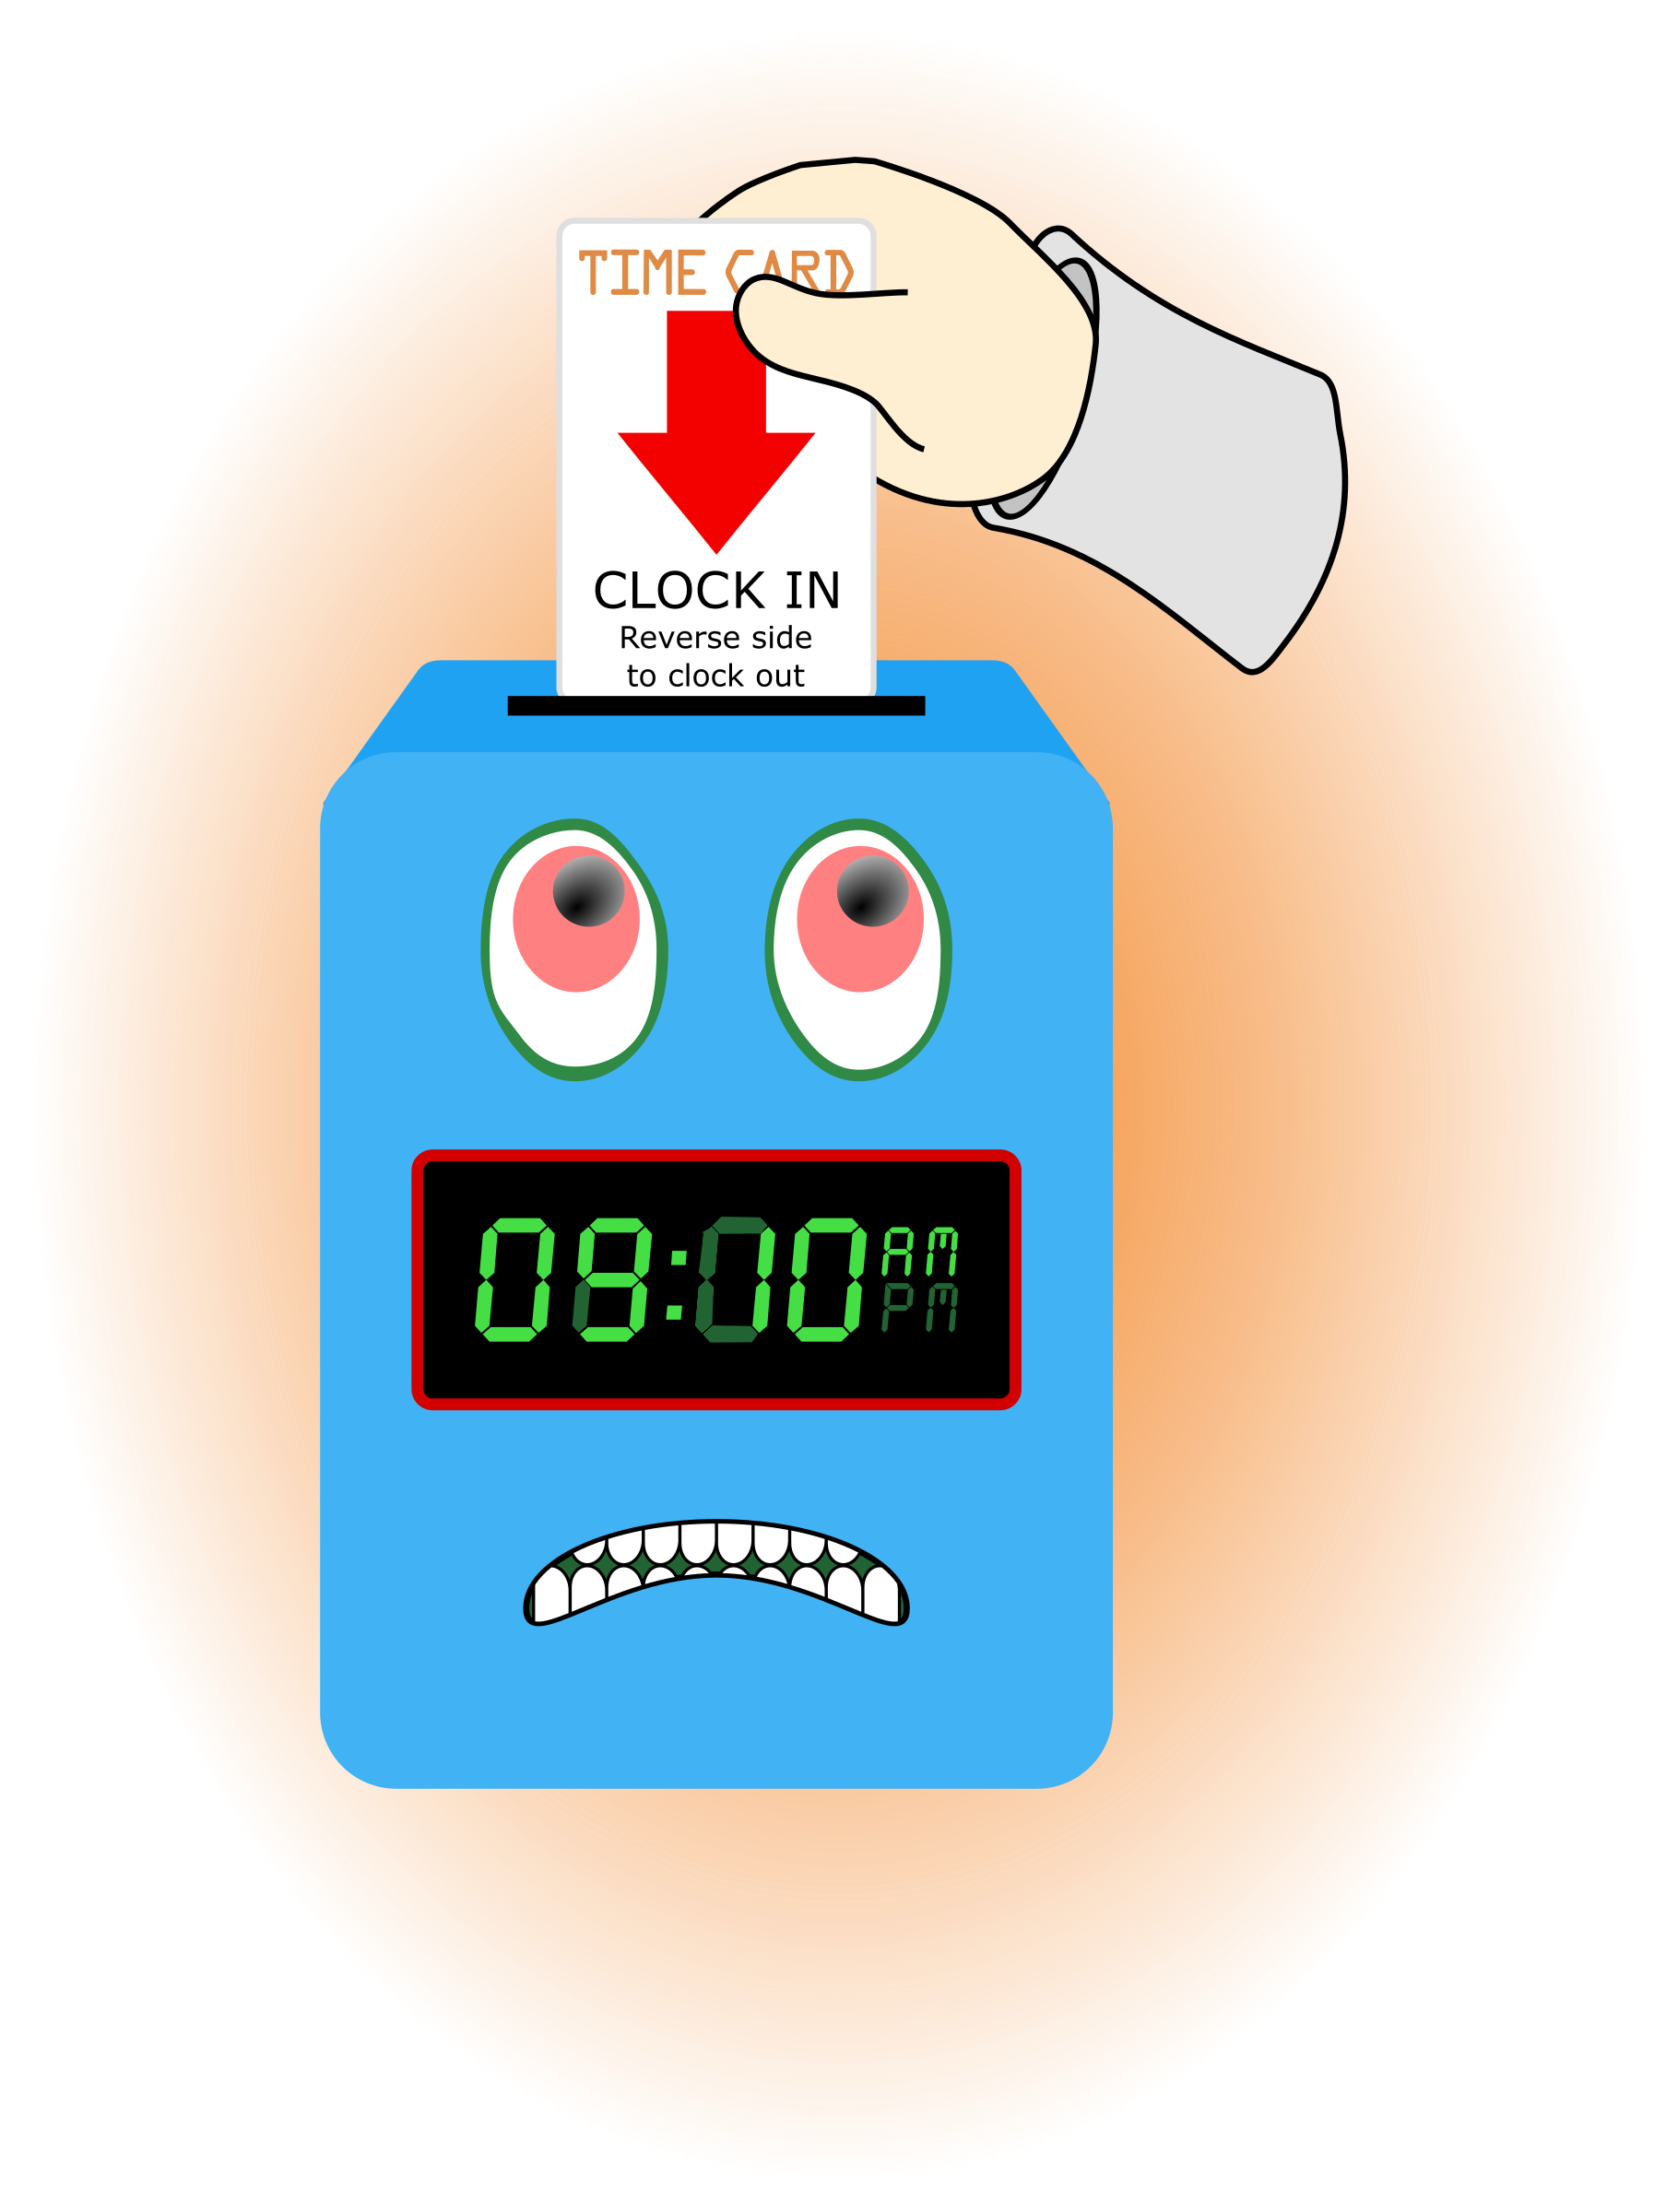
1. Sub-topic:
Discussion: No discussion
Outcome, Actions, Timeframe:
D. Human Resource Issues (Staffing and Training)
1. Sub-topic: Time Sheets Due
Discussion:
Outcome, Actions, Timeframe: Staff should submit time sheets by Friday July 26, 2019 @ 12:00 noon.
2. Sub-topic: Training Needs
Discussion: Areas identified by supervisors and staff discussed
Outcome, Actions, Timeframe: All staff complete training needs assessment.
3. Sub-topic: Training Topic (s)- MAB, Managing Aggressive Behaviors
Discussion: T. Scott reviewed the Premises and key concepts.
Outcome, Actions, Timeframe: This is the annual required review of MAB
4. Sub-topic: Pending List Needs

Discussion: All staff should review and ensure items are submitted in a timely manner.
Outcome, Actions, Timeframe: See Pending list
5. Sub-topic: Self Evaluations
Discussion:
Outcome, Actions, Timeframe: B. Smith please turn in self-evaluation to Mr. Whitter
6. Sub-topic: Meetings with supervisors
Discussion: Please meet with supervisors after meeting
Outcome, Actions, Timeframe: J. Bartley, O. Jones, D. Walker, J. Johnson, G. Strickland, R. McBride.
7. Sub-topic: Residential Counselor Position
Discussion: Travis Scott will be leaving IYPC in a few weeks we are currently advertising to fill the position.
Outcome, Actions, Timeframe:
8. Sub-topic: OVER DUE Training Request
Discussion:
Outcome, Actions, Timeframe: Persons who have not completed the requested PREA training by July 29, 2019 will receive a corrective action memo. The PREA training is required every 2 years. Because of our DJJ Review that is occurring all staff who do not have a PREA training recorded for 2019 were asked, at the last 2 staff meetings to complete the training again. ALL STAFF MUST SUBMITT A PRINTOUT SHOWING PROOF OF MEETING THIS REQUEST.

E. Annual Budget Planning and Process
1. Sub-topic:
Discussion: No discussion
Outcome, Actions, Timeframe:

II. Health and Safety: Program/Regional Coordinators
A. External Inspections
1. Sub-topic:
Discussion: No discussion
Outcome, Actions, Timeframe:
B. Self-Inspections (Reports, analysis, and recommendations)
1. Sub-topic:
Discussion: No discussion
Outcome, Actions, Timeframe:
C. Incident Reports (Reports, analysis of trends, recommendations)
1. Sub-topic:
Discussion: No discussion
Outcome, Actions, Timeframe:
III. Quality Improvement
A. File Audits and Case Record Review (reports and recommendations)
1. Sub-topic:
Discussion: No discussion
Outcome, Actions, Timeframe:
B. Outcome Management (status, reports, recommendations)
1. Sub-topic: 30/60/90 Day Follow-up contacts/Responses
Discussion:
Outcome, Actions, Timeframe: S. Twining indicated all follow-up contacts were up to date.
C. Accreditation and Regulatory Requirements
1. Sub-topic:
Discussion: No discussion
Outcome, Actions, Timeframe:
D. Policy and Procedure Updates and/or Review
1. Sub-topic:
Discussion: No discussion
Outcome, Actions, Timeframe:
E. Participant Complaint and Grievance (specific and quarterly review of trends)
1. Sub-topic:
Discussion: No discussion
Outcome, Actions, Timeframe:
F. Planning Documents (reports, status of goals and objectives, reformulation)
1. Sub-topic: Strategic Plan
Discussion: No discussion
Outcome, Actions, Timeframe:
2. Sub-topic: Accessibility Plan
Discussion: No discussion
Outcome, Actions, Timeframe:
3. Sub-topic: Cultural Competence Plan
Discussion: No discussion
Outcome, Actions, Timeframe:
4. Sub-topic: Input Plan
Discussion: No discussion
Outcome, Actions, Timeframe:
5. Sub-topic: Community Relations plan
Discussion: No discussion

Outcome, Actions, Timeframe:

IV. Risk Management
A. Risk Management Plan (exposure to loss)
1. Sub-topic:
Discussion: No discussion
Outcome, Actions, Timeframe:

B. Employee Concerns or Complaints
1. Sub-topic: Open Mic
Discussion: Staff Questions, Concerns, Complaints, Requests, etc.
Outcome, Actions, Timeframe:
*There is a request to use the TV’s in the living rooms.
Replacement power cords were purchased. Please Do Not Remove them. If you discover a cord
removed complete an UER, this will allow supervisors to review the camera to see who remove it.
*The female desk arrangement will be changed to provide a shorter desk, similar to the
arrangement on the male side.
*During house meetings the px have requested a change in the menu cycle. Mrs. McCray will meet
with px to discuss additional menu item to put in the rotation.
*A request to do more activities like outings to Sonic was made. Staff only need to submit a petty
cash request form ahead of time.
C. Potential regulatory audits and/or investigation of operations
1. Sub-topic:
Discussion: No discussion
Outcome, Actions, Timeframe:
V. Information Technology
A. Technology Plan
1. Sub-topic:
Discussion: No discussion
Outcome, Actions, Timeframe:

VI. Clinical/Program
A. Medical and Medication Issues
1. Sub-topic:
Discussion:
Outcome, Actions, Timeframe:
B. Counseling and Programming Issues
1. Sub-topic: Participant Updates/Concerns
Discussion:
Outcome, Actions, Timeframe:
2. Sub-topic: Shift Coverage Needs
Discussion: Staff are responsible to securing coverage when they would like to take time off. On the leave request staff should indicate details of the outcome for coverage.
Outcome, Actions, Timeframe:
a) Request for coverage by co-workers- K. Lee requested assistance with coverage the first week in August (8th/9th).
b) Request for coverage by program- THANK YOU!!! To staff who have agreed to work this week, filling the gaps.
VII. Other Business:
1. Sub-topic: Meeting Sign-Out
Discussion: Staff signed out on the meeting attendance log

Outcome, Actions, Timeframe: Sign-out Time- 6:20pm
2. Sub-topic: A Drop For Your Bucket

Discussion: Recognizing co-workers for the “extra” they do to make the work environment better. We applaud all that you do and want to let you know we are grateful. Thank You!!!
Outcome, Actions, Timeframe:
Shout Out From | Shout Out To | Because
M. McMann | N. Wales | Giving good compliments!
M. McMann | K. Lee | Always has a BIG SMILE for everyone and positive comments.
M. McMann | R. McBride | Has a soft spoken but powerful voice that encourages change.
M. McMann | B. Smith | Being patient with staff working through Pyxis issues.
E. McCrea | W. Harmon | Being a pleasure to work w/ and looking out for co-workers.
J. Mattox | R. McBride | Did a good job with the px with the tie-dye project.
S. Carter | E. McCrea | Thanks for filling in when needed to take off. It’s appreciated!
S. Carter | A Dennis
S. Carter | M. McMann
R. McBride | M. McMann | Having a great memory, keeping co-worker updated w/ events.
W. Harmon | M. McMann | Helping w/ to get logged on the to PREA training.
S. Twining | McMann | Being invested in the job.
C. McCray | R. McBride | Having a big picture approach, creative ideas, willing to follow-up on ideas.

3. Sub-topic:

Discussion: Wishing the July Birthday Staff many more!!!
Outcome, Actions, Timeframe:
James Johnson 7/5
Shaci Davis 7/9
Dawn Walker 7/10
Naomi Thompson 7/16
Gretchen Strickland 7/29

Submitted by:
Cassandra McCray 7/25/19

