Meeting Minutes
CDS Family & Behavioral Health Services, Inc.

Meeting: IYPC STAFF MEETING/TRAINING
Date: July 11, 2019
Time: 4:00PM
Location: 1400 NW 29TH ROAD, GAINESVILLE, FLORIDA
Date of Next Meeting: THE 2ND and 4TH THURSDAYS
Present: C. McCray, Z. Whitter, N. Thompson, T. Scott, B. Cox, S. Davis, J. Turk, B. Smith, J. Mattox,
J. Barley, S. Carter, S. Davis, O. Jones, C. Jonas, K. Lee, R. McBride, M. McMann, N. Wales, V. Allen,
M. Barnard, A. Dennis, S. Durham, W. Harmon, E. McCrea, G. Strickland, A. Rowden
Absent:, E. Holcombe, J. Sturm, S. Dixon, J. Rollins, S. Sterling, S. Cooper, S. Twining, L.
Jonas

BRING BUCKETS FROM DROP IN THE BUCKET WALL, thank you!!!

I. Business Operations:
A. Monthly Budget (Revenue and Expenses)
1. Sub-topic:
Discussion: No discussion
Outcome, Actions, Timeframe:
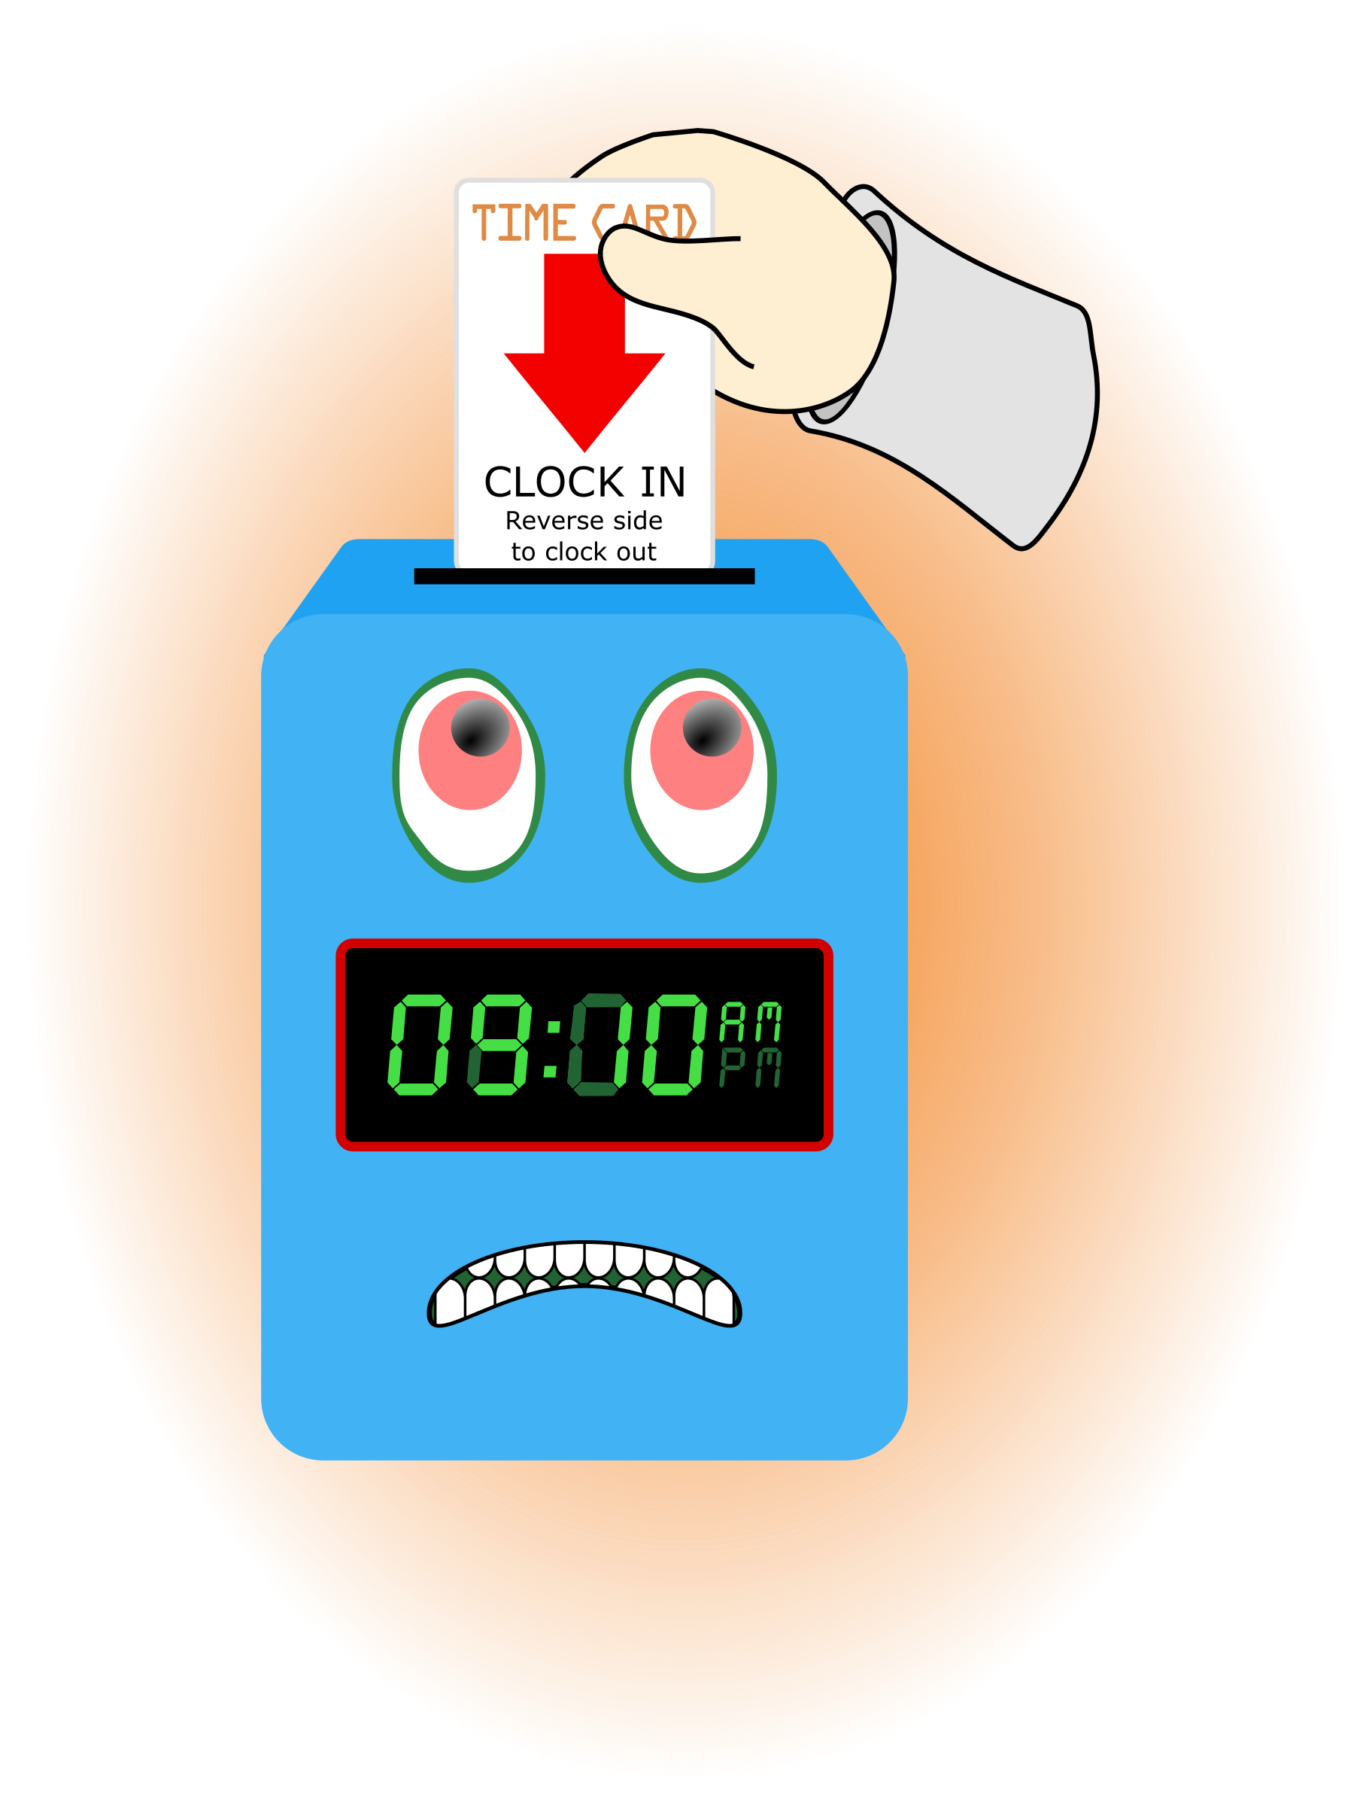
B. Marketing and Business Development
1. Sub-topic:
Discussion: No discussion
Outcome, Actions, Timeframe:
C. Regulatory Issues
1. Sub-topic:
Discussion: No discussion
Outcome, Actions, Timeframe:
D. Human Resource Issues (Staffing and Training)
1. Sub-topic: Time Sheets Due
Discussion:
Outcome, Actions, Timeframe: Staff should submit time sheets by Friday July 12, 2019 @ 12:00 noon.
2. Sub-topic: Training Needs
Discussion: Areas identified by supervisors and staff discussed
Outcome, Actions, Timeframe:
3. Sub-topic: Training Topic (s)- Human Trafficking 101
Discussion: The training is available on SkillPro. This required training must be completed for the training year.

Outcome, Actions, Timeframe: Staff should complete the training and submit verification of completing to Mrs. McCray by July 25, 2019.
4. Sub-topic: Pending List Needs
Discussion: Recently renewed Driver’s License, Auto Insurance verification
Outcome, Actions, Timeframe: Please submit to a supervisor as you renew.
5. Sub-topic: Self Evaluation
Discussion: S. Davis, J. Bartley, M. McMann
Outcome, Actions, Timeframe: Turn in to Mr. Whitter today
6. Sub-topic: Meetings with supervisors
Discussion: Please meet with supervisors after meeting
Outcome, Actions, Timeframe: J. Martinez

E. Annual Budget Planning and Process
1. Sub-topic:
Discussion: No discussion
Outcome, Actions, Timeframe:

II. Health and Safety: Program/Regional Coordinators
A. External Inspections
1. Sub-topic:
Discussion: No discussion
Outcome, Actions, Timeframe:
B. Self-Inspections (Reports, analysis, and recommendations)
1. Sub-topic:
Discussion: No discussion
Outcome, Actions, Timeframe:
C. Incident Reports (Reports, analysis of trends, recommendations)
1. Sub-topic:
Discussion: No discussion
Outcome, Actions, Timeframe:

III. Quality Improvement
A. File Audits and Case Record Review (reports and recommendations)
1. Sub-topic:
Discussion: No discussion
Outcome, Actions, Timeframe:

B. Outcome Management (status, reports, recommendations)
1. Sub-topic: 30/60/90 Day Follow-up contacts/Responses
Discussion:
Outcome, Actions, Timeframe:
C. Accreditation and Regulatory Requirements
1. Sub-topic:
Discussion: No discussion
Outcome, Actions, Timeframe:
D. Policy and Procedure Updates and/or Review
1. Sub-topic:
Discussion: No discussion
Outcome, Actions, Timeframe:
E. Participant Complaint and Grievance (specific and quarterly review of trends)
1. Sub-topic:
Discussion: No discussion
Outcome, Actions, Timeframe:
F. Planning Documents (reports, status of goals and objectives, reformulation)
1. Sub-topic: Strategic Plan
Discussion: No discussion
Outcome, Actions, Timeframe:
2. Sub-topic: Accessibility Plan
Discussion: No discussion
Outcome, Actions, Timeframe:
3. Sub-topic: Cultural Competence Plan
Discussion: No discussion
Outcome, Actions, Timeframe:
4. Sub-topic: Input Plan
Discussion: No discussion
Outcome, Actions, Timeframe:
5. Sub-topic: Community Relations plan
Discussion: No discussion

Outcome, Actions, Timeframe:

IV. Risk Management
A. Risk Management Plan (exposure to loss)
1. Sub-topic:
Discussion: No discussion
Outcome, Actions, Timeframe:

B. Employee Concerns or Complaints
1. Sub-topic: Open Mic
Discussion: Staff Questions, Concerns, Complaints, Requests, etc.
Outcome, Actions, Timeframe:
C. Potential regulatory audits and/or investigation of operations
1. Sub-topic:
Discussion: No discussion
Outcome, Actions, Timeframe:

V. Information Technology
A. Technology Plan
1. Sub-topic:
Discussion: No discussion
Outcome, Actions, Timeframe:

VI. Clinical/Program
A. Medical and Medication Issues
1. Sub-topic: FOCUS FOCUS FOCUS
Discussion: Medication
Outcome, Actions, Timeframe: Continue to make sure you are not distracted while handling medication.

B. Counseling and Programming Issues
1. Sub-topic: Participant Updates/Concerns
Discussion:
Outcome, Actions, Timeframe: Review of new px @ Summer B
2. Sub-topic: Shift Coverage Needs
Discussion: Staff are responsible to securing coverage when they would like to take time off. On the leave request staff should indicate details of the outcome for coverage.
Outcome, Actions, Timeframe:
a) Request for coverage by co-workers-
b) Request for coverage by program-
NEED SATURDAY AND SUNDAY EVENING SHIFTS.

3. Sub-topic: Supervision Expectations
Discussion: Discussed different scenarios and the best practice for supervision. On outings, in vans, in dining room, rec. area in back yard, bedrooms, living rooms.
Outcome, Actions, Timeframe: Role model being right
4. Sub-topic: Inventory Process
Discussion: Exercise for discharge of Px personal items.
Outcome, Actions, Timeframe:
5. Sub-topic: Intake Process
Discussion: Adding the Photo Permission Form to the packet
Outcome, Actions, Timeframe: Have px and parent/guardian complete. Fill in all the blanks. READ!!!
6. Sub-topic: Assigning Seating and Beds
Discussion: Use an option to assist in positive supervision to divide the group and group for success.
Outcome, Actions, Timeframe: Follow process outlined and document in PLB
7. Sub-topic: Meal wrap up process
Discussion:
Outcome, Actions, Timeframe: Have px scrap dishes, stack in bins, utensils in soapy water.
8. Sub-topic: Fire Alarm Process
Discussion: We are on a test mode until WW can correct/replace parts
Outcome, Actions, Timeframe: SILENCE, ACKNOWLEDGE, CHECK AREA, RESET
9. Sub-topic:
Discussion:
Outcome, Actions, Timeframe:

VII. Other Business:
1. Sub-topic: Graduation
Discussion:
Outcome, Actions, Timeframe:
2. Sub-topic: A Drop For Your Bucket

Discussion: Recognizing co-workers for the “extra” they do to make the work environment better. We applaud all that you do and want to let you know we are grateful. Thank You!!!
Outcome, Actions, Timeframe: Intakes – good job, smith, parker, durham, mcmann

Submitted by:

Cassandra McCray 7/11/19

