Meeting Minutes
CDS Family & Behavioral Health Services, Inc.

Meeting: IYPC STAFF MEETING/TRAINING
Date: May 9, 2019
Time: 4:00PM
Location: 1400 NW 29TH ROAD, GAINESVILLE, FLORIDA
Date of Next Meeting: THE 2ND and 4TH THURSDAYS
Present: C. McCray, Z. Whitter, N. Thompson, T. Scott, B. Cox, S. Davis, J. Turk, B. Smith, J. Mattox,
J. Barley, S. Carter, S. Davis, O. Jones, C. Jonas, K. Lee, R. McBride, M. McMann, N. Wales, V. Allen,
M. Barnard, A. Dennis, S. Durham, W. Harmon, E. McCrea, G. Strickland, A. Rowden
Absent:, E. Holcombe, J. Sturm, S. Dixon, J. Rollins, S. Sterling, S. Cooper, S. Twining, L.
Jonas
I. Business Operations:
A. Monthly Budget (Revenue and Expenses)
1. Sub-topic:
Discussion: No discussion
Outcome, Actions, Timeframe:
B. Marketing and Business Development
1. Sub-topic:
Discussion: No discussion
Outcome, Actions, Timeframe:
C. Regulatory Issues
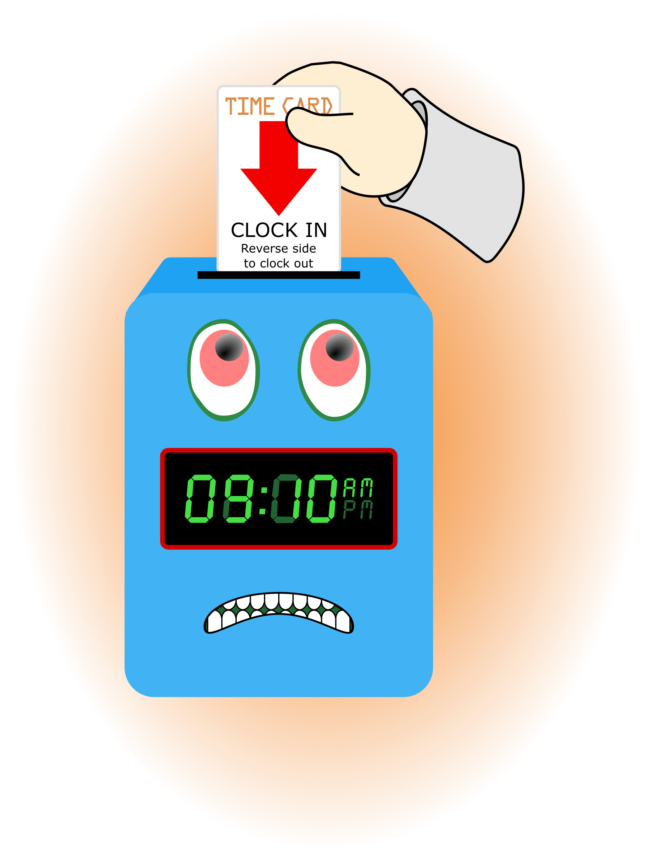
1. Sub-topic:
Discussion: No discussion
Outcome, Actions, Timeframe:
D. Human Resource Issues (Staffing and Training)
1. Sub-topic: Time Sheets Due May 17, 2019
Discussion: Payroll emails, pay stubs
Outcome, Actions, Timeframe: Staff should submit time sheets by Friday May 17, 2019 @ 12:00 noon.
2. Sub-topic: Training Needs
Discussion: Areas identified by supervisors and staff discussed
Outcome, Actions, Timeframe:
3. Sub-topic: Training Topic (s)-
Discussion: Complete the CDS Intranet training for Interpretive Summary 1.

Outcome, Actions, Timeframe: Interpretive Summary 1- Test Due May 23, 2019, turn in test and sign training roster.
4. Sub-topic: Pending List Needs
Discussion: Staff need to submit new auto insurance renewal documents and new driver’s license verification
Outcome, Actions, Timeframe:
5. Sub-topic: Self Evaluation
Discussion: Kevin Lee, Oladis Jones
Outcome, Actions, Timeframe: Pick-up form from Mr. Whitter
6. Sub-topic: Meetings with supervisors
Discussion: Please meet with supervisors after meeting
Outcome, Actions, Timeframe: G. Strickland, R. McBride, Juan Martinez
7. Sub-topic: TRAINING- SUICIDE INTERVENTION
Discussion: Information presented by Angie Rowden
Outcome, Actions, Timeframe:
8. Sub-topic: TRAINING- ACTIVE SHOOTER- PREVENTION PART 1
Discussion: Information presented by ASO, Cary Gallop
Outcome, Actions, Timeframe: The training will be MAY 23, 2019 BEGINNING 3:30PM UNTIL 5:30PM
9. Sub-topic: TRAINING- REVIEW/UPDATE TRAINING FILES
Discussion: Audit training files for hours and topics. Another audit will occur in June.
Outcome, Actions, Timeframe: Focus on completing needed trainings by June 30, 2019
10. Sub-topic: TRAINING- REQUIRED: MAB AND ANNUAL RETREAT
Discussion:
Outcome, Actions, Timeframe: MAB dates to be announced soon. Annual Retreat will be August 7, 8, 9, 2019.

E. Annual Budget Planning and Process
1. Sub-topic:
Discussion: No discussion
Outcome, Actions, Timeframe:

II. Health and Safety: Program/Regional Coordinators
A. External Inspections
1. Sub-topic:
Discussion: No discussion
Outcome, Actions, Timeframe:
B. Self-Inspections (Reports, analysis, and recommendations)
1. Sub-topic:
Discussion: No discussion
Outcome, Actions, Timeframe:
C. Incident Reports (Reports, analysis of trends, recommendations)
1. Sub-topic:
Discussion: No discussion
Outcome, Actions, Timeframe:

III. Quality Improvement
A. File Audits and Case Record Review (reports and recommendations)
1. Sub-topic:
Discussion: No discussion
Outcome, Actions, Timeframe:
B. Outcome Management (status, reports, recommendations)
1. Sub-topic: 30/60/90 Day Follow-up contacts/Responses
Discussion:
Outcome, Actions, Timeframe: Mr. Cox provided information for contacts that were made. Thank you to Mr. Cox for reaching out to the parents/guardians and to staff for working with the youth in a positive manner to ensure successful outcomes.
C. Accreditation and Regulatory Requirements
1. Sub-topic:
Discussion: No discussion
Outcome, Actions, Timeframe:
D. Policy and Procedure Updates and/or Review
1. Sub-topic:
Discussion: No discussion
Outcome, Actions, Timeframe:
E. Participant Complaint and Grievance (specific and quarterly review of trends)
1. Sub-topic:
Discussion: No discussion
Outcome, Actions, Timeframe:
F. Planning Documents (reports, status of goals and objectives, reformulation)
1. Sub-topic: Strategic Plan
Discussion: No discussion
Outcome, Actions, Timeframe:
2. Sub-topic: Accessibility Plan
Discussion: No discussion
Outcome, Actions, Timeframe:
3. Sub-topic: Cultural Competence Plan
Discussion: No discussion
Outcome, Actions, Timeframe:
4. Sub-topic: Input Plan
Discussion: No discussion
Outcome, Actions, Timeframe:
5. Sub-topic: Community Relations plan
Discussion: No discussion

Outcome, Actions, Timeframe:

IV. Risk Management
A. Risk Management Plan (exposure to loss)
1. Sub-topic:
Discussion: No discussion
Outcome, Actions, Timeframe:

B. Employee Concerns or Complaints
1. Sub-topic: Open Mic
Discussion: Staff Questions, Concerns, Complaints, Requests, etc.
Outcome, Actions, Timeframe:
C. Potential regulatory audits and/or investigation of operations
1. Sub-topic:
Discussion: No discussion
Outcome, Actions, Timeframe:

V. Information Technology
A. Technology Plan
1. Sub-topic:
Discussion: No discussion
Outcome, Actions, Timeframe:

VI. Clinical/Program
A. Medical and Medication Issues
1. Sub-topic: FOCUS FOCUS FOCUS
Discussion: Medication Reminder Board, what it include???
Outcome, Actions, Timeframe:

B. Counseling and Programming Issues
1. Sub-topic: Participant Updates/Concerns
Discussion:
Outcome, Actions, Timeframe:

2. Sub-topic: Shift Coverage Needs
Discussion: Staff are responsible to securing coverage when they would like to take time off. On the leave request staff should indicate details of the outcome for coverage.
Outcome, Actions, Timeframe:
a) Request for coverage by co-workers-
b) Request for coverage by program-
NEED SATURDAY AND SUNDAY EVENING SHIFTS.
3. Sub-topic: Ensuring Safety
Discussion: A px parents may NOT be the legal guardian and may not be approved for contact. To confirm the correct person check ID’s.
Outcome, Actions, Timeframe: ALWAYS check the px file for approved contacts.
4. Sub-topic: MOVIE RATING RESTRICTIONS
Discussion:
Outcome, Actions, Timeframe: Only G and PG movies may be shown at IYPC
5. Sub-topic: AGENCY/PROGRAM POLICIES
Discussion: Supervisors are required to review the program videos on a regular bases
Outcome, Actions, Timeframe: The surveillance reviews may result in a conversation and/or corrective action for activity that is viewed.
VII. Other Business:
1. Sub-topic: Meeting Sign-Out
Discussion: Staff signed out on the meeting attendance log
Outcome, Actions, Timeframe: Sign-out Time- __________________
2. Sub-topic: A Drop For Your Bucket

Discussion: Recognizing co-workers for the “extra” they do to make the work environment better. We applaud all that you do and want to let you know we are grateful. Thank You!!!
Outcome, Actions, Timeframe:
Comments:

