Meeting Minutes
CDS Family & Behavioral Health Services, Inc.

Meeting: IYPC STAFF MEETING/TRAINING
Date: April 11, 2019
Time: 4:00PM
Location: 1400 NW 29TH ROAD, GAINESVILLE, FLORIDA
Date of Next Meeting: THE 2ND and 4TH THURSDAYS
Attending: C. McCray, B. Cox, A. Rowden, J. Turk, B. Smith, J. Mattox, J. Bartley, S. Carter,
S. Durham, O. Jones, C. Jonas, K. Lee, M. McMann, S. Parker, S. Twining, N. Wales, D. Walker,
W. Harmon, J. Martinez, E. McCrea, A. McQueen
Supervision Coverage: Z. Whitter, N. Thompson, T. Scott
Absent: S. Davis, R. McBride, M. Clemmons, A. Dennis, G. Strickland
I. Business Operations:
A. Monthly Budget (Revenue and Expenses)
1. Sub-topic:
Discussion: No discussion
Outcome, Actions, Timeframe:
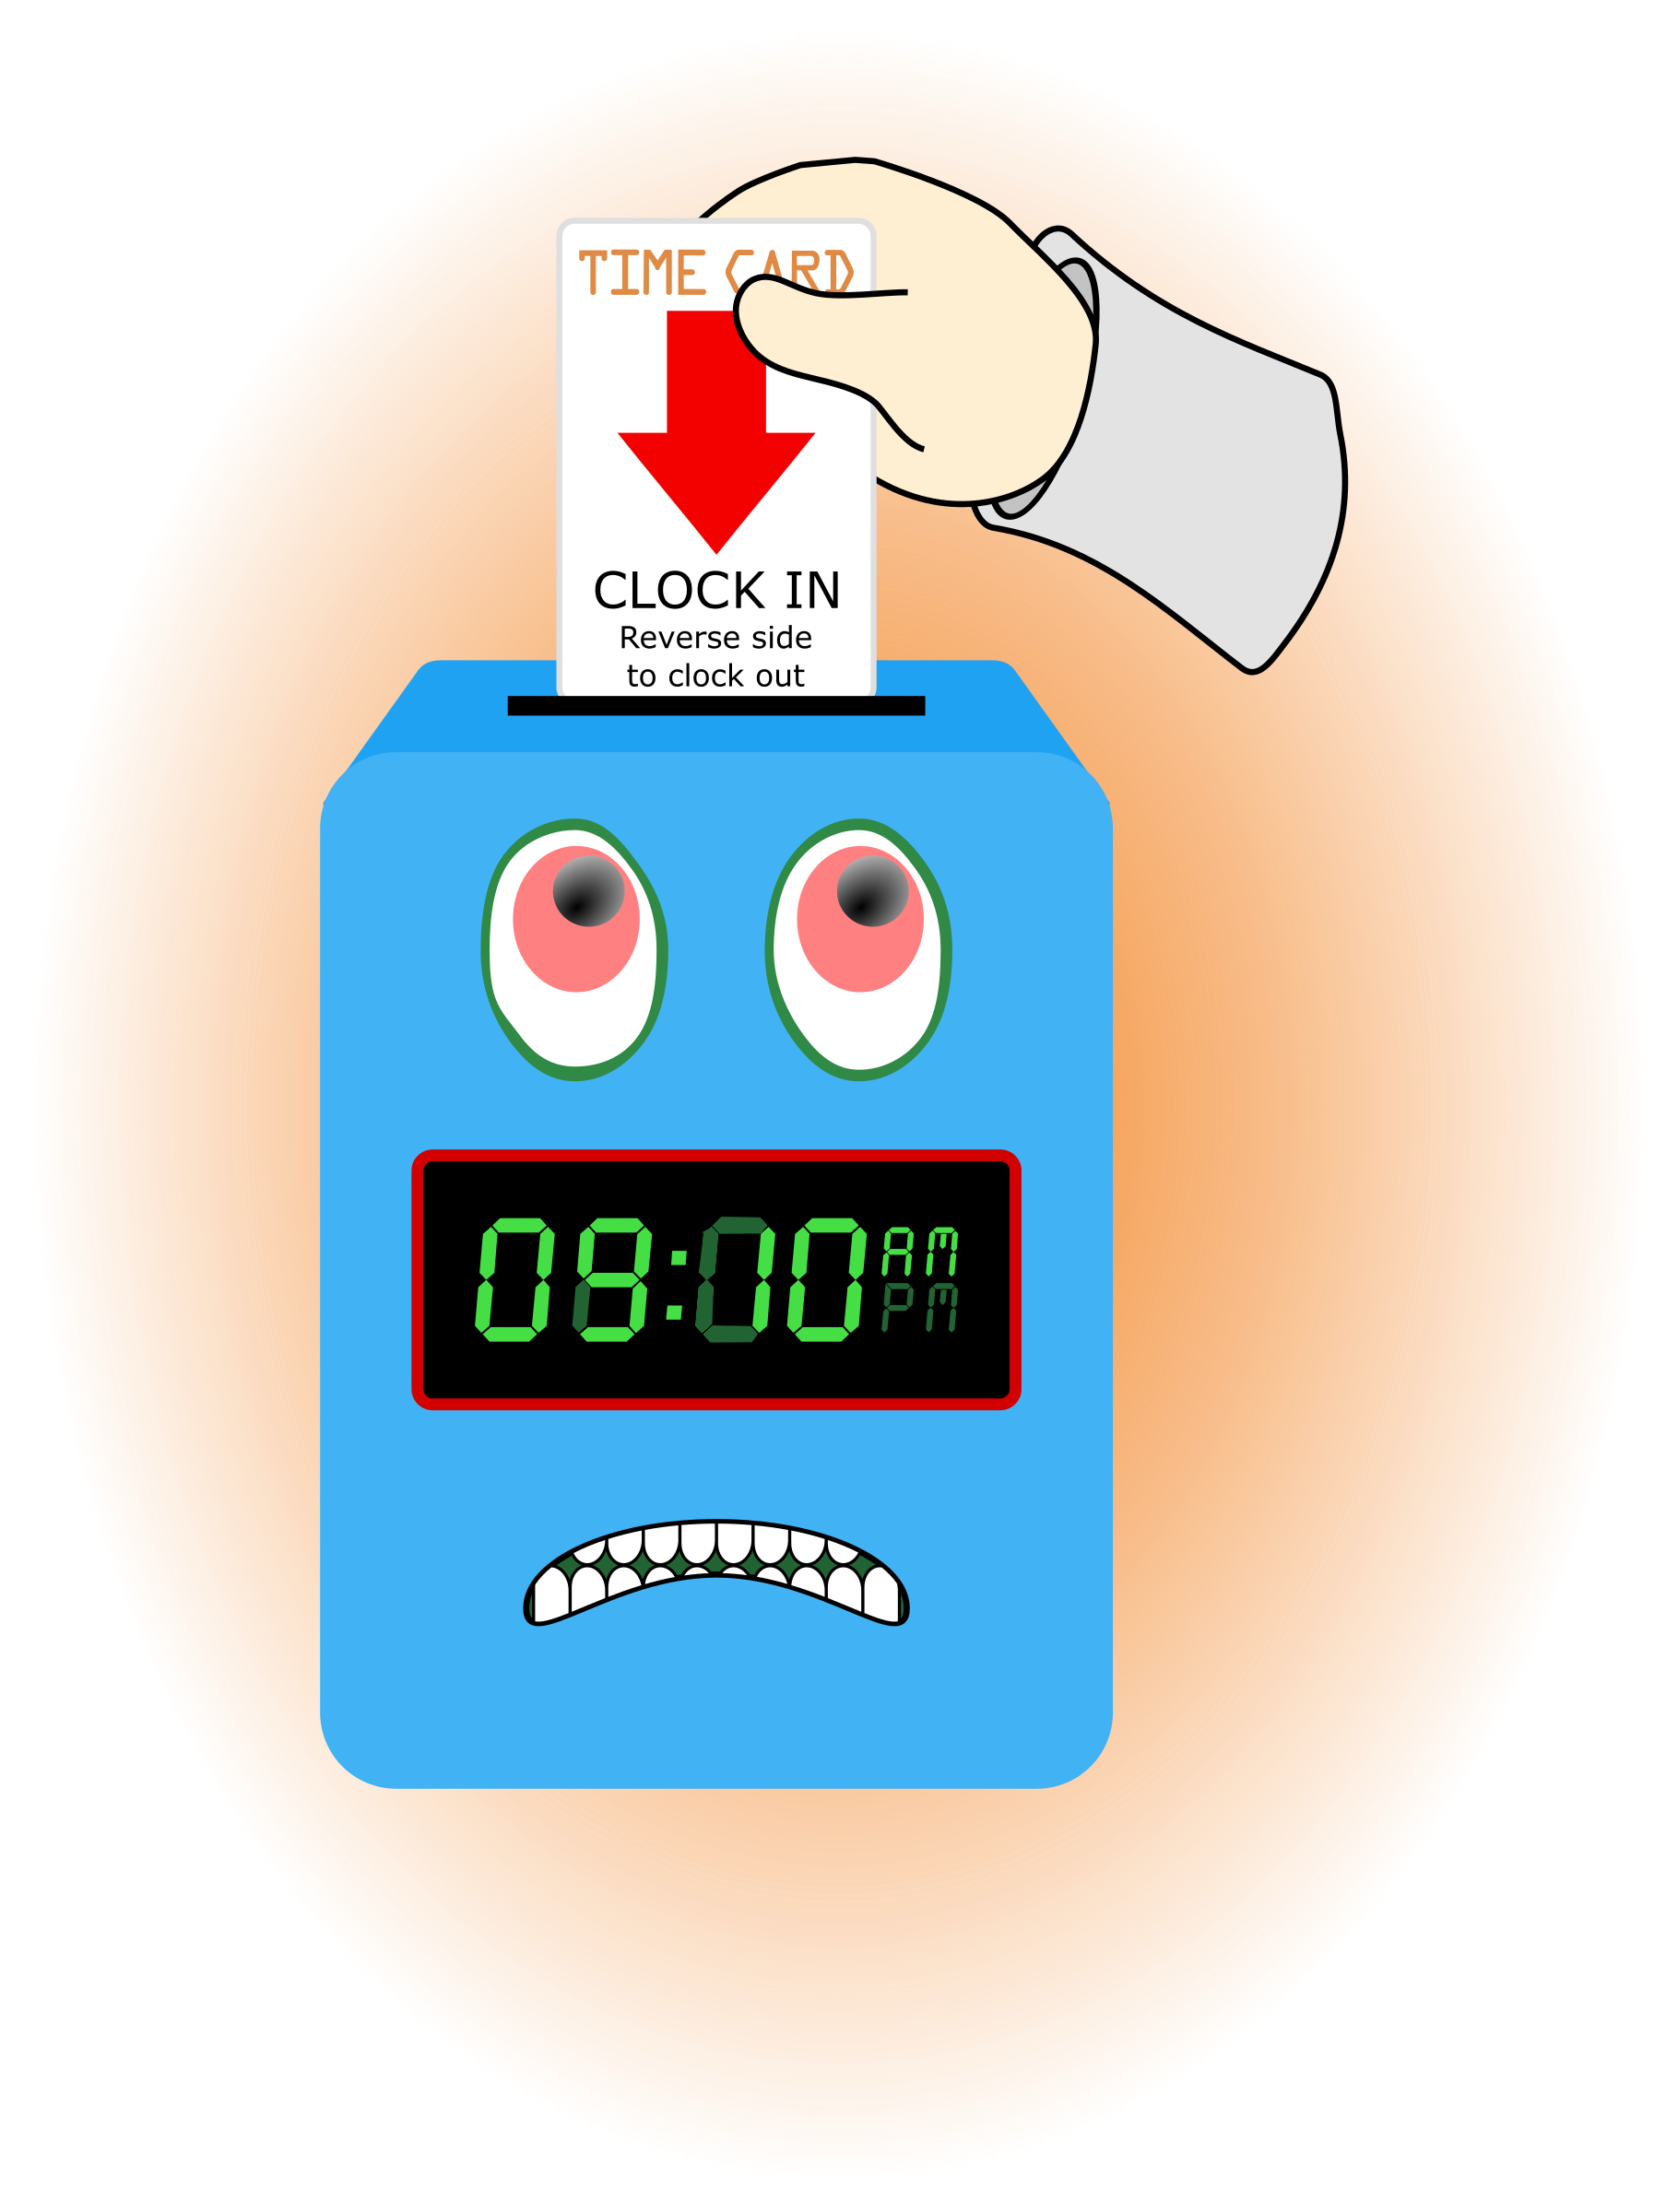
B. Marketing and Business Development
1. Sub-topic:
Discussion: No discussion
Outcome, Actions, Timeframe:
C. Regulatory Issues
1. Sub-topic:
Discussion: No discussion
Outcome, Actions, Timeframe:
D. Human Resource Issues (Staffing and Training)
1. Sub-topic: Time Sheets Due
Discussion: Staff should predict and record the time they work Friday and Saturday. If the time actual time worked changes, call and leave a message on Mr. Whitters
Outcome, Actions, Timeframe: Staff should submit time sheets by Friday 19, 2019 @ 12:00 noon.
2. Sub-topic: Training Needs
Discussion: Areas identified by supervisors and staff discussed
Outcome, Actions, Timeframe:
3. Sub-topic: Training Topic (s)-
Discussion: Attachment Disorder, Participant Interactions

Outcome, Actions, Timeframe: Attachment Disorder- Test Due April 25, 2019, turn in test and sign training roster.
4. Sub-topic: Pending List Needs
Discussion:
Outcome, Actions, Timeframe:
5. Sub-topic: Self Evaluation
Discussion:
Outcome, Actions, Timeframe: Pick-up form from Mr. Whitter
6. Sub-topic: Meetings with supervisors
Discussion: Please meet with supervisors after meeting
Outcome, Actions, Timeframe: G. Strickland, R. McBride
7. Sub-topic: New Hire
Discussion:
Outcome, Actions, Timeframe: WELCOME Angela McQueen

E. Annual Budget Planning and Process
1. Sub-topic:
Discussion: No discussion
Outcome, Actions, Timeframe:

II. Health and Safety: Program/Regional Coordinators
A. External Inspections
1. Sub-topic:
Discussion: No discussion
Outcome, Actions, Timeframe:
B. Self-Inspections (Reports, analysis, and recommendations)
1. Sub-topic:
Discussion: No discussion
Outcome, Actions, Timeframe:
C. Incident Reports (Reports, analysis of trends, recommendations)
1. Sub-topic:
Discussion: No discussion
Outcome, Actions, Timeframe:

III. Quality Improvement
A. File Audits and Case Record Review (reports and recommendations)
1. Sub-topic:
Discussion: No discussion
Outcome, Actions, Timeframe:

B. Outcome Management (status, reports, recommendations)
1. Sub-topic: 30/60/90 Day Follow-up contacts/Responses Mr. Cox
Discussion: Today is Mr. Cox’s birthday.
Outcome, Actions, Timeframe: Mr. Cox provided information for contacts that were made. Thank you to Mr. Cox for reaching out to the parents/guardians and to staff for working with the youth in a positive manner to ensure successful outcomes.
For The Strength Of The Pack is the Wolf,
And The Strength Of The Wolf Is The Pack.” the second jungle book (1895) by Rudyard Kipling
C. Accreditation and Regulatory Requirements
1. Sub-topic:
Discussion: No discussion
Outcome, Actions, Timeframe:
D. Policy and Procedure Updates and/or Review
1. Sub-topic:
Discussion: No discussion
Outcome, Actions, Timeframe:
E. Participant Complaint and Grievance (specific and quarterly review of trends)
1. Sub-topic:
Discussion: No discussion
Outcome, Actions, Timeframe:
F. Planning Documents (reports, status of goals and objectives, reformulation)
1. Sub-topic: Strategic Plan
Discussion: No discussion
Outcome, Actions, Timeframe:
2. Sub-topic: Accessibility Plan
Discussion: No discussion
Outcome, Actions, Timeframe:
3. Sub-topic: Cultural Competence Plan
Discussion: No discussion
Outcome, Actions, Timeframe:
4. Sub-topic: Input Plan
Discussion: No discussion
Outcome, Actions, Timeframe:
5. Sub-topic: Community Relations plan
Discussion: No discussion

Outcome, Actions, Timeframe:

IV. Risk Management
A. Risk Management Plan (exposure to loss)
1. Sub-topic:
Discussion: No discussion
Outcome, Actions, Timeframe:

B. Employee Concerns or Complaints
1. Sub-topic: Open Mic
Discussion: Staff Questions, Concerns, Complaints, Requests, etc.
Outcome, Actions, Timeframe:
C. Potential regulatory audits and/or investigation of operations
1. Sub-topic:
Discussion: No discussion
Outcome, Actions, Timeframe:

V. Information Technology
A. Technology Plan
1. Sub-topic:
Discussion: No discussion
Outcome, Actions, Timeframe:

VI. Clinical/Program
A. Medical and Medication Issues
1. Sub-topic: FOCUS FOCUS FOCUS
Discussion: Medication Reminder Board, what it include???
Outcome, Actions, Timeframe:

B. Counseling and Programming Issues
1. Sub-topic: Participant Updates/Concerns
Discussion:
Outcome, Actions, Timeframe:

2. Sub-topic: Shift Coverage Needs
Discussion: Staff are responsible to securing coverage when they would like to take time off. On the leave request staff should indicate details of the outcome for coverage.
Outcome, Actions, Timeframe:
a) Request for coverage by co-workers-
b) Request for coverage by program-
NEED SATURDAY AND SUNDAY EVENING SHIFTS.
3. Sub-topic: Ensuring confidentiality
Discussion: When visitors are in the control room we should make sure the px names are covered
Outcome, Actions, Timeframe: The cover is currently in Mrs. McCray’s box.
2. Sub-topic: Participant Personal Belongings
Discussion: Review DRAFT
Outcome, Actions, Timeframe: This will apply for px who will NOT be in house to sleep and are NOT discharged from the program.
2. Sub-topic: Outing Evaluation Forms
Discussion: Good and not so good information is desired.
Outcome, Actions, Timeframe: Thank you, the feedback is valuable in many ways.
VII. Other Business:
1. Sub-topic: Meeting Sign-Out
Discussion: Staff signed out on the meeting attendance log
Outcome, Actions, Timeframe: Sign-out Time- __________________
2. Sub-topic: A Drop For Your Bucket
Discussion: Recognizing co-workers for the “extra” they do to make the work environment better. We applaud all that you do and want to let you know we are grateful. Thank You!!!
Outcome, Actions, Timeframe:
Comments:
2. Sub-topic: FL Network QI Tour. 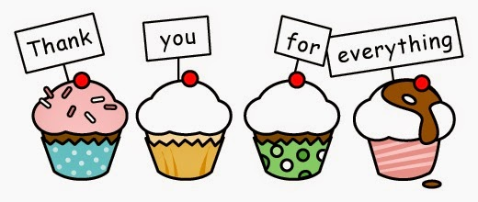
Discussion: The prep, tour, wrap-up was EXCELLET!
Outcome, Actions, Timeframe: EVERYONE, All that you did was greatly appreciated!

