Meeting Minutes
CDS Family & Behavioral Health Services, Inc.
Meeting: IYPC STAFF MEETING/TRAINING
Date: March 4, 2019
Time: 4:00PM
Location: 1400 NW 29TH ROAD, GAINESVILLE, FLORIDA
Date of Next Meeting: THE 2ND and 4TH THURSDAYS March 14, 2019
Present: C. McCray, Z. Whitter, N. Thompson, T. Scott, B. Cox, S. Davis, J. Turk, B. Smith, J. Mattox,
J. Barley, S. Carter, S. Davis, O. Jones, C. Jonas, K. Lee, R. McBride, M. McMann, N. Wales, V. Allen,
M. Barnard, A. Dennis, S. Durham, W. Harmon, E. McCrea, G. Strickland, A. Rowden
Absent:, E. Holcombe, J. Sturm, S. Dixon, J. Rollins, S. Sterling, S. Cooper, S. Twining, L.
Jonas
I. Business Operations:
A. Monthly Budget (Revenue and Expenses)
1. Sub-topic:
Discussion: No discussion
Outcome, Actions, Timeframe:
B. Marketing and Business Development
1. Sub-topic: Capital Fund Drive/Land Lease
Discussion:
Outcome, Actions, Timeframe: Keith Perry and Chuck Clemmons are sponsoring a member bill in the Senate and House to help fund the new shelter. The contract has been signed for the land agreement.
C. Regulatory Issues
1. Sub-topic:
Discussion: No discussion
Outcome, Actions, Timeframe:
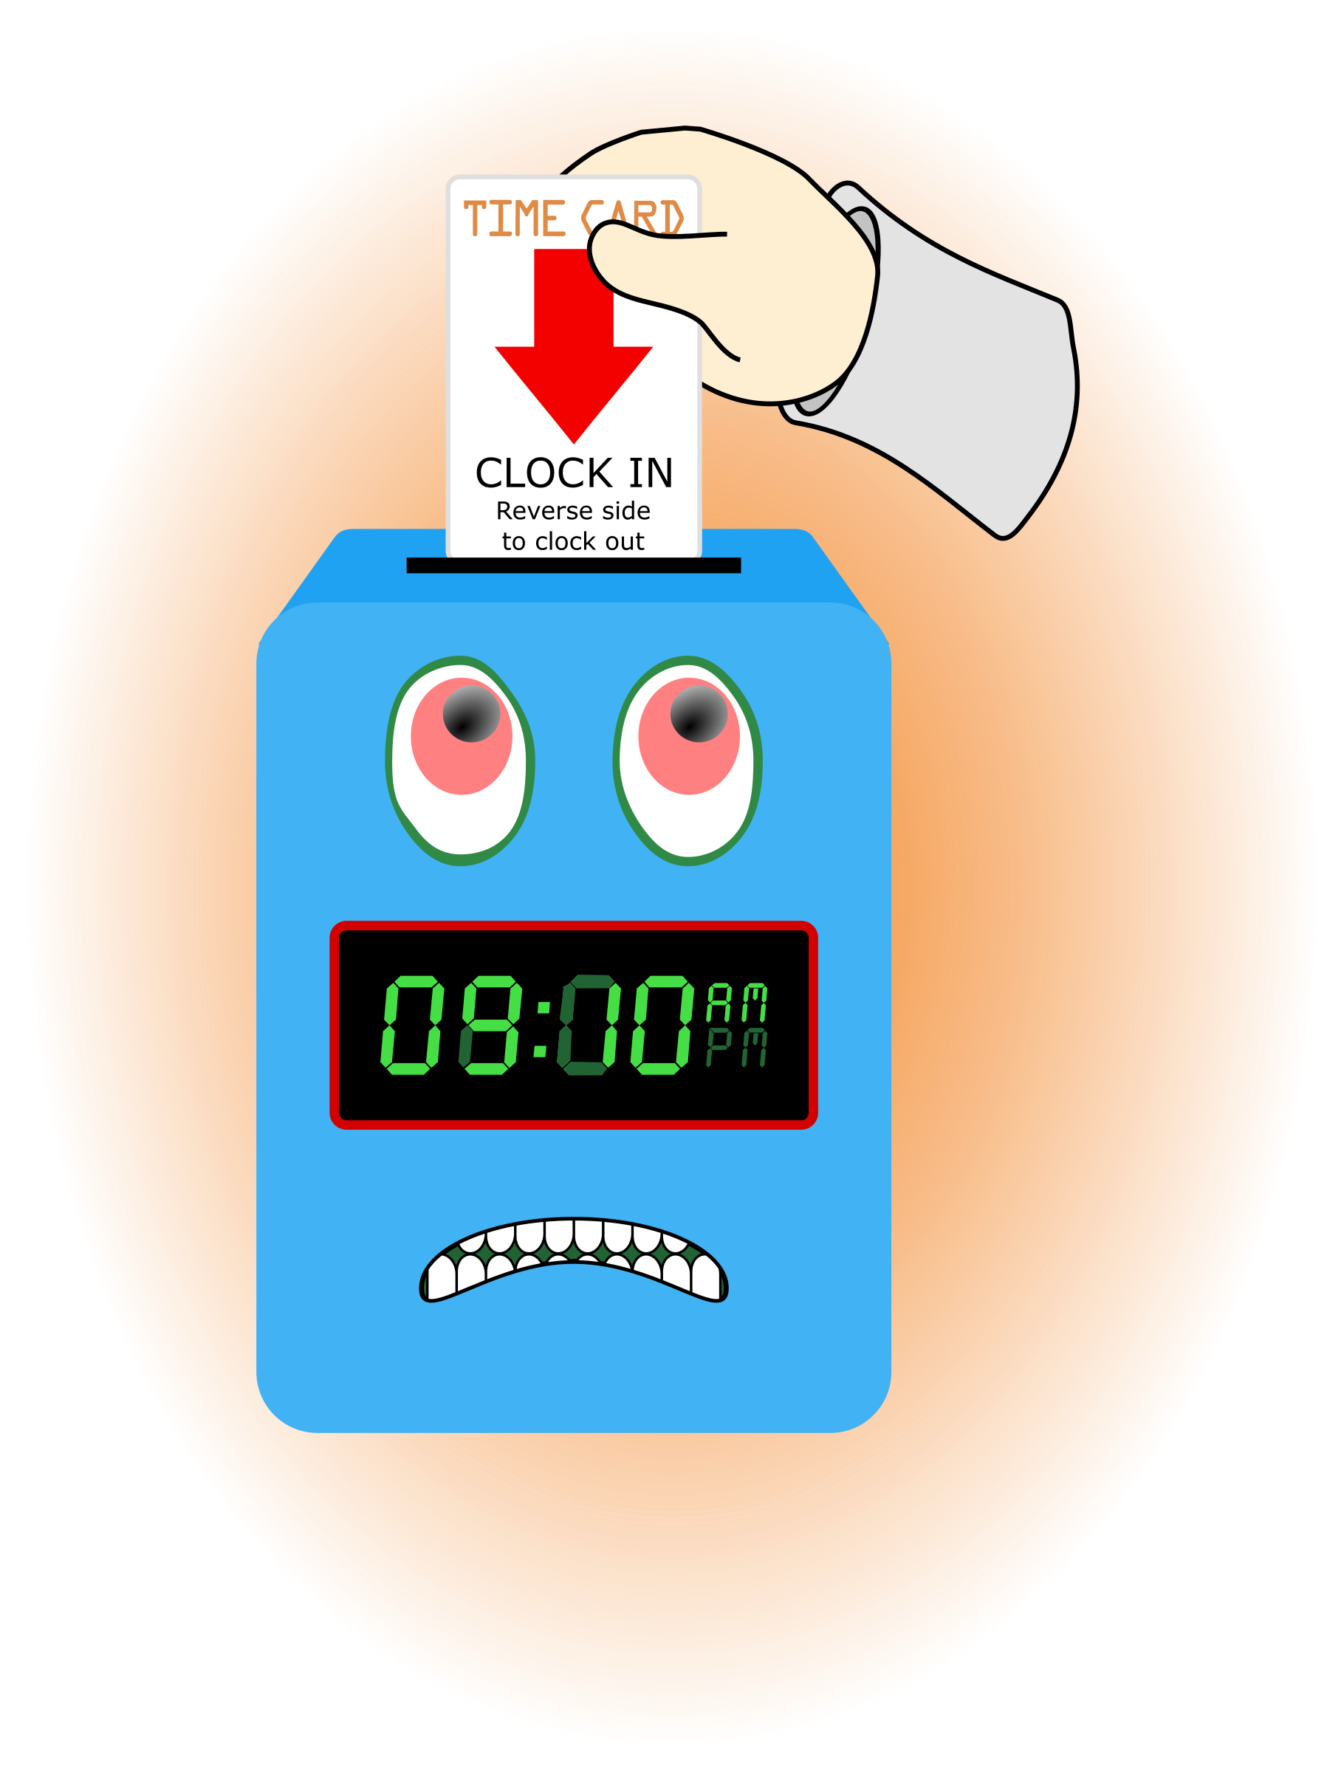
D. Human Resource Issues (Staffing and Training)
1. Sub-topic: Time Sheets Due
Discussion:
Outcome, Actions, Timeframe: Staff should submit time sheets by noon on Friday March 5, 2019 by noon.
2. Sub-topic: Training Needs
Discussion: Areas identified by supervisors and staff discussed
Outcome, Actions, Timeframe:
3. Sub-topic: Today’s Training Topic- Adolescent Brain Development
Discussion: Don’t ask WHY. Do say TELL ME WHAT YOU DID.
Avoid questions that contain more than ONE CONCEPT. There is already too much going on in their brain. REST- Allow the teen brain time to take in ideas and process them.
We work with humans during the BEST time for them to LEARN, if we teach and help them practice positive skills. We have them before LOCK-UP.
Outcome, Actions, Timeframe: Look for opportunities to use these thoughts.
4. Sub-topic: Today’s Training Topic- Nutritional Needs of Adolescents
Discussion:
Outcome, Actions, Timeframe: Staff should share the information with at meal times and when the opportunity presents.
4. Sub-topic: Today’s Training Topic- Medication Distribution- Responding to discrepancies
Discussion:

Outcome, Actions, Timeframe: Staff learned to check for discrepancies and how to clear them.
5. Sub-topic: Pending List Needs
Discussion:
Outcome, Actions, Timeframe:
Erica McCrea- need to turn in Self-Evaluation
CPR/1st Aid Certification- Recertification by March 14, 2019 [William Harmon, Brian Smith]
Recertification by April 1, 2019 [Naomi Thompson]
6. Sub-topic: Hireselect survey
Discussion:
Outcome, Actions, Timeframe: Thank you for your participation.
E. Annual Budget Planning and Process
1. Sub-topic:
Discussion: No discussion
Outcome, Actions, Timeframe:

II. Health and Safety: Program/Regional Coordinators
A. External Inspections
1. Sub-topic:
Discussion: No discussion
Outcome, Actions, Timeframe:
B. Self-Inspections (Reports, analysis, and recommendations)
1. Sub-topic:
Discussion: No discussion
Outcome, Actions, Timeframe:
C. Incident Reports (Reports, analysis of trends, recommendations)
1. Sub-topic:
Discussion: No discussion
Outcome, Actions, Timeframe:

III. Quality Improvement
A. File Audits and Case Record Review (reports and recommendations)
1. Sub-topic:
Discussion: No discussion
Outcome, Actions, Timeframe:
B. Outcome Management (status, reports, recommendations)
1. Sub-topic: 30/60/90 Day Follow-up contacts/Responses
Discussion:
Outcome, Actions, Timeframe: Mr. Cox provided information for contacts that were made. Thank you to Mr. Cox for reaching out to the parents/guardians and to staff for working with the youth in a positive manner to ensure successful outcomes.
C. Accreditation and Regulatory Requirements
1. Sub-topic:
Discussion: No discussion
Outcome, Actions, Timeframe:
D. Policy and Procedure Updates and/or Review
1. Sub-topic:
Discussion: No discussion
Outcome, Actions, Timeframe:
E. Participant Complaint and Grievance (specific and quarterly review of trends)
1. Sub-topic:
Discussion: No discussion
Outcome, Actions, Timeframe:
F. Planning Documents (reports, status of goals and objectives, reformulation)
1. Sub-topic: Strategic Plan
Discussion: No discussion
Outcome, Actions, Timeframe:
2. Sub-topic: Accessibility Plan
Discussion: No discussion
Outcome, Actions, Timeframe:
3. Sub-topic: Cultural Competence Plan
Discussion: No discussion
Outcome, Actions, Timeframe:
4. Sub-topic: Input Plan
Discussion: No discussion
Outcome, Actions, Timeframe:
5. Sub-topic: Community Relations plan
Discussion: No discussion

Outcome, Actions, Timeframe:

IV. Risk Management
A. Risk Management Plan (exposure to loss)
1. Sub-topic:
Discussion: No discussion
Outcome, Actions, Timeframe:

B. Employee Concerns or Complaints
1. Sub-topic: Open Mic
Discussion: Staff Questions, Concerns, Complaints, Requests, etc.
Outcome, Actions, Timeframe:
C. Potential regulatory audits and/or investigation of operations
1. Sub-topic: Program Re-licensure
Discussion: DCF will be here March 4, 2019 to go through the on site process

Outcome, Actions, Timeframe: Preparation in all the usual areas is needed.
V. Information Technology
A. Technology Plan
1. Sub-topic:
Discussion: No discussion
Outcome, Actions, Timeframe:
VI. Clinical/Program
A. Medical and Medication Issues
1. Sub-topic: Accountability with medication
Discussion:
Outcome, Actions, Timeframe: The person logging into Pyxis needs to be the person assisting the px with meds. Check to ensure px are swallowing the pills. When the count is off you need to respond, missing medication requires a CCC report. ONLY count/transfer pills over the tray.
Don’t handle medication and do ANY other task.
B. Counseling and Programming Issues
1. Sub-topic: Participant Updates/Concerns
Discussion:
Outcome, Actions, Timeframe:
2. Sub-topic: Shift Coverage Needs
Discussion: Staff are responsible to securing coverage when they would like to take time off. On the leave request staff should indicate details of the outcome for coverage.
Outcome, Actions, Timeframe:
a) Request for coverage by co-workers-
b) Request for coverage by program-
Friday 3/1/19, 3/4/19 need afternoon school pick-up 1:00pm until 4:30pm.
Shifts a) Saturday morning and evening/male or female
3. Sub-topic: Southernisms
Discussion:
Outcome, Actions, Timeframe: Everyone should address youth by their preferred name.
VII. Other Business:
1. Sub-topic: Meeting Sign-Out
Discussion: Staff signed out on the meeting attendance log
Outcome, Actions, Timeframe: Sign-out Time- __________________
2. Sub-topic: Staff Shout Outs

Discussion: Recognizing co-workers for the “extra” they do to make the work environment better. We applaud all that you do and want to let you know we are grateful. Thank You!!!
Outcome, Actions, Timeframe:
Respectfully submitted by:

Name Date

