Meeting Minutes
CDS Family & Behavioral Health Services, Inc.

Meeting: IYPC STAFF/TRAINING
Date: February 10, 2019
Time: 4:00PM
Location: 1400 NW 29TH ROAD, GAINESVILLE, FLORIDA
Date of Next Meeting: THE 2ND and 4TH THURSDAYS
Present: C. McCray, Z. Whitter, N. Thompson, T. Scott, B. Cox, S. Davis, J. Turk, B. Smith, J. Mattox,
J. Barley, S. Carter, S. Davis, O. Jones, C. Jonas, K. Lee, R. McBride, M. McMann, N. Wales, V. Allen,
M. Barnard, A. Dennis, S. Durham, W. Harmon, E. McCrea, G. Strickland, A. Rowden
Absent:, E. Holcombe, J. Sturm, S. Dixon, J. Rollins, S. Sterling, S. Cooper, S. Twining, L.
Jonas
I. Business Operations:
A. Monthly Budget (Revenue and Expenses)
1. Sub-topic:
Discussion: No discussion
Outcome, Actions, Timeframe:
B. Marketing and Business Development
1. Sub-topic:
Discussion: No discussion
Outcome, Actions, Timeframe:
C. Regulatory Issues
1. Sub-topic:
Discussion: No discussion
Outcome, Actions, Timeframe:
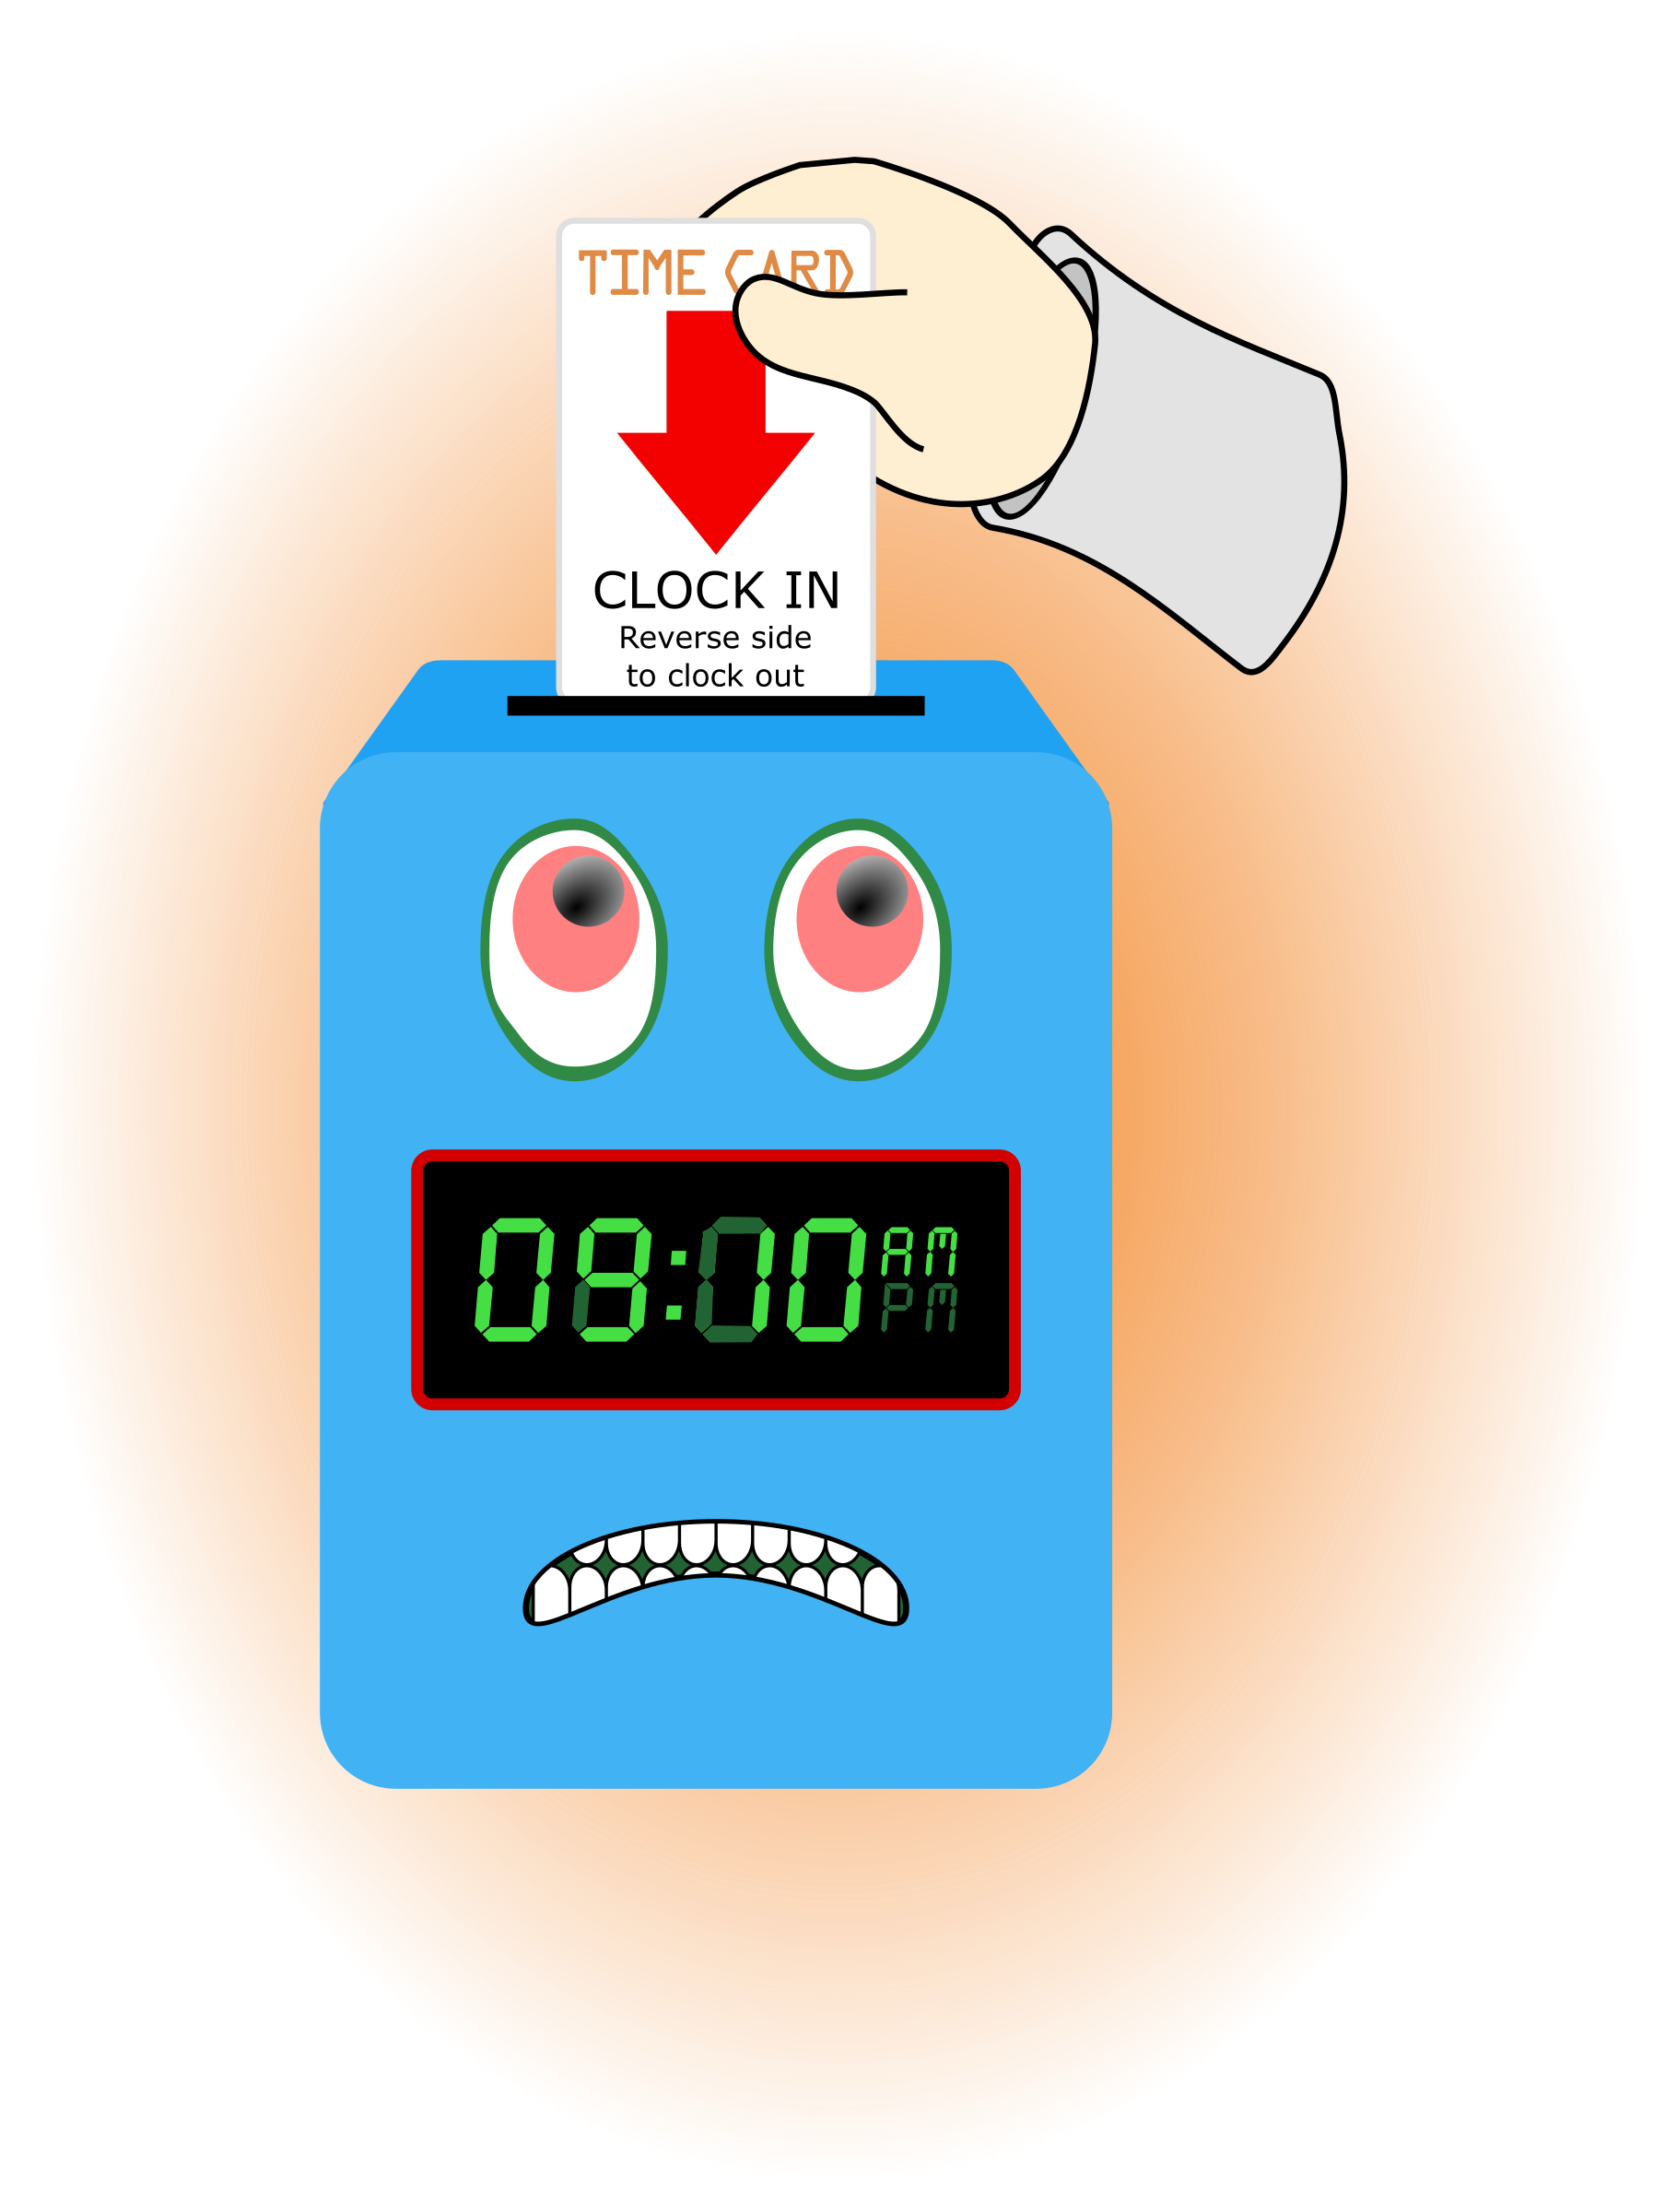
D. Human Resource Issues (Staffing and Training)
1. Sub-topic: Time Sheets Due
Discussion: Time sheets should be submitted directly to the supervisor’s office. Call Mr. Whitter to inform him of any changes needed after Friday. Leave detail message on his voice mail.
Outcome, Actions, Timeframe: Staff should submit time sheets by Friday at 12:00 noon.
2. Sub-topic: Training Needs
Discussion: Areas identified by supervisors and staff discussed
Outcome, Actions, Timeframe:
3. Sub-topic: Today’s Training Topic- Intake Process/ Screening and Intake Progress Note
Discussion:

Outcome, Actions, Timeframe:
4. Sub-topic: Pending List Needs
Discussion:
Outcome, Actions, Timeframe:
E. Annual Budget Planning and Process
1. Sub-topic:
Discussion: No discussion
Outcome, Actions, Timeframe:
II. Health and Safety: Program/Regional Coordinators
A. External Inspections
1. Sub-topic:
Discussion: No discussion
Outcome, Actions, Timeframe:
B. Self-Inspections (Reports, analysis, and recommendations)
1. Sub-topic:
Discussion: No discussion
Outcome, Actions, Timeframe:
C. Incident Reports (Reports, analysis of trends, recommendations)
1. Sub-topic:
Discussion: No discussion
Outcome, Actions, Timeframe:
III. Quality Improvement
A. File Audits and Case Record Review (reports and recommendations)
1. Sub-topic:

Discussion: No discussion
Outcome, Actions, Timeframe:
B. Outcome Management (status, reports, recommendations)
1. Sub-topic: 30/60/90 Day Follow-up contacts/Responses
Discussion:
Outcome, Actions, Timeframe: Mr. Cox provided information for contacts that were made. Thank you to Mr. Cox for reaching out to the parents/guardians and to staff for working with the youth in a positive manner to ensure successful outcomes.
C. Accreditation and Regulatory Requirements
1. Sub-topic:
Discussion: No discussion
Outcome, Actions, Timeframe:
D. Policy and Procedure Updates and/or Review
1. Sub-topic:
Discussion: No discussion
Outcome, Actions, Timeframe:
E. Participant Complaint and Grievance (specific and quarterly review of trends)
1. Sub-topic:
Discussion: No discussion
Outcome, Actions, Timeframe:
F. Planning Documents (reports, status of goals and objectives, reformulation)
1. Sub-topic: Strategic Plan
Discussion: No discussion
Outcome, Actions, Timeframe:
2. Sub-topic: Accessibility Plan
Discussion: No discussion
Outcome, Actions, Timeframe:
3. Sub-topic: Cultural Competence Plan
Discussion: No discussion
Outcome, Actions, Timeframe:
4. Sub-topic: Input Plan
Discussion: No discussion
Outcome, Actions, Timeframe:
5. Sub-topic: Community Relations plan
Discussion: No discussion

Outcome, Actions, Timeframe:

IV. Risk Management
A. Risk Management Plan (exposure to loss)
1. Sub-topic:
Discussion: No discussion
Outcome, Actions, Timeframe:

B. Employee Concerns or Complaints
1. Sub-topic: Open Mic
Discussion: Staff Questions, Concerns, Complaints, Requests, etc.
Outcome, Actions, Timeframe: Items placed in the clothes closet are NOT for staff. Please don’t shop the clothes closet.
C. Potential regulatory audits and/or investigation of operations
1. Sub-topic:
Discussion: No discussion
Outcome, Actions, Timeframe:
V. Information Technology
A. Technology Plan
1. Sub-topic:
Discussion: No discussion
Outcome, Actions, Timeframe:
VI. Clinical/Program
A. Medical and Medication Issues
1. Sub-topic:
Discussion: No discussion
Outcome, Actions, Timeframe:
B. Counseling and Programming Issues
1. Sub-topic: Participant Updates/Concerns
Discussion:
Outcome, Actions, Timeframe:
2. Sub-topic: Shift Coverage Needs
Discussion: Staff are responsible to securing coverage when they would like to take time off. On the leave request staff should indicate details of the outcome for coverage.
Outcome, Actions, Timeframe:
a) Request for coverage by co-workers-
b)Request for coverage by program-
3. Sub-topic: Shredder Use
Discussion: Consistent maintenance is needed to ensure continued equipment success.
Outcome, Actions, Timeframe: Place all items to be shred in the bin on top of the shredder
VII. Other Business:
1. Sub-topic: Meeting Sign-Out
Discussion: Staff signed out on the meeting attendance log
Outcome, Actions, Timeframe: Sign-out Time- __________________
2. Sub-topic: Staff Shout Outs
Discussion: Recognizing co-workers for the “extra” they do to make the work environment better. We applaud all that you do and want to let you know we are grateful. Thank You!!!
Outcome, Actions, Timeframe:

Respectfully Submitted by:
Cassandra McCray |  | 2/10/19
Name Date

