Meeting Minutes
CDS Family & Behavioral Health Services, Inc.
Meeting: IYPC STAFF/TRAINING
Date: 1/24/19
Time: 4:00PM
Location: 1400 NW 29TH ROAD, GAINESVILLE, FLORIDA
Date of Next Meeting: THE 2ND, 2/14/19 and 4TH THURSDAYS
Present: C. McCray, Z. Whitter, N. Thompson, T. Scott, B. Cox, S. Davis, J. Turk, B. Smith, J. Mattox,
J. Barley, S. Carter, S. Davis, O. Jones, C. Jonas, K. Lee, R. McBride, M. McMann, N. Wales, V. Allen,
M. Barnard, A. Dennis, S. Durham, W. Harmon, E. McCrea, G. Strickland
Absent: A. Rowden, E. Holcombe, J. Sturm, S. Dixon, J. Rollins, S. Sterling, S. Cooper, S. Twining, L.
Jonas
I. Business Operations:
A. Monthly Budget (Revenue and Expenses)
1. Sub-topic:
Discussion: No discussion
Outcome, Actions, Timeframe:
B. Marketing and Business Development
1. Sub-topic:
Discussion: No discussion
Outcome, Actions, Timeframe:
C. Regulatory Issues
1. Sub-topic:
Discussion: No discussion
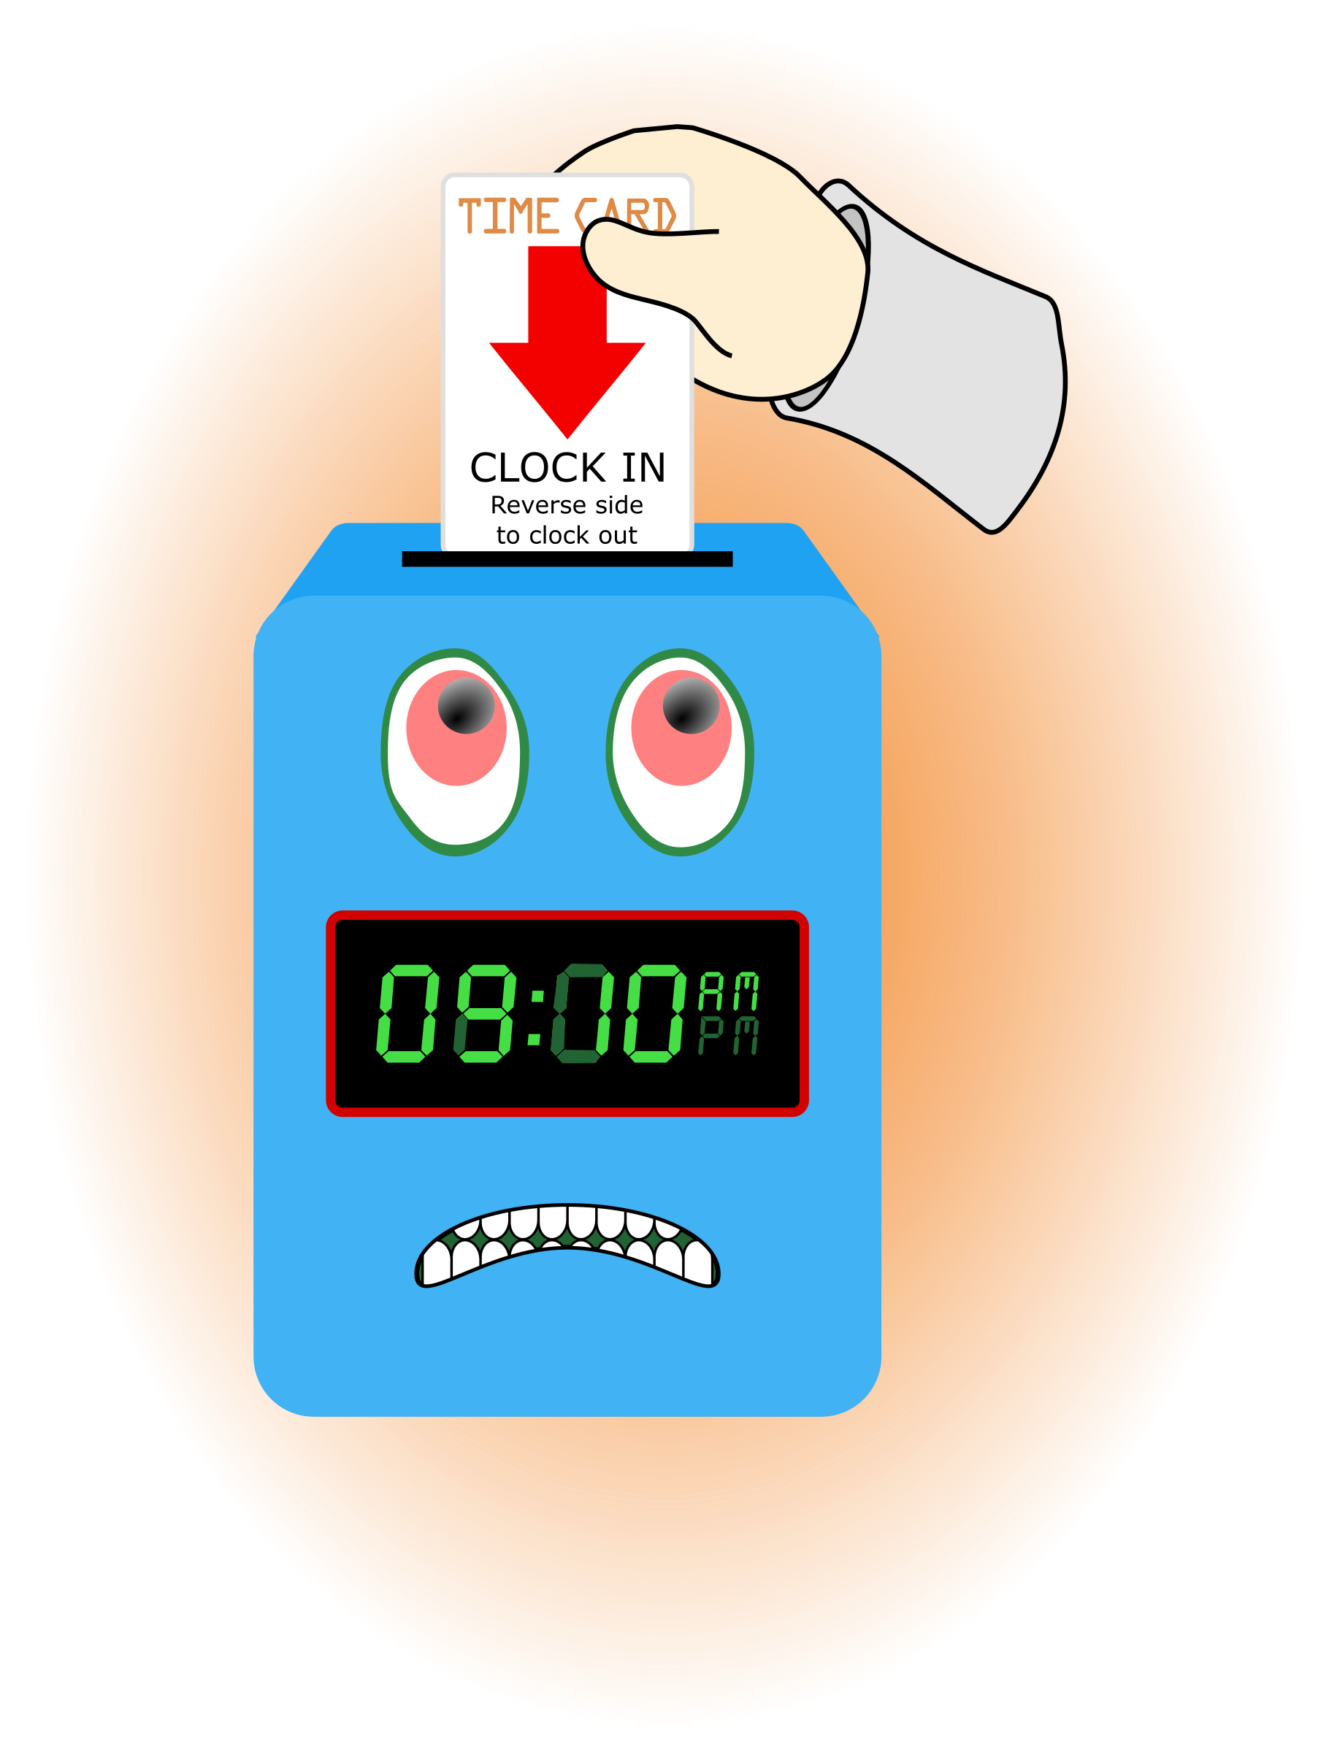
Outcome, Actions, Timeframe:
D. Human Resource Issues (Staffing and Training)
1. Sub-topic: Time Sheets Due Friday @ noon, January 25, 2019
Discussion:
Outcome, Actions, Timeframe: Staff should submit time sheets by
2. Sub-topic: Training Needs
Discussion: Areas identified by supervisors and staff discussed
Outcome, Actions, Timeframe:
3. Sub-topic: Today’s Training Topic- Fire Safety Equipment
Discussion: All staff should complete the CD Intranet Fire Extinguishers and Fire Safety 2 Training

Outcome, Actions, Timeframe: Review the information provided, complete the tests and provide documentation to Mr. Cox by February 14, 2019.
4. Sub-topic: DJJ Skillpro
Discussion: All staff need to complete the process to sign-in on Skill Pro
Outcome, Actions, Timeframe: Due Date to complete is 2/14/19
5. Sub-topic: Pending List Needs
Discussion: Any pending list items will now become a part of the documentation on your evaluation.
Outcome, Actions, Timeframe: Mr. Whitter will be contacting you to schedule your evaluations S. Durham, A. Dennis, S. Cooper, L. Jonas, R. McBride, C. Jonas and B. Smith. THANK YOU for completing your self-evaluation and turning it in. M. Barnard please contact Mr. Whitter to get your self-evaluation.
6. Sub-topic: WELCOME
Discussion: New hires joining/rejoining the IYPC team. Introductions
Outcome, Actions, Timeframe: Dawn Hunt and Sheila Parker
E. Annual Budget Planning and Process
1. Sub-topic:
Discussion: No discussion
Outcome, Actions, Timeframe:
II. Health and Safety: Program/Regional Coordinators
A. External Inspections
1. Sub-topic:
Discussion: No discussion
Outcome, Actions, Timeframe:
B. Self-Inspections (Reports, analysis, and recommendations)
1. Sub-topic:
Discussion: No discussion
Outcome, Actions, Timeframe:
C. Incident Reports (Reports, analysis of trends, recommendations)
1. Sub-topic:
Discussion: No discussion
Outcome, Actions, Timeframe:
III. Quality Improvement
A. File Audits and Case Record Review (reports and recommendations)
1. Sub-topic:
Discussion: No discussion

Outcome, Actions, Timeframe:
B. Outcome Management (status, reports, recommendations)
1. Sub-topic: 30/60/90 Day Follow-up contacts/Responses
Discussion:
Outcome, Actions, Timeframe: Mr. Cox provided information for contacts that were made. Thank you to Mr. Cox for reaching out to the parents/guardians and to staff for working with the youth in a positive manner to ensure successful outcomes.
Comments: Summaries of contact being made was provided for 4 past participants. Comments included attitudes changes have occurred, pxs are happier, helpful at home, better communication is occurring, and thanks sent to staff.
C. Accreditation and Regulatory Requirements
1. Sub-topic:
Discussion: No discussion
Outcome, Actions, Timeframe:
D. Policy and Procedure Updates and/or Review
1. Sub-topic:
Discussion: No discussion
Outcome, Actions, Timeframe:
E. Participant Complaint and Grievance (specific and quarterly review of trends)
1. Sub-topic:
Discussion: No discussion
Outcome, Actions, Timeframe:
F. Planning Documents (reports, status of goals and objectives, reformulation)
1. Sub-topic: Strategic Plan
Discussion: No discussion
Outcome, Actions, Timeframe:
2. Sub-topic: Accessibility Plan
Discussion: No discussion
Outcome, Actions, Timeframe:
3. Sub-topic: Cultural Competence Plan
Discussion: No discussion
Outcome, Actions, Timeframe:
4. Sub-topic: Input Plan
Discussion: No discussion
Outcome, Actions, Timeframe:
5. Sub-topic: Community Relations plan
Discussion: No discussion

Outcome, Actions, Timeframe:

IV. Risk Management
A. Risk Management Plan (exposure to loss)
1. Sub-topic:
Discussion: No discussion

Outcome, Actions, Timeframe:
B. Employee Concerns or Complaints
1. Sub-topic: Open Mic
Discussion: Staff Questions, Concerns, Complaints, Requests, etc.
Outcome, Actions, Timeframe: 1-The laundry bags aren’t working well for laundry, the strings are a problem. The bags are too small for all the intake clothing. Other options will be explored. 2-Everyone needs to remember not to use px names across files. If needed px should be identified by their px number. 3- Equipment needed includes a new DVD player and basketball goal.
2. Sub-topic: Meetings with supervisors
Discussion: Need to connect with staff for a discussion. Send Mr. Whitter and Mrs. McCray an email with two to three times you are available to come in to meet. We will reply to your email with a confirmation time.
Outcome, Actions, Timeframe: Sharonda Day, Shaci Davis schedule via email by Monday January 28, 2019.
C. Potential regulatory audits and/or investigation of operations
1. Sub-topic: Quality Improvement Outcome
Discussion:
Outcome, Actions, Timeframe: Discussed the outcome of the QI review
V. Information Technology
A. Technology Plan
1. Sub-topic: Pyxis System-DISCREPANCIES
Discussion: All discrepancies must be cleared before leaving at the end of each shift. There may be a slight delay in the discrepancy showing in the system.
Outcome, Actions, Timeframe: Staff should check the Pyxis system near the end of each shift and clear any discrepancy that shows. Any discrepancy not completed should be noted on the Shift Exchange Report.
VI. Clinical/Program
A. Medical and Medication Issues
1. Sub-topic:
Discussion: No discussion
Outcome, Actions, Timeframe:
B. Counseling and Programming Issues
1. Sub-topic: Participant Updates/Concerns
Discussion: Remember that the participants are here because they have needs that our program has identified we are capable of assisting with.
Outcome, Actions, Timeframe: Each staff while on duty has the responsibility to assist in meeting those needs for the entire time on duty.
2. Sub-topic: Shift Coverage Needs
Discussion: Staff are responsible to securing coverage when they would like to take time off. On the leave request staff should indicate details of the outcome for coverage.
Outcome, Actions, Timeframe:
a) Request for coverage by co-workers-
b)Request for coverage by program-
3. Sub-topic: Staff Meeting
Discussion: Reminder that staff meeting is considered one of your shifts.
Outcome, Actions, Timeframe: Everyone is expected to arrive by 4:00pm and be prepared to stay until 6:00pm .
4. Sub-topic: Documentation of staff arriving and leaving the facility
Discussion: As you arrive on site staff should notify the staff on duty and ask them to document your arrival. As you leave, for any reason, you should notify the staff on duty to document you are leaving.
Outcome, Actions, Timeframe: Staff documenting in the PLB should indicate the arrival and departure of staff, visitors and participants. Staff arrivals and departures should also be highlighted with the orange color for a supervisor to review.
5. Sub-topic: Late arrival for shifts
Discussion: When staff have not arrived by the starting time of their shift, staff on duty should:
Outcome, Actions, Timeframe:
1) Check the Shift Coverage Binder to confirm who should be on shift and arrival time
- Call the person expected to arrive if it is 5 minutes past the expected arrival time
- Notify Mr. Whitter or Mrs. McCray if the staff has not arrived or you were unable to reach them by 10 minutes past the expected arrival time.
6. Sub-topic: New Program Cell Phones
Discussion: How to use them. Staff are expected to use and track the phones.
Outcome, Actions, Timeframe:
VII. Other Business:
1. Sub-topic: Meeting Sign-Out
Discussion: Staff signed out on the meeting attendance log
Outcome, Actions, Timeframe: Sign-out Time- __________________
2. Sub-topic: Staff Shout Outs/ Drop In The Buckets

Discussion: Recognizing co-workers for the “extra” they do to make the work environment better. We applaud all that you do and want to let you know we are grateful. Thank You!!!
Outcome, Actions, Timeframe:
Shout Outs were given to:
Sheila Parker for helping with the QI prep.
Naomi Thompson for QI help specific to program appearance
Mr. Harmon for all of his handi-man assistance.
Major Shout Out to everyone who helped in the preparation for the QI review!
Respectfully submitted by:
Cassandra L. Evans-McCray |  | 1/24/19
Name Date

