Meeting Minutes
CDS Family & Behavioral Health Services, Inc.

Meeting: IYPC STAFF MEETING/TRAINING
Date: January 9, 2020
Time: 4:00PM
Location: 1400 NW 29TH ROAD, GAINESVILLE, FLORIDA
Date of Next Meeting: THE 2ND and 4TH THURSDAYS
Present: C McCray, B Cox, S Parker, S Carter, K Lee, M McMann, N Wales, J Turk, J Mattox, A Rowden, B Smith, S Twining,
R Cannon, S Davis, S Durham, R McBride, J Bartley, D Walker, W Harmon, E McCrea, G Strickland,
Z Whitter, N Thompson, B Ross.
Absent: O Jones, S Warmack, J Johnson,
I. Business Operations:
A. Monthly Budget (Revenue and Expenses)
1. Sub-topic:
Discussion: No discussion
Outcome, Actions, Timeframe:
B. Marketing and Business Development
1. Sub-topic:
Discussion: No discussion
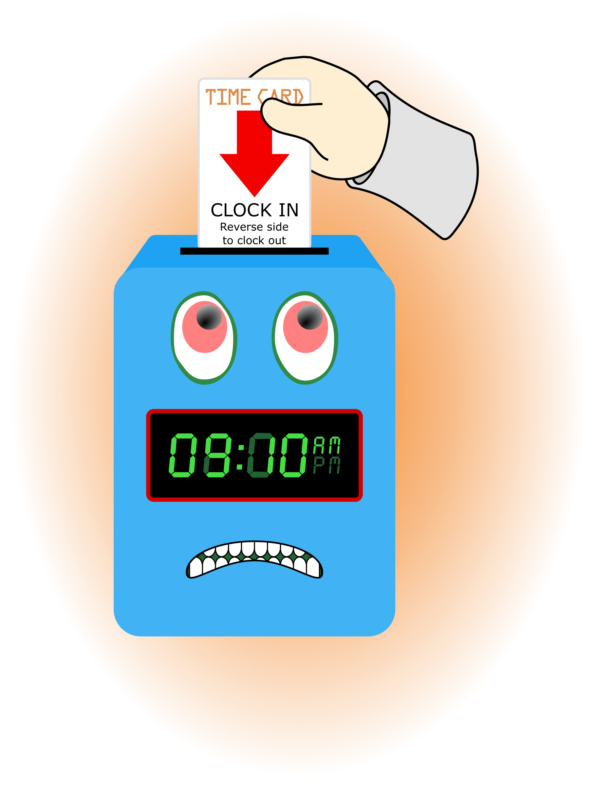
Outcome, Actions, Timeframe:
C. Regulatory Issues
1. Sub-topic:
Discussion: No discussion
Outcome, Actions, Timeframe:
D. Human Resource Issues (Staffing and Training)
1. Sub-topic: Time Sheets Due
Discussion:
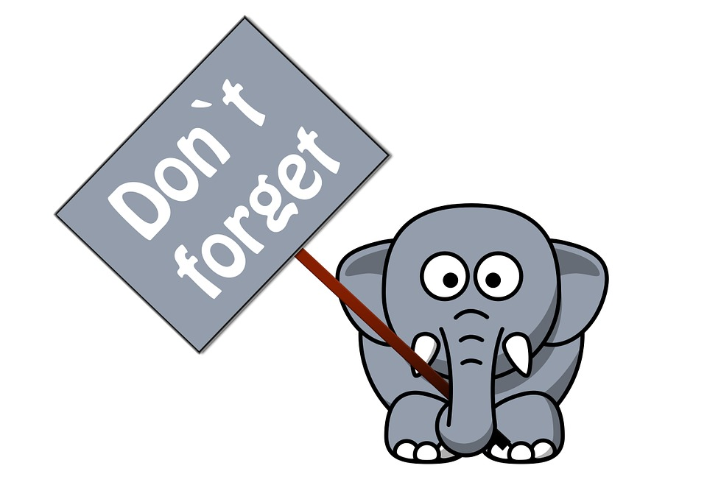
Outcome, Actions, Timeframe: Staff should submit time sheets by Fri. January 10, 2020 @ 9:00 am.
2. Sub-topic: Training Needs
Discussion: Areas identified by supervisors and staff discussed
Outcome, Actions, Timeframe: Staff should register for the RHY training site and complete the training assignments as noted on the grid provided.
3. Sub-topic: Training Topic (s)- FIRE DRILLS
Discussion: Following the dates identified in the Program Log Book and following documentation guidelines.
Outcome, Actions, Timeframe: Complete the January documentation where form was not available.

E. Annual Budget Planning and Process
1. Sub-topic:
Discussion: No discussion
Outcome, Actions, Timeframe:

II. Health and Safety: Program/Regional Coordinators
A. External Inspections
1. Sub-topic:
Discussion: No discussion
Outcome, Actions, Timeframe:
B. Self-Inspections (Reports, analysis, and recommendations)
1. Sub-topic:
Discussion: No discussion
Outcome, Actions, Timeframe:
C. Incident Reports (Reports, analysis of trends, recommendations)
1. Sub-topic:
Discussion: No discussion
Outcome, Actions, Timeframe:

III. Quality Improvement
A. File Audits and Case Record Review (reports and recommendations)
1. Sub-topic:
Discussion: No discussion
Outcome, Actions, Timeframe:
B. Outcome Management (status, reports, recommendations)
1. Sub-topic: 30/60/90 Day Follow-up contacts/Responses
Discussion:
Outcome, Actions, Timeframe: Mr. Cox provided information for contacts that were made. Thank you to Mr. Cox for reaching out to the parents/guardians and to staff for working with the youth in a positive manner to ensure successful outcomes.

Follow-up Comments:
Male participant- Fx indicates the px is showing behaviors that are more manageable, he’s also more helpful at home.

C. Accreditation and Regulatory Requirements
1. Sub-topic:
Discussion: No discussion
Outcome, Actions, Timeframe:
D. Policy and Procedure Updates and/or Review
1. Sub-topic:
Discussion: No discussion
Outcome, Actions, Timeframe:
E. Participant Complaint and Grievance (specific and quarterly review of trends)
1. Sub-topic:
Discussion: No discussion
Outcome, Actions, Timeframe:
F. Planning Documents (reports, status of goals and objectives, reformulation)
1. Sub-topic: Strategic Plan
Discussion: No discussion
Outcome, Actions, Timeframe:
2. Sub-topic: Accessibility Plan
Discussion: No discussion
Outcome, Actions, Timeframe:
3. Sub-topic: Cultural Competence Plan
Discussion: No discussion
Outcome, Actions, Timeframe:
4. Sub-topic: Input Plan
Discussion: No discussion
Outcome, Actions, Timeframe:
5. Sub-topic: Community Relations plan
Discussion: No discussion

Outcome, Actions, Timeframe:

IV. Risk Management
A. Risk Management Plan (exposure to loss)
1. Sub-topic:
Discussion: No discussion
Outcome, Actions, Timeframe:

B. Employee Concerns or Complaints
1. Sub-topic: Open Mic
Discussion: Staff Questions, Concerns, Complaints, Requests, etc.
Outcome, Actions, Timeframe: None noted

C. Potential regulatory audits and/or investigation of operations
1. Sub-topic:
Discussion: No discussion
Outcome, Actions, Timeframe:

V. Information Technology
A. Technology Plan
1. Sub-topic:
Discussion: No discussion
Outcome, Actions, Timeframe:

VI. Clinical/Program
A. Medical and Medication Issues
1. Sub-topic: FOCUS FOCUS FOCUS
Discussion: Medication Reminder Board, what it include???
Outcome, Actions, Timeframe: We have had 3 Medication error CCC calls in the last two weeks. Do not forget the Medication Procedures, Policies and Practices. When the 10 Medication Rights are followed it is rare that an error is made. If you have questions ASK!

B. Counseling and Programming Issues
1. Sub-topic: Participant Updates/Concerns
Discussion: Review current px in house
Outcome, Actions, Timeframe: There are legal guidelines for interactions with persons outside of CDS. Follow agency policy and program practice and we will be more consistent with our messages. First ask yourself what is the policy for this situation. Thinking “I saw/hear ??? do/say is not a practice we want to have.


2. Sub-topic: Shift Coverage Needs
Discussion: Staff are responsible to securing coverage when they would like to take time off. On the leave request staff should indicate details of the outcome for coverage.
Outcome, Actions, Timeframe: The schedule for the current and upcoming week was reviewed and confirmed.
a) Request for coverage by co-workers-
b) Request for coverage by program-
VII. Other Business:
1. Sub-topic: Volunteer Event
Discussion: One day/time event with volunteers from a student organization at UF. Looking of ideas/suggestions of an activity/event.
Outcome, Actions, Timeframe: A “Field Day” was suggested, to occur on a Sunday.
2. Sub-topic: A Drop For Your Bucket
Discussion: Recognizing co-workers for the “extra” they do to make the work environment better. We applaud all that you do and want to let you know we are grateful. Thank You!!!
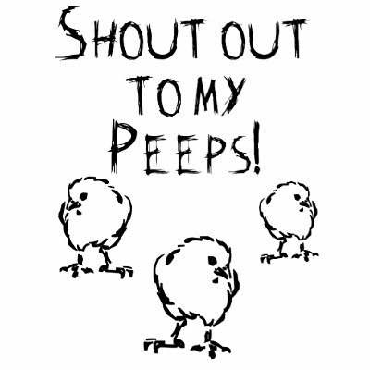
Outcome, Actions, Timeframe: None noted
3. Sub-topic: Team Building Activity
Discussion: The group participated in a activity of exchanging gifts via the “Wright Family Christmas Exchange” process.
Outcome, Actions, Timeframe: Staff used communication, following instructions, listening and staying on task skills to have an activity that was fun and enganging.

