CDS FAMILY & BEHAVIORAL HEALTH SERVICES, INC.

Stakeholder Survey 2015 Total returned: 32 Survey Period: 9-1-15-10/30/15

Questions: | Strongly  Agree | Agree | No  Opinion | Disagree | Strongly  Disagree | N/A | Comments:
- CDS has a good working relationship with our organization. | 23 | 9
- CDS has competent and professional staff. | 22 | 10
- CDS has staff that is accessible to our organization. | 21 | 11
- CDS is responsive to our input and ideas. | 21 | 9 | 2
- CDS has a strong partnership with our organization at the administrative and/or management level. | 22 | 9 | 1
- CDS has a strong partnership with our organization at the direct service staff level. | 21 | 11
- CDS shares pertinent participant related information with our agency, as appropriate. | 22 | 9 | 1
- CDS provides timely information to assist our work. | 21 | 10 | 1
- CDS does a good job of following up on its participants. | 21 | 8 | 3
- CDS does a good job of arranging or referring to community services. | 21 | 9 | 1 |  |  | 1
- CDS has a positive impact on most of the participants it serves. | 24 | 5 | 2 |  |  | 1
- Please include any additional comments you would care to make.
Please place a check mark next to the CDS program(s) with which you currently have contact:
Interface Youth Programs Prevention Programs
___Interface Youth Program-Residential ___ Levy County Prevention Coalition
___Family Action ___ Reichert House
___ Spotlight on Youth
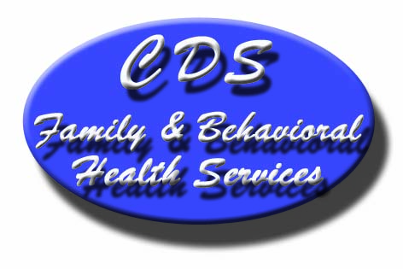
___ Alachua County Health and Wellness Coalition
___ Independent Living
___ Project Success or Too Good for Drugs

Thank you for completing this survey. Your input is part of our ongoing effort to improve our program services.
Stakeholder Comments

Needs a more secured facility

The staff are always available to answer any questions we have

This is a great partnership for our circuit JPO staff!!

Have had long working relationship.

Cindy Starling and all the staff at the interface youth shelter parter with us at the highest level of cooperation

CDS is an exemplary organization. Outstanding staff.

CDS has strong leadership and is always accessible to our organization and to the community

Cindy Starling is integral to our office and programs

CDS works hard to establish positive working relationships with community organizations.

Putnam County School District loves working with CDS staff.

