CDS FAMILY & BEHAVIORAL HEALTH SERVICES, INC.
3615 SW 13th St, Suite 4
Gainesville, FL 32608
(352) 244-0628 x3810
peggy_vickers@cdsfl.org

Stakeholder Survey Results 2012

Questions: | Strongly  Agree | Agree | No  Opinion | Disagree | Strongly  Disagree | N/A | Comments:
- CDS has a good working relationship with our organization. | 18  67% | 9  33% | 0 | 0 | 0 | 0 | - CDS has a great working relationship with numerous agencies.  - Not only do we have board level participants, but in collection of valuable data.
- CDS has competent and professional staff. | 14  52% | 13  48% | 0 | 0 | 0 | 0 | - Will miss some staff due to budget cuts.  - When we have a need, staff have always been helpful.
- CDS has staff that is accessible to our organization. | 16  59% | 10  37% | 0 | 0 | 0 | 1  4% | 1. Staff have always been available.
- CDS is responsive to our input and ideas. | 15  56% | 11  41% | 1  4% | 0 | 0 | 0
- CDS has a strong partnership with our organization at the administrative and/or management level. | 16  59% | 10  37% | 1  4% | 0 | 0 | 0 | 1. Always
- CDS has a strong partnership with our organization at the direct service staff level. | 12  44% | 13  48% | 1  4% | 0 | 0 | 1  4% | 1. Always
- CDS shares pertinent participant related information with our agency, as appropriate. | 13  48% | 12  44% | 1  4% | 0 | 0 | 1  4% | 1. Their information is further shared also with other providers.
- CDS provides timely information to assist our work. | 15  56% | 12  44% | 0 | 0 | 0 | 0
- CDS does a good job of following up on its participants. | 14  52% | 9  33% | 3  11% | 0 | 0 | 1  4%
- CDS does a good job of arranging or referring to community services. | 15  56% | 10  37% | 2  7% | 0 | 0 | 0
- CDS has a positive impact on most of the participants it serves. | 16  59% | 9  33% | 2  7% | 0 | 0 | 0 | - I’m sure Mr. Beasley has helped lots of patients, but I don’t see them all, if that makes any sense.  - We have feedback from other partner agencies about service CDS provides.
- Please include any additional comments you would care to make. | - Everyone does a magnificent job. Great to work together on numerous projects.  - I have worked for CDS for 20+ years.  - I have not worked with Project Interface in the last few years; this info is based on previous experience. I’ll be happy to continue whenever my services are needed.  - CDS provides excellent, cost effective services. Agency leadership is highly respected and committed to youth and families.  - CDS is awesome to work with! They are “student centered” and always communicate with us!  - Wonderful Job. Please keep all of your Putnam programs.  - Wonderful Staff. We appreciate all you do!  - It has been great working with CDS, the staff are extremely helpful.  - Great folks – great program!  - David Beasley is a pleasure to work with.  - Our program could not operate at such a high level without CDS.  - The PCADC appreciates the years of service provided by CDS by its consistent participation on our Board of Directors.  - Ms. Stephanie Douglas has been a great point of contact.
Please place a check mark next to the CDS program(s) with which you currently have contact:
Interface Youth Programs Prevention Programs SAMH Programs
19/ Interface Youth Program-Residential 8/ Reichert House 3/ SAMH East (Outpatient, TASC & TANF)
13/ Family Action 5/ Spotlight on Youth 7/ Drug Free Communities Support Program
4/PIPSA
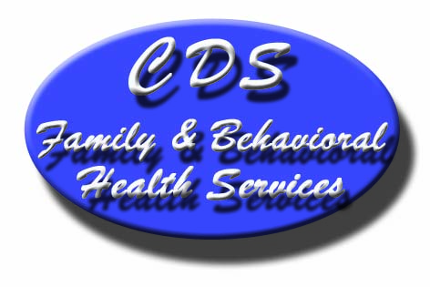

Thank you for completing this survey. Your input is part of our ongoing effort to improve our program services.

