Infection Control Policy
Purpose: The intent of the following policy is to ensure that CDS staff is aware of best practices regarding Universal Infection Control to facilitate the safety of employees, participants and visitors. It is further intended to ensure compliance with 65D-30.004(9), 65D-30.004(10) rules regarding Universal Infection Control and the regulatory requirements of other entities having oversight over CDS.
Policy: It is the policy of CDS to have a written plan for exposure control regarding infectious disease that applies to all staff, volunteers, visitors and participants and meet the minimum educational requirements for HIV and AIDS pursuant to section 381.0035, F.S. and all infection prevention and control educational activities as required by contractual agreements. The associated policy by reference is P1039 Blood borne Pathogen Exposure Control Program.
Procedure and/or Process:
The following procedure is used for employees:

- All new employees are oriented to read the Infection Control Policy and the Blood borne Pathogen Exposure Control Program. At Orientation of New Employees the Human Resources Department provides a video entitled Blood borne Pathogens education ( on Hepatitis B and Blood borne Pathogen Exposure.
- All clinical staff and any other direct staff contact with participants shall receive four hours of education on HIV/AIDS/TB training within the first six months of employment.
- 500/501 HIV/AIDS/TB Training may be provided by a trained Health Department employee or a CDS employee who is aware of the training materials. Licensed staff must meet the standards set out by their licensure requirements.
- All clinical staff and any other direct staff contact with participants shall receive two hours of education on HIV/AIDS/TB training every two years thereafter.
- The Human Resources Department and/or the Program/Regional Director maintain all documentation of staff training in individual employee files.

CDS meets the minimum educational requirements for HIV and AIDS pursuant to section 381.0035, F.S. and all infection prevention and control educational activities. Documentation of these training activities is maintained either in the Employee Personnel Record or at the Program site where the employee works.

Participants who are identified at high risk and participant’s known to have infectious diseases are referred to the Health Department for HIV and TB testing and pre and posttest counseling as appropriate.

Documentation of these activities is maintained in the participant record.

Testing Services
The Health Departments provide both confidential and anonymous HIV testing.
In confidential testing your name and date of birth will appear on your test and information sheet.
In anonymous testing a barcode and your date of birth are used as identifiers. Your name is never recorded on any paperwork or test.
Fee
There is an optional $20 fee for anonymous HIV testing. You can pay some, none, or all and still be tested.
Health Department Staff
A trained and qualified staff with many years of experience will provide testing and counseling services to you. We are bilingual in English and Spanish.
How to Test
Participants can make an appointment in Alachua County by calling 352- 334-7960. In Putnam County by calling 386-326-3200 in Columbia County by calling 386-758-1068 Health Department accept walk-in appointments, however, scheduled clients will be seen first.
The testing procedure will include pre and post test counseling.
Results are only given in person.
Confidential Rapid Test (Clearview) will give results in approximately 15 minutes. (Only available Monday through Friday from 9:00am to 4:00pm, not during extended hours.)
Anonymous blood test is sent to a state lab and results come back in 2 weeks from the original appointment date. At the time of your test you will be scheduled a return appointment date to pick up test results.
If a Test is Positive
Your Health Department counselor will discuss options with you. He/she will help you get medical treatment and care by providing eligibility determination information.
Your counselor will inform you of eligibility determination services for HIV infected individuals, like Ryan White and ADAP (AIDS Drug Assistance Program) and a case manager will be assigned to you if you are eligible.
Other Services available at the Health Department
Free male/female condoms and lubrication.
Useful information about STD’s, safe sex, and HIV.
Educational pamphlets and material.

What is Infection Control?

Infection control is any policy or practice designed to stop the spread of infection(s) among individuals.

What is an Infection Control Program?

An infection control program is a comprehensive system of resources, policies, and practices designed to stop the introduction or spread of infection(s) among a designated group of individuals.

Why have an Infection Control Program?

In order to safeguard the health of participates, visitors, and employees, it is our responsibility to implement certain infection control measures.
Who is responsible for Infection Control?

As employees we all have responsibility for controlling the introduction and spread of infection. For some employees, the responsibility is incidental, such as regularly hand-washing after using the restroom. For other employees, infection control practices are an integral part of their daily duties. Regardless of the nature of our responsibilities, an effective program requires an active commitment from each of us.

Infection and the Infection Process

Before discussing the principles of our infection control program, it may help if we first look at infection and the infection process, that is, how infections occur.
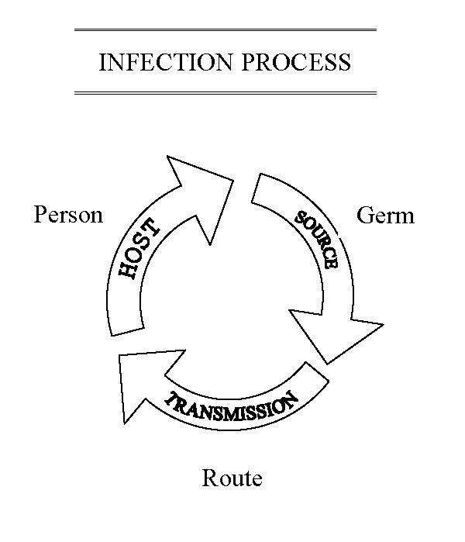
Infection is the state or condition in which the body or part of it is invaded by a pathogenic agent (infectious organism), which under favorable conditions multiplies and produces effects that are injurious or harmful. An infection can be as simple and mild as a pimple or common cold, or it can be as complex and life threatening as the disease known as AIDS. The seriousness of a disease is determined by both the nature of the infecting organism, and the health of the host (person). For example, the virus that causes the common cold can be deadly if the host is in a deteriorated condition.

The infection process involves three basic elements: A SOURCE OF INFECTIOUS ORGANISMS (e.g., virus or bacteria), A SUSCEPTIBLE HOST (i.e., someone who can become infected), and a MEANS OF TRANSMISSION (i.e., a way or getting the organism on or inside the susceptible person).
Let’s take a further look at these three elements.

Source of Infectious Organisms

The primary source of infectious organisms at our agency is other people who are infected: participates, employees, and visitors. Other potential sources include contaminated food and equipment, the swimming pool, and, in very rare instances, infected animals. People are a source when they have an infectious disease (e.g., measles) or they are a "carrier" for the disease (e.g., hepatitis-B carrier). Only a few infectious diseases produce a carrier state and not all people who are infected become carriers.

- Means of Transmission

There are essentially four main routes or methods for the transmission of infectious organisms, or gems: CONTACT, VEHICLE, AIRBORNE, and VECTORBORNE. Some organisms can be transmitted by more than one route; some have only one method by which they can be carried. Because this is so important to infection control, the routes of transmission will be discussed in more detail in the next section.

- Susceptible Host

All of us are potential hosts for infectious organisms. However, our resistance to infection varies greatly, depending upon the state of our health, previous infections with the same organism, and inoculations and vaccinations.

Means of Transmission

The four major routes of transmission are CONTACT, VEHICLE, AIRBORNE, and VECTORBORNE. A good understanding of the manner in which organisms are transmitted can be very helpful in developing and appreciating a range of methods of infection control.

- Contact Transmission

Direct Contact: This involves direct physical transfer from an infected person to a susceptible host. It can occur during routine care and management such as bathing, changing dressings, and other activities involving direct personal contact.

Indirect Contact: This involves personal contact of the susceptible host with contaminated objects, such as bed linens, clothing, instruments, cups, and toothbrushes.

Droplet Contact: Infectious organisms may be expelled as a result of coughing, sneezing, or talking by an infected person. These may strike vulnerable areas of a susceptible host such as the eyes, nose, mouth, open cuts, or sores. This is considered contact since the droplets usually travel no more than three feet.
- Vehicle Transmission

This applies to infections, which are transmitted in the following contaminated materials/vehicles:
- Food, as in salmonellosis
- Water, as in hepatitis A
- Drugs, as in bacteremia
- Blood, as in hepatitis B

- Airborne Transmission

This occurs by dissemination of organisms in tiny droplets of water (which may stay airborne for long periods of time), or in tiny suspended dust particles. Organisms that are carried in this manner can be widely dispersed.

- Vectorbome Transmission

This is simply mechanical, as by an insect carrying the virus on its feet.

Principles of Infection Control
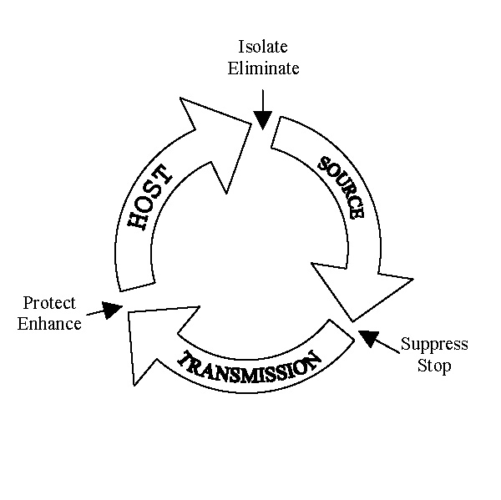
The principles of infection control are designed to suppress or stop the INFECTION PROCESS. These are summarized as follows:

- Isolate or eliminate the source of INFECTIOUS ORGANISMS.
- Suppress or stop the MEANS OF TRANSMISSION.
- Protect or enhance the resistance of the SUSCEPTIBLE HOST.

Specific Strategies and Actions

What follows are specific strategies or actions that can be taken regarding each of these principles. These are separated into general and specific. General pertains to things that should be done by all staff. Specific refers to strategies or actions taken by designated staff.

ISOLATE OR ELIMINATE THE SOURCE OF INFECTIOUS ORGANISMS.

General
- Take appropriate action regarding your own health, particularly as it pertains to the control and treatment of infectious disease -- follow medical advice and ensure treatments are completed.
- Report any potentially infectious disease to your supervisor -- when in doubt, consult with medical staff.
- Practice and promote good personal hygiene and the development of a healthy lifestyle.
- Store all foodstuffs properly -- destroy food which has not been stored properly, or which looks or smells unusual.
- As medically indicated, modify contact with those who are infectious.
- Take appropriate precautions when handling items labeled as infectious or contaminated.

Specific
- Screen all new participates for the presence of infectious organisms.
- Direct and refer medical treatment as appropriate.
- Routinely inspect food storage facilities (including refrigerators) and procedures.
- Properly sanitize food and waste containers.

SUPPRESS OR STOP THE MEANS OF TRANSMISSION.

General
- Develop good hand washing habits. (See section on hand washing facilities.)
- Practice and require good personal hygiene with particular attention to keeping nails trimmed short and clean.
- Use protective wear (gloves) when indicated by treatment plan of policy, and follow appropriate procedures for putting them on and off. Keep protective wear handy at all times.
- Do not share clothing, personal articles (comb, toothbrush, razor), bed linens, towels, or eating and drinking utensils from a person who is infectious or about whom you know nothing.
- Avoid or minimize unnecessary close contact with individuals who are infectious or suspected of harboring an infectious disease.

Specific Procedure Directors, supervisors, counselors/case managers, youth care/direct care workers, administrative and maintenance personnel are expected to implement CDS written procedure and training in managing blood borne pathogens and the practice of universal precautions.
Universal Precautions Requirements
Staff must use universal precautions when handling blood or other body fluids including:
•Gloves and double gloving when risk of contamination is present.
•Puncture proof containers for needle disposal.
•Blood spills and other body fluids cleaned with bleach in a 1:10 solution.
•Linen/clothing washed in hot water with detergent.
•Washing hands thoroughly with hot soap and water in case of any contact with body fluid.
Each facility must designate a staff member to ensure that each site is furnished with:
A Universal Precaution Compliance Kit

Transport Vehicles
Any vehicle used to transport participants must be equipped with a first aid kit that includes gloves and a pocket mask as well as a fire extinguisher. The Kits and Fire Extinguisher must be inspected regularly.

PROTECT OR ENHANCE THE RESISTANCE OF THE SUSCEPTIBLE HOST.

General
- Practice and promote good personal hygiene and the development of health behaviors.
- Obtain inoculations and vaccinations when medically indicated.
- Employees are encouraged to report to their supervisor any specific vulnerabilities to infectious disease to include pregnancy, diabetes, lymphoma, leukemia, neoplasia, granulocytopenia, uremia, AIDS, and treatment with certain antibodies, corticosteroids, irradiation, or immunosuppressive agents
- Treat and cover exposed wounds, to include burns and scratches, when working with (potentially) contaminated materials and infectious persons.

