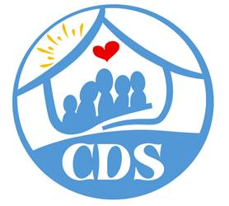

CDS Family & Behavioral Health Services, Inc.
Empowering Youth & Building Strong Families for a Brighter Tomorrow

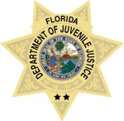

Department of Juvenile Justice

To increase public safety by reducing juvenile delinquency

through effective prevention, intervention and treatment services that

strengthen families and turn around the lives of troubled youth.

Department of Children & Families
Protect the vulnerable, promote strong and economically self-sufficient
families, and advance personal and family recovery and resiliency.

