
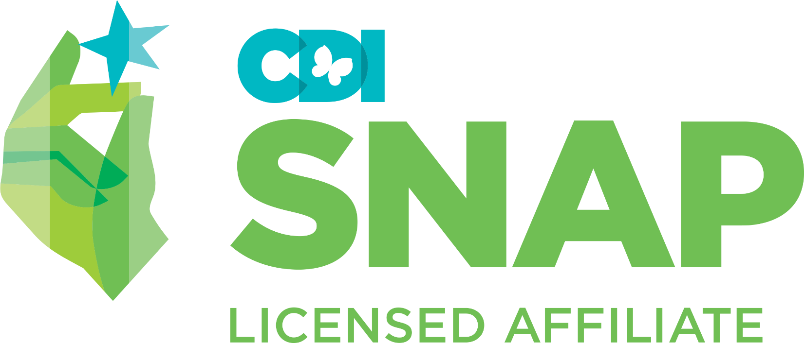
SNAP® GIRLS Parent Group Weekly Evaluation

Parent Name(s): _____________________________ Facilitator(s):

Child Name/Client #: __________________________

Rating scale:
1 = refuses to participate; 2 = some evidence of skill, required coaching; 3 = effectively demonstrates skill; 4 = not observable

NOTE: for certain observations of a client’s participation a numerical rating will suffice; others require an explanation in note column
Generalization Activities

Date | Session Topic | Home Practice | Goal Review | Role-Play  (identifies skill demonstrated; effectively demonstrates skill) | Conceptualization  (questions and information provided indicate understanding of skill) | Effective Communication  (demonstrates active listening, assertive (non) verbal skills, stays on topic, contributions are relevant) | Notes
 | - SNAP® Parenting
 | - Hard and Cool Thoughts
 | 3.Tracking
 | - Effective Directions
 | - Family Game—Joint Session
 | - Rewarding
 | - Healthy Relationships
 | - Setting Effective Limits
 | - Joint Session -Time Outs
 | - Dealing with Bullying
 | - Family Problem Solving
 | - Joint Session – Final Review
 | - Graduation and Measures

