
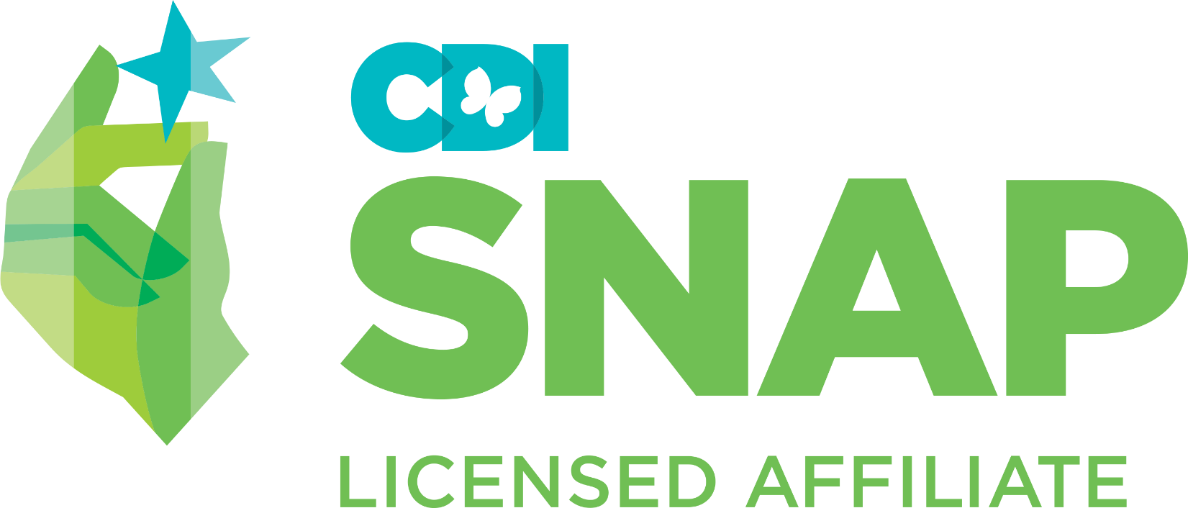
SNAP® GIRLS Group Weekly Evaluation

Parent Name(s): _____________________________ Facilitator(s): __

Child Name/Client #: __________________________

Rating scale:
1 = refuses to participate; 2 = some evidence of skill, required coaching; 3 = independently demonstrates skill; 4 = not observable

NOTE: for certain observations of a client’s participation a numerical rating will suffice; others require an explanation in note column

Date | Session Topic | Social Skills  (cooperative with peers and Leaders; interacts positively with others) | Effective Communi-cation  (uses listening skills; expresses self appropriately) | Skill Practice  (demonstrates steps of SNAP in role-play and during natural learning oppor-tunities) | Skill Conceptualization  (demonstrates understanding of topic) | Home  Practice | Behaviour  (follows group rules, structure, and expectations; requires redirection/limit setting; responsive to praise, points) | Notes  (mood/demeanor; important insights and information)
 | - Orientation/Listening
 | - Introduction to SNAP®
 | - Solving Problems
 | - Feelings
 | - Joint Group / Family Game
 | - Body Cues
 | - Hard Thoughts / Cool Thoughts 1
 | - Hard Thoughts / Cool Thoughts 2
 | - Joint Session – Time Outs
 | - Dealing with Bullying
 | - When You Are Not So Sure
 | - Joint Session: Final Review
 | - Final Celebration and Post Group Measures

