
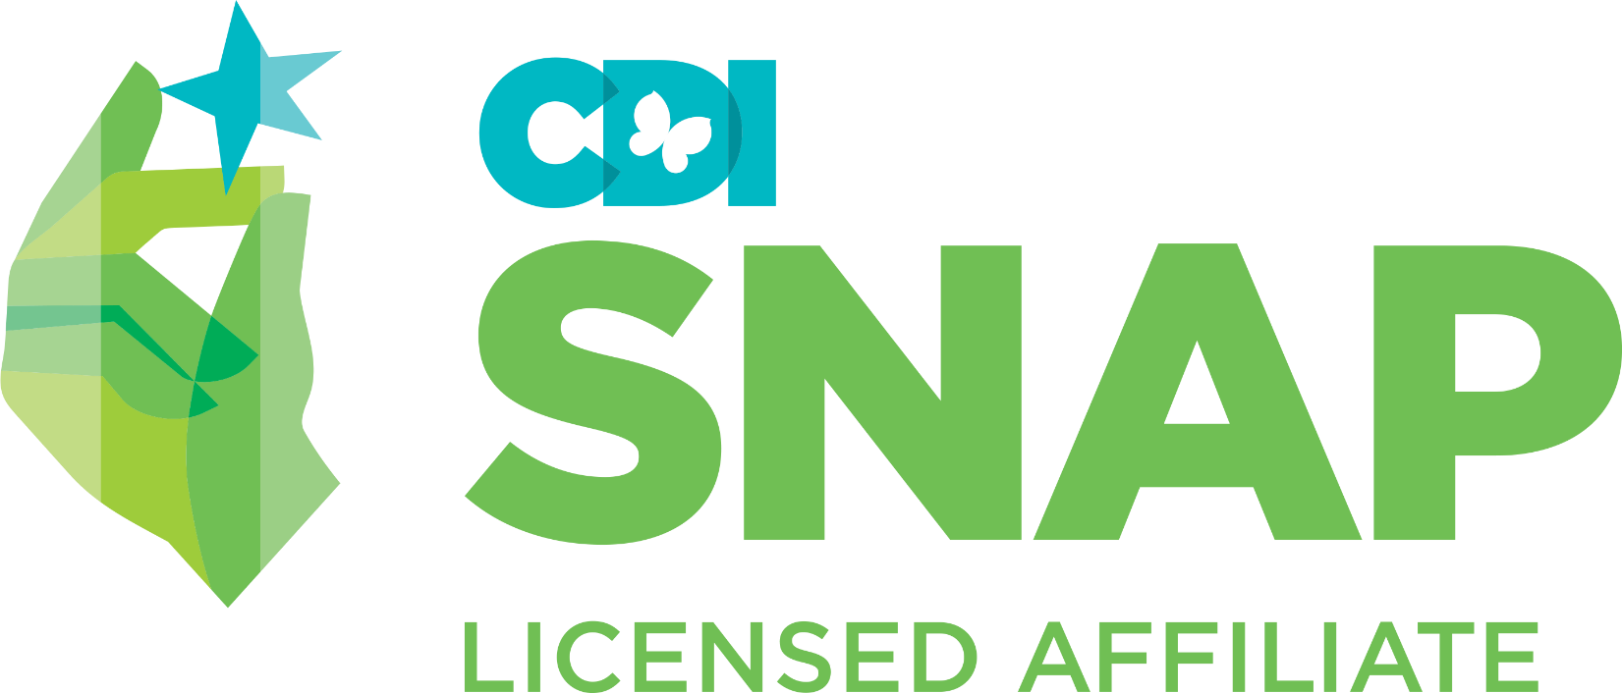
SNAP® BOYS Weekly Parent Evaluation

Parent Name(s): _____________________________ Facilitator(s):

Child Name/Client #: __________________________

Rating scale:
1 = refuses to participate; 2 = some evidence of skill, required coaching; 3 = effectively demonstrates skill; 4 = not observable

NOTE: for certain observations of a client’s participation a numerical rating will suffice; others require an explanation in note column
Generalization Activities

Date | Session Topic | Home Practice | Goal Review | Role-Play  (identifies skill demonstrated; effectively demonstrates skill) | Conceptualization  (questions and information provided indicate understanding of skill) | Effective Communication  (demonstrates active listening, assertive (non) verbal skills, stays on topic, contributions are relevant) | Notes
 | - SNAP® for Parents
 | - Tracking & Monitoring
 | - Listening & Effective Directions
 | - Joint Session
 | - Encouraging, Charting, & Rewards 1
 | - Charting and Rewards 2
 | - Effective Consequencing
 | - Consequencing & Joint Session
 | - Stopping Stealing and Lying
 | - Problem Solving (PASTE)
 | - Dealing With Bullying
 | - Home and School Relations
 | - Final Celebration

