CDS FAMILY & BEHAVIORAL HEALTH SERVICES, INC.
3615 SW 13th St, Suite 4
Gainesville, FL 32608
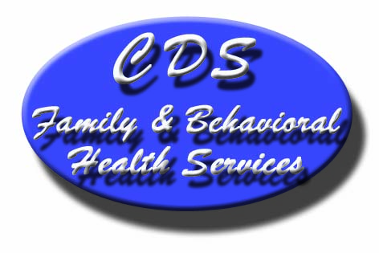

Stakeholder Survey Questions

Questions: | Strongly  Agree | Agree | No  Opinion | Disagree | Strongly  Disagree | N/A | Comments:
- CDS has a good working relationship with our organization.
- CDS has competent and professional staff.
- CDS has staff that is accessible to our organization.
- CDS is responsive to our input and ideas.
- CDS has a strong partnership with our organization at the administrative and/or management level.
- CDS has a strong partnership with our organization at the direct service staff level.
- CDS shares pertinent participant related information with our agency, as appropriate.
- CDS provides timely information to assist our work.
- CDS does a good job of following up on its participants.
- CDS does a good job of arranging or referring to community services.
- CDS has a positive impact on most of the participants it serves.
- Please include any additional comments you would care to make.
Please place a check mark next to the CDS program(s) with which you currently have contact:
Interface Youth Programs Prevention Programs
___Interface Youth Program-Residential ___ Alachua County Health and Wellness Coalition
__
___ Family Action ___ Levy County Prevention Coalition

___ SNAP Stop Now and Plan ___ Project Success or Too Good for Drugs

___ Independent Living
Thank you for completing this survey. Your input is part of our ongoing effort to improve our program services.

